10/30/2022
Hilda Campbell
COPE Scotland. W: WWW.COPE-SCOTLAND.ORG ESTABLISHED 1991 Registered Charity Number SC022807
Brief introductory workshop on Network Weaving
Session planning

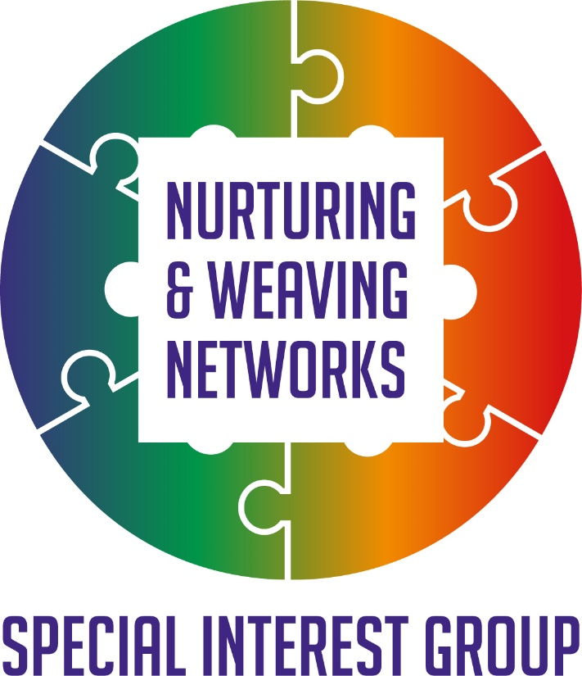

30/10/2022

Background to the workshop materials

The Q Community Network Weaving Learning Series

Following a learning opportunity within the Q community on Network Weaving there was an interest from those who had attended in how we could share the ideas and tools more widely.
This website offers the link to the Network Weavers handbook as well as an opportunity to sign up for the newsletter and connect with others interested in Network Weaving. https://networkweaver.com/
It was clear to those not familiar with the term Network Weaving that some introductory workshop to invite curiosity would be helpful. This brief workshop is one response to support that. We are grateful to June Holley and Kristin Johnstad for their support and wisdom. June wrote the Network Weavers Handbook and Kristin was one of the lead trainers in the Network Weaving Learning Series.
Following the Network Weaving Learning series, a Nurturing and Weaving Networks Special Interest Group was established within the Q Community. We welcome guests as well as members of the Q community https://q.health.org.uk/community/groups/nurturing-and-weaving-networks/

We were also delighted to connect with Hexitime https://hexitime.com/ and create space there also for those interested in learning and sharing skills and ideas around Networks and Network Weaving. https://hexitime.com/activity/contribute-to-the-nurturing-and-weaving-networks-special-interest-group

Who is the session aimed at?

This session is suitable for anyone who has an interest in Networks and how they can become more effective and how they as members of Networks can support the Networks to achieve more.

Aim of the session

To invite curiosity in participants around the concept of Network Weaving and the value of this approach in their communities, organisations, and groups.

Objectives

- Through experiential learning offer a moment to pause meditation, to promote the value of being present and giving your attention to the now.
- To explore the different ways, we may already connect with others
- To be presented with the idea of Network Weaving
- To raise awareness of what Network Weaving can offer
- To focus on why Networks matter
- To be presented with other possible sources of information

Materials needed if delivering in person

- Laptop, projector and speakers
- Access to the internet and links to videos
- A room where a group can work undisturbed, which is comfortable
- Tea coffee and refreshments,
- Specific access requirements if needed e.g., a portable loop system
- Pens and paper for notes
- Flipchart and pens
- Slides and instructor's notes for the slides and exercises
- Handout of reading materials
- Materials to support the evaluation technique being used

Training techniques used

- Mini lecture
- Socratic questions
- Facilitated discussion
- Video
- Group discussion
- Reflection

Materials needed if delivering online

- Laptop and sound
- Access to the internet and links to videos
- Virtual space to meet in teams/zoom with possible break-out rooms depending on group size
- An awareness of any specific access requirements of participants
- Slides and instructor's notes for the slides and exercises
- Handout of reading materials
- Materials to support the evaluation technique being used

Training techniques used

- Mini lecture
- Socratic questions using the chat function
- Discussion in break-out rooms
- Video
- Group discussion
- Reflection

Timeline

This workshop can be delivered in an hour, though if the participants have time for you to extend this, then you can offer more chances for discussion and extend the time to suit.
Ideas for timing, however, these are flexible to what the group needs
- 2minutes welcome and setting the scene for the session
- 3 minutes to be in the moment, you can use a video or talk through meditation, there are many to choose from check out the 3minute relaxer or time to pause on www.cope-scotland.org as just two examples
- 2 minutes covering the aims and objectives of the session
- 10minutes to invite people to share their ideas and discuss can be done in the chat box/at tables if face to face/in breakout rooms
- 3minutes mini lecture
- 10 minutes to invite people to share their ideas and discuss can be done in the chat box/at tables if face to face/in breakout rooms
- 10minutes mini lecture
- 5 minutes of feedback in chat or with thoughts from the group if face to face
- Mini lecture 5min
- 5 minutes of feedback in chat or with thoughts from the group if face to face
- 5 minutes closing thoughts and sharing

Evaluation and feedback
There are many ways of capturing feedback some of which you may have already in place. A simple tool can be asking people the questions ‘What worked’ and ‘Even better if’ this can be done in the chat function if face to face on the day as part of an evaluation form.
Thank people for coming and close
These planning notes accompany the facilitators notes and PowerPoint slides for the Introductory workshop on Network Weaving and can be freely used and shared, all we ask is you credit the original sources.

