Use of the SlaM Coaching Framework to enable improvement work

Introduction
The system of profound knowledge (Deming 1982) provides a great conceptual framework (Appendix One) to have in mind when working with teams within and across systems to reduce unwarranted variation and contribute to building a culture of continuous improvement.
Evidence-based coaching and health coaching frameworks and models are all fairly similar. Slam Partners (The South London and Maudsley coaching and consultancy service) developed its own coaching framework, REACH©, which enables people to have straightforward and healthier conversations that lead to positive actions. This framework has evolved over the last 10 years and it is successfully used with and by clinical teams, leaders, service users and carers. It has been used in research studies focussing on recovery. It is versatile and accessible for service users, carers and staff across health, social care and voluntary organisations.
Latterly, it has been adapted for use more specifically in development programmes focussing on improvement. Participants have reported that using this framework as a tool has helped them facilitate conversations with teams to overcome obstacles in improvement work. This has helped teams move from ‘walking on eggshells’ to having courageous conversations that then enabled them to create a psychologically safe space to do the work.
Introducing The REACH© Framework
The REACH© framework emphasises accountability more explicitly than other frameworks and models and involves connecting the head (thinking), heart (feeling) and hand (doing) to achieve identified goals. Each letter of REACH© represents a stage of the coaching conversation and at the heart of the framework is:
Dynamic contracting
This means making explicit the psychological contract you have with the team you are coaching, and this will help you build rapport and create a psychologically safe environment to learn and improve. Psychological safety is “the belief that the work environment is safe for interpersonal risk taking and that people feel able to speak up with relevant ideas, questions, concerns or mistakes without fear of being punished or humiliated” (Edmondson, 2018). It is worth spending a bit of time at the start of your work with a team to create a safe container in which team members feel able to openly share ideas, struggles and mistakes. This investment should have a positive impact on team members’ willingness to take risks and learn from failure.
Questions might include:
- What do you need in a group to feel safe?
- Can you think of a situation in a team where you felt safe? And/or a situation where you didn’t? What triggered this? How did that make you feel? And how did you respond?
- What do you expect/need from me ? (and what do you expect from them?)
- In order to feel safe, what should we agree on to maximize the way we can work together?
- What are the boundaries of the work?
- What are your specific roles in this work?
- Who is your sponsor? What do you need from them?
- What about confidentiality?
- How will you know that our work together has been successful?
- How do you want to manage different perspectives?
- How should we give each other feedback as we work together?
Reflect: an active process that utilises active listening skills and creates an opportunity for connecting thoughts and feelings about the improvement work. This requires exquisite listening throughout the conversation and the skill to acknowledge the team’s contribution to the development and execution of the improvement.
Questions might include:
- You set an aim, developed your driver diagram and measurement plan and you have started testing change idea XX, what have you learned from the work so far?
- What has gone well?
- What is your data telling you?
- When you look at this chart what do you think is going on in the system?
- Learning how to use SPC charts can sometimes provoke anxiety, how are you all feeling about using these to understand variation and focus your improvement efforts?
- What do you think might be influencing this data?
- What have been the barriers with executing your PDSAs?
- What tests have failed?
- What has your learning been?
Explore: use the system of profound knowledge more specifically here. Ask powerful questions to help the team test assumptions and do the Study part of the PDSA cycles and make connections with the wider system context.
Questions in the different lenses of profound knowledge might include:
Understanding and knowledge of Variation
Questions might include:

- How has your data helped you to test the assumptions you made when planning for your PDSA?
- Can I suggest that you may need to interrogate the data further because…?
- What help would you like with your data?
- How confident are you in using and describing your data?
- Your data is suggesting that the there is no improvement and you have been working on this for 30 days – what is your next step?
- How are you engaging the wider team to understand and use their data?
Understanding and knowledge of Psychology
Questions might include:
- On a scale of 1-10 how confident are you that the team/service is committed to this improvement work?
- What assumptions need further testing?
- What might help engage and motivate people to participate?
- What is helping and hindering your progress with this improvement work?
- If this improvement work fails what are the potential consequences for patients, families’ carers and staff?
- How can you engage other people in the improvement work?
- What is the difficult conversation that if had would help move this work forward?
- How are you working together as the Qteam for this project?
Understanding and knowledge of Systems
Questions might include:
- What impact is this change idea that you have been testing having on other parts of the system?
- Who do you now need to involve?
- Your data is suggesting that the change idea has resulted in success and is ready for … (either adapting, adopting, testing in other teams in the system), what do you need from leaders/managers and sponsor so that you can share your learning and make recommendations for next steps?
- What problem needs solving for you to make progress?
Theory of Knowledge and expertise
Questions might include:
- How have you involved and used the expertise and knowledge of service users and carers who use the services?
- How have you engaged other key parts of the system?
- What clinical/academic expertise do you need to draw upon?
- What national guidelines do you need to use (e.g. NICE)?
- What other improvement expertise would help you?
- How might your learning utilising Lean help you?

Agree outcomes: this helps to focus the conversation, consider the best approach to solving a problem and agree desired results. This helps you to work with the team to drill down the next smart aim they need to set to progress the work.
Questions might include:
- You have several tools that can help you with first understanding a problem (such as using nominal group technique, fishbone, process mapping, Lean tools). Which have you used?
- Of the tools you have which one may be best utilised to help you with this improvement?
- What is the data you have generated telling you about potential solutions to the problem?
- What are the potential solutions within your gift you could try when you leave here today?
- What do you need to escalate and to whom by when?
- Using your PDSA form what is you plan and aim/goal for tomorrow, 30 days?
- What will success look like?
- What data do you need to collect?
- What data analysis will you need to do?
- What do you need from each other to optimise the potential for success?
- What do you need from your sponsor?
Commit to action: this is essential in the process as it helps to determine the action that needs to be taken (by whom and by when). This may require the person coaching to help the team practice skills to confront and challenge each other or others in the system.
Questions might include:
- What will you do now when we conclude our time together today?
- What’s the outcome you want in the next day, 30, 60 and 90 days?
- Who will do what, by when?
- What do you need from me as the person supporting and challenging you in your improvement work?
- On a scale of 1-10 how committed are you to taking this action?
Hold to account: the team need to take responsibility to follow through and identify the potential consequences of not achieving the outcome.
Questions might include:
- If you don’t follow through on the next part of the improvement what might the consequences be for patients, staff, the system?
- How will you work together to keep pace?
- What do you need from your sponsor?
- How can I work with you to help you hold yourselves to account?

Appendix One

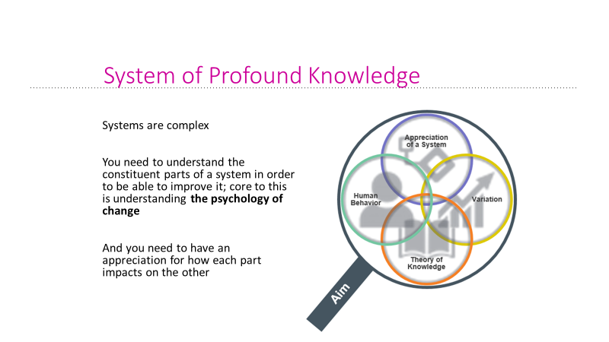
Before you can improve you need to understand the complexity of the system you’re working within and trying to impact upon.
Take away message “The system of profound knowledge provides a lens. It provides a new map of theory by which to understand and optimize our organizations.”
(Deming, Out of the Crisis)

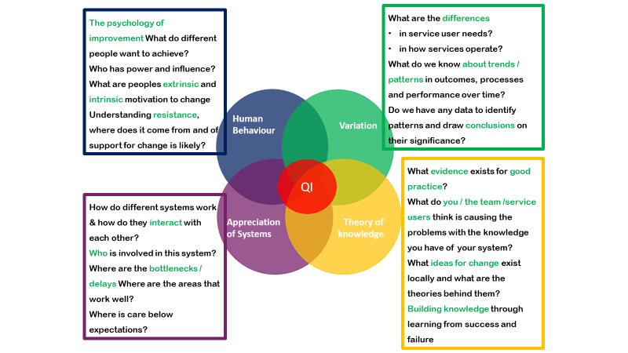

Important to consider human behaviour because this has an impact on how we engage with improvement work
If we were all going out for dinner after this and there was a choice of 2 restaurants. We’ve looked at the online reviews. One scores 5* for food and 3* for atmosphere. The other score 5* for atmosphere and 3* for food. Who wants to go to restaurant 1? Who would rather go to restaurant 2? Anyone look at a different factor when choosing a restaurant? Price? Does it involve leaving your local area? What if there was a last minute change of plan? Who would feel OK with that, who might feel a bit irritated because they’d planned their route and already looked at the menu and chosen what they want? Who would feel safe enough to speak up? How would people know/ feel that they have been heard? What are they willing to sacrifice to get their own way?
People have different motivations and expectations and reactions to change. We need to understand all of this at the start of an improvement project to make sure we are working towards a joint goal, shared understanding of what quality would look like, and so we can bring people who may be more anxious about change along with us on the journey and lack of psychological safety will have an impact.

It’s important to understand variation in a system before we make any changes.
If we think about my heart rate. Would we expect it to be exactly 60bpm every time we check it? No, that would be weird. We’d expect there to be a bit of variation and if we monitor it over time we can work out what’s normal for me. But what would we do if we check it one day and it’s 120bpm. Would you recommend I start taking medication or make drastic change to my lifestyle based on that? No – find out why it was 120. I’ve just run upstairs. What if it remains at around 120 for a sustained period of time? Then we’d need to take some action.

Understanding variation helps us know when we should be making changes, where we should focus our improvement efforts (do some patients, wards, teams etc have different outcomes to others).

We need to understand the system we are trying to improve
Healthcare systems are not linear a-b-c. Some parts may be very efficient while others are slow, some parts may be impacted by another service, if you change one part of your system you might have a big impact elsewhere. Often in healthcare improvement involves adding something new to a system or tweaking a small bit of it – these have limited impact or could make things more complex. By spending time understanding the system we are trying to change we can work out where we can simplify it and make it more efficient and identify where the key challenges are that we need to focus on.

What knowledge exists about the improvements we want to make
Is there already good evidence and/or learning across the system are there that we can draw on? Do people have their own theories about changes that can be made? We can use QI methodology of PDSA cycles to test out these ideas on a small scale and build knowledge about what works and what doesn’t.

