Rasheed Kaja to Everyone 13:04
Hi all - I am an emergency medicine clinician interested in combining simulation research using QI methodology for non educational use i.e. healthcare systems. I am from Great Yarmouth James Paget Hospital.
I assume you are referring to process or system simulation.
‘What is process simulation? Process simulation is a method of analysing and improving business processes using computer-based forecasting models. Process simulation allows businesses to explore “what if” scenarios, analyse the impact of changes to processes, and identify opportunities for improvement.’
Because most QI Projects in the NHS are not ‘process’ specific they will not provide data or simulation design information. Process and system simulation would only be effective if the NHS adopted ‘standard work’, then a simulation would truly represent work as done.
The basic process information for a process simulation is derived from a ‘process model’. This is not the same as a ‘process map’. Process models can be designed, by Business Analysts, from process maps plus a thorough understanding of the process. Simulation computer code can be written and a process simulation undertaken. Process maps are used by front line staff as a representation of work as done and a baseline for continuous improvement (CI). CI is very different from QI although a lot of the same tools are used.
Rasheed Kaja to Everyone 13:23
Is this process map/ change in culture - evidence based i.e. If I adopt it for a prospective study - is it validated elsewhere prospectively in health care settings i.e. A good example? - I am trying to understand why I should use this framework instead of what is already happening (albeit a failure).
What is already happening? – Quality Improvement and the Model for Improvement.
The application of these techniques in the NHS has been heavily influenced by the USA and Donald M Berwick. These techniques are described in ‘The Improvement Guide’ published in the USA by Jossey-Bass, Second Edition 2009. The Forward by Donald M Berwick, MD, MPP. On page 394 we are told – 51. Standardisation (Create a Formal Process) ‘(Eliminating quality problems) The use of standards, or standardisation, has a negative and bureaucratic connotation for many people. But an appropriate amount of standardisation can be a foundation on which improvement in quality and costs is built. Standardisation is one of the primary methods to reduce variation in a system. The use of standardisation, or creating a more formal process, should be considered for the parts of a system that have a big effect on the outcomes (leverage points)’. The NHS seems to have missed this point.
The only, large scale, application of standard work in healthcare is provided by the Virginia Mason Institute (VMI) in the USA. The NHS have been working with VMI for many years but standard work, although included is one of the diagrams, was not discussed in its Impact report referenced during the webinar nor the NHS Impact report.
The WMI publication ‘Accelerating Health Care Transformation with Lean and Innovation’ published in the USA by CRC Press, 2014. The forward by Donald M. Berwick, MD is the best, and probably only, example of the application of standard work in healthcare. Standard work is reference throughout the book. Page 8 states ‘A critically important principal in lean thinking is standard work. Standard work captures the current bets-known way to do something. Typically, this has been carefully worked out based on evidence and testing, and takes into account the coordination of flow with others in the value stream. Variation from standard work simply based on the personal preferences of the one doing the work is considered waste’.
Deming and Juran have a lot to say on this subject as well. I will post a list of the books that I read and consider to be absolute ‘must reads’ in order to gain a full understanding of the subject.
Debbie Brazil to Everyone 13:23
Can you illustrate the difference between a focus on process and outcome using an example?
My favourite illustration is from the book ‘Toyota Kata’ by Mike Rother, published by McGraw Hill, 2010. Here it is: (Also used in the webinar with some additional text by me)
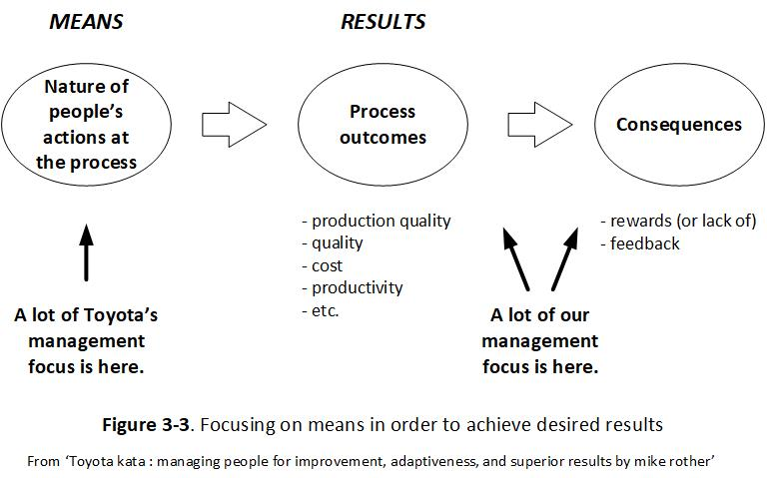
The difference between focus on process rather that outcomes is that the only way to improve outcomes is to improve process. You can’t improve process without standard work.
Lindsey Mclean to Everyone 13:24
Are there any ways to measure the success of CI processes?
Yes. CI is dependent on standard work. With standard work it is possible the collect repeatable process performance data at specific point in the process. Improvement can then be measured and monitored.
Rollo Moore to You (Direct Message) 13:26
Would you hold that focus on CI i.e. at the process, is very like focus on 'work-a-rounds' in Safety II related literature (Braythwaite et al)? or very different ?
Yes. Unless work-a-rounds (work-as-done) are incorporated into standard work and formalised you cannot implement CI.
In a lecture by Braithwaite, that I attended, ‘Patient safety: new issues, ideas and innovations’, by Jeffrey Braithwaite, PhD, FAIM, FCHSM, FFPHRCP, FAcSS, Hon FRACMA, Professor and Director Australian Institute of Health Innovation, 10 October, 2017, Birmingham, England, he speaks at length about the difference between Work-as-imagined and work-as-done and the effect that this has on patient safety. (I can provide his slides from this lecture)
And therefore the only real solution is to try and reconcile work-as-imagined and work-as-done and publish it as standard work. This is not a simple task but is certainly achievable with the right knowledge and tools.
Yvonne Morgan to Everyone 13:28
Would the Document Management System sit within Process Management System in the culture change or would it sit in QMS?
The Document Management System and the Process management System, and the Safety Management System can all sit within the Quality Management System (QMS).
Lawrence Brad to Everyone 13:28
Can you map this to learning organisations or now learning health systems? These are terms we see and can you comment on how important for us in NHS to focus on?
I have tried to map key CI activities to an organisation learning system. The only way you learn from your mistakes is by changing what you do. This is difficult to achieve without standard work. The NHS makes the same mistakes over and over again so it is very important to focus on this.
I used this illustration in the webinar. (I’m in the process of up-dating it)
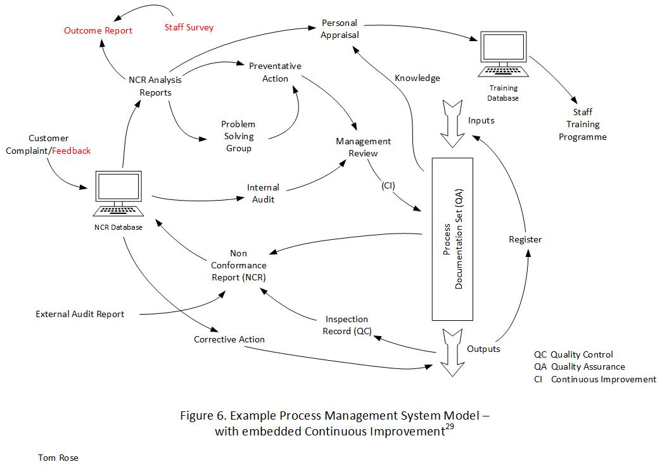
Amanda to Everyone 13:38
@Lindsey Mclean we have been doing a lot of work on person centred measures. Is that what you were talking about or the value that QI adds to the system?
Lindsey Mclean 13:40
I'd not thought about them separately - so I'd welcome a conversation about person centred measures.
The Health Foundation has a publication ‘Helping measure person-centred care’ published in 2014. The Q Lab’s second project looked at ‘Service Principals’ related to a specific healthcare issue. Person centred care is similar and is part of Service delivery and therefore one of the ‘Quality’ measures. It’s not a process in its own right and should be incorporated into all relevant processes similar to the way ‘candour’ is treated. This should be part of the standard Service/process design criteria.
Tim Windsor-Shaw to Everyone 13:41
Process mapping can document current work done as a baseline and help reduce avoidable variation in work. A process can usefully be granular to what is happening at one time, one place, one work team. Any higher than this granularity and you may miss opportunities to improve efficiencies and reduce waste.
Helen Turner to Everyone 13:49
Where could Clinical Audit sit in this process/system?
Clinical Audit will not change other than the adoption of their new framework. The now framework includes a section on ‘Process’ but it is not clear to me how this should be interpreted. Audit findings will be included in the QMS as shown in the diagram above (Fig. 8).
Chris Jackson to Everyone 13:50
Would you include OD In that framework?
Organization development (OD) is an effort that focuses on improving an organization's capability through the alignment of strategy, structure, people, rewards, metrics, and management processes. This should be part of the standard Service/process design criteria.
Helen Turner to Everyone 13:55
Where is that example of the 2 box tea making process map?
Here:
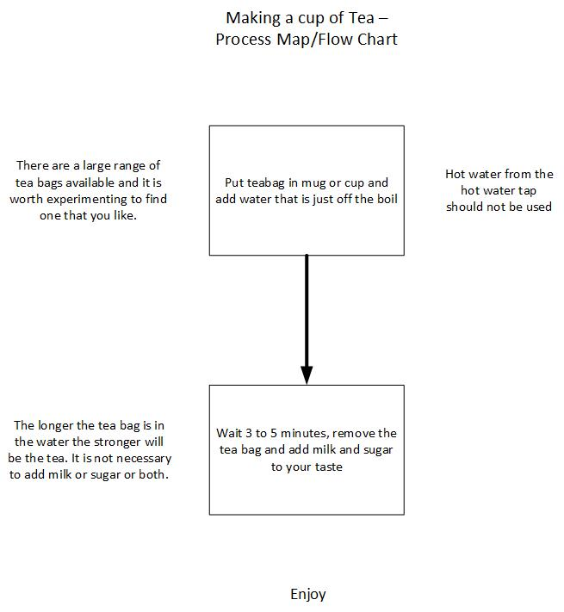
Ann Fewtrell to Everyone 13:56
That ward rounds map is work as imagined not work as done.
That is true – I know from personal experience having recently been in hospital. I’ve been unable to find anyone prepared to work with me to map WAD. Any offers? As show on the illustration it is taken from a guidance document: Royal College of Physicians, Royal College of Nursing. Ward rounds in medicine: principles for best practice. London: RCP, 2012 Copyright © Royal College of Physicians 2012. Reproduced with permission. This publication has been updated but the illustration reflects the previous version.
Tom Rose 29th November 2023

