Psychology4Improvement: Exploring the QI journey of emotions

Introduction
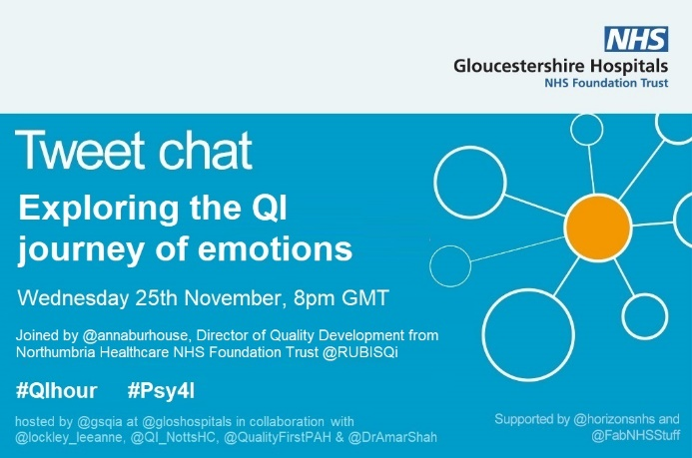
The second Psychology4Improvement #QIHour Twitter Chat was held on 25th November 20.00-21.00, exploring the Journey of Emotions in Improvement.
The chat was hosted by GSQIA (The Gloucestershire Safety and Quality Improvement Academy) in collaboration with Leeanne Lockley, Nottinghamshire Healthcare NHS Foundation Trust, Princess Alexandra Hospital (NHS Harlow) and Dr Amar Shah.
The event was run in partnership with the Psychology4Improvement #QExchange2019 team, and the hosts were joined by Director of Quality Development at Northumbria NHS Foundation Trust, Anna Burhouse.

Summary
There were 409 tweets from 43 participants during the QI hour itself, with a total of 527 tweets from 64 participants and 1.405m impressions over a 24 hour period from when the chat began.
A Wakelet summary of the QI hour is available here, and a full transcript can be found here.
Responses have been thematically analysed by question. The key emotions, feelings and behaviours identified by participants are also reflected as word clouds, both as an overall summary and broken down by question.
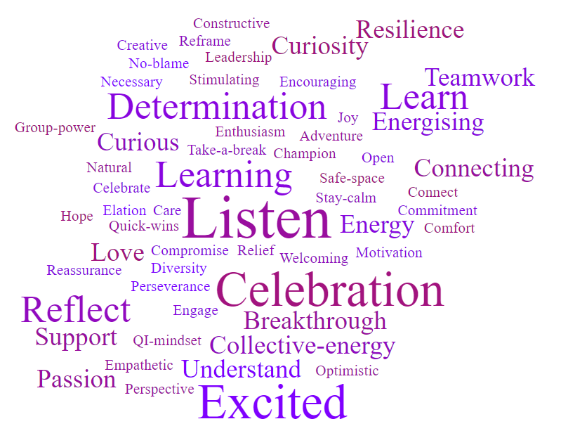
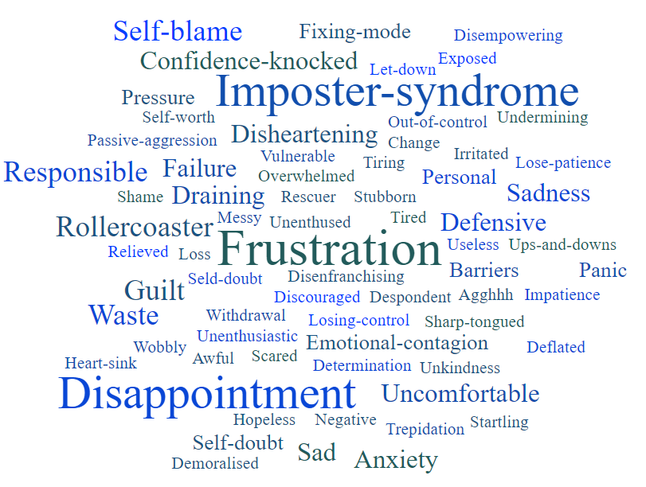
Fig. 1 – Overall summary word cloud for difficult feelings and behaviours
Fig. 2 – Overall summary word cloud for positive feelings and behaviours
Thematic analysis by question
- What are some of the difficult feelings and emotions you’ve experienced as a project coach or lead & do your emotions change at different stages of a QI project? Does your internal reaction ever differ from your outward behaviour?
“I find creativity energising, minds & hearts are open (including mine). Then something happens, at the interface between ideas & reality, which can feel like a heart sink”
@charlie_psych
- The start of projects is a time for optimism, curiosity and excitement. This also leads to anxiety and trepidation, but negative feelings are normally outweighed by good.

- The ‘messy middles’ can be more challenging, where barriers to translating ideas into reality are identified, and energy and enthusiasm wanes – but this is also where the learning lies.

- This can be disappointing and frustrating for improvers, and sadness is common when it seems like potential is wasted or hard work is lost.

- Many improvers struggle with feelings of personal responsibility and self-blame for not supporting teams to overcome challenges.

- As a result, many improvers describe actively working to separate their role as a coach from feeling responsible for problem solving or delivering the project, and have to resist falling into ‘fixing mode’ or a heroic leadership approach.

- External behaviours tend to differ from internal reactions, as improvers seek to maintain momentum and morale.

- Feelings of imposter syndrome are very common, and ideas were shared around how to reframe this and encourage open and honest discussion.

        - Psychological safety is created to encourage open, honest dialogue and reflection with a project team about these challenges.
“I've reframed it as Imposter Thinking, as a syndrome pathologises it whereas I can change how I think about things”
@BrianwDolan

        - Ultimately, joy and energy is found in connecting with others, and through the excitement and curiosity of project teams, which helps improvers through these struggles.
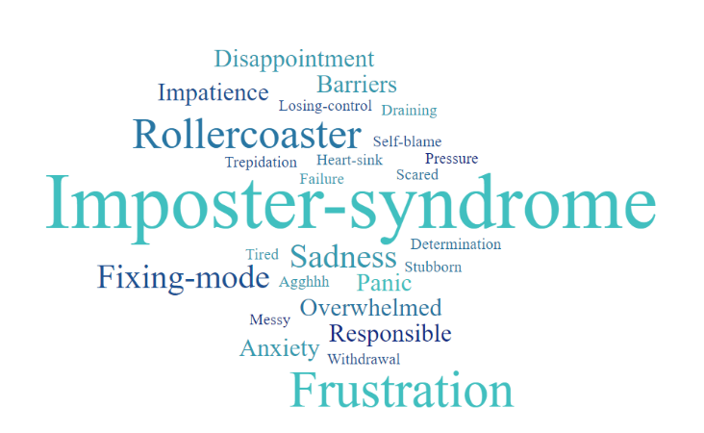
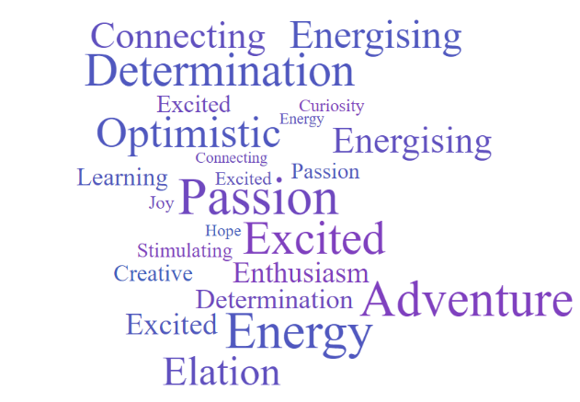
Fig. 4 – Q1 positive feelings and behaviours
Fig. 3 – Q1 difficult feelings and behaviours

- What is your emotional reaction when you encounter difficult characters or challenging behaviours as part of improvement work? What impact does this have?

- This can be disheartening and emotionally draining, particularly for those who are uncomfortable with conflict. These situations can impact confidence and lead to self-doubt.

- Negative behaviours can feel undermining, leaving improvers feeling vulnerable or defensive. It can take work and resilience to overcome natural urges to distance or blame oneself, but it is recognised the way one reacts to challenging behaviour is something we can control.
“It can be draining but also makes me curious about why, which can then reveal a new perspective through which to engage and connect”
@ThinkSpeakThink
- Overall, conflict, resistance and diversity of thought are welcomed and seen as a natural part of change.

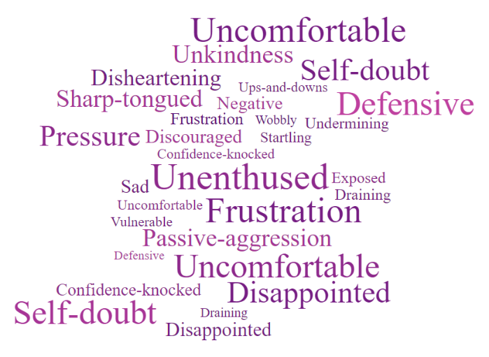
- Listening with curiosity to different perspectives gets us closer to understanding the wider truth, overcoming obstacles and helping people feel heard.
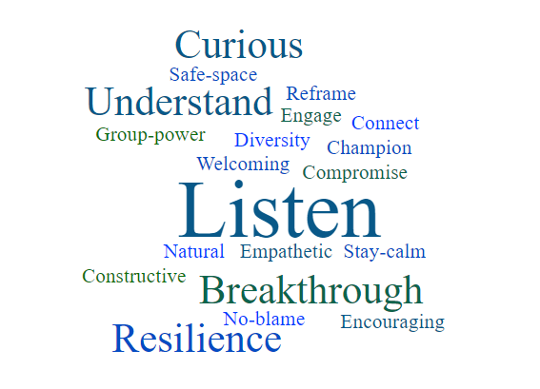
Fig. 6 – Q2 positive feelings and behaviours
Fig. 5 – Q2 difficult feelings and behaviours

- How does it feel when things don’t work? How do you make sense of why it's happened? What does your response look like when it goes well, and when it goes badly?
“We invest so much of ourselves in this work and care so deeply”
@annaburhouse
- Improvers admit this can be disheartening, especially when deeply invested in the work. Seeing improvement potential wasted is disappointing and impacts enthusiasm.

    - There is a sense of responsibility when things don’t go to plan, resulting in feelings of guilt, shame and self-blame.
“Reflection with the team is so much more useful than a ‘post-mortem’ on your own. So much more learning and a lot less stressful”
@rachel_n_trask

    - However, there is consensus that failure is a necessary part of improvement and the PDSA process which ultimately results in learning.

    - Keeping the continuous improvement mindset at the forefront and naming and accepting the tendencies to take this personally helps improvers overcome these difficult emotions and refocus energy proactively.

    - Exploring why things haven’t worked with the project team helps process these feelings, identify learning and build psychological safety.
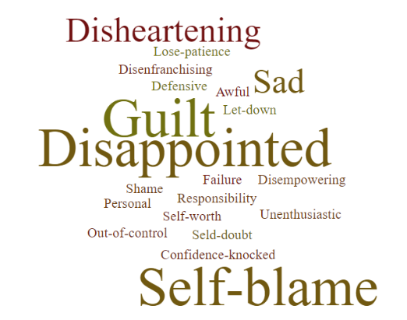
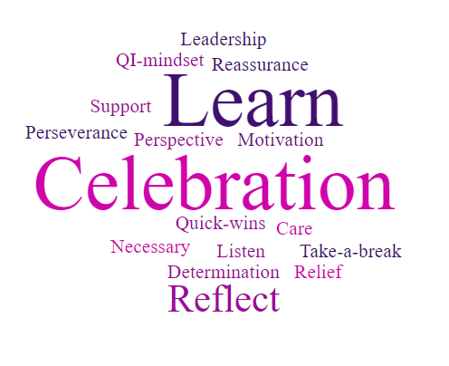

Fig. 7 – Q3 difficult feelings and behaviours
Fig. 8 – Q3 positive feelings and behaviours

- How does it feel when you are part of a project team that loses momentum, enthusiasm or the work ‘fizzles out’? How are your emotions & behaviours affected by other members of the team?
“I never take it for granted that QI projects will fly & teams will be sustained. Challenging the status quo is one of the hardest things to do & people in project teams need ongoing love & support”
@helenbevan

- Even the most experienced improvers recognise it doesn’t always work out, and that on-going support is needed to help teams maintain momentum.

- When work does ‘fizzle’, improvers can feel demoralised and frustrated at wasted effort.

- ‘Emotional contagion’ is common as improvers feed off the emotions of a project team. This is countered by the collective energy derived from working with teams, and in celebrating successes.

- Improvers recognise their role can be to ‘hold the uncertainty’ for a team but admit this can sometimes be tiring.
“How the team feel about the importance of the work will impact the whole group”
@joyfurnival
          - Again, it was acknowledged that self-reflection is needed to notice when the ‘inner rescuer’ is ignited and finding the balance between cheerleading and problem solving.

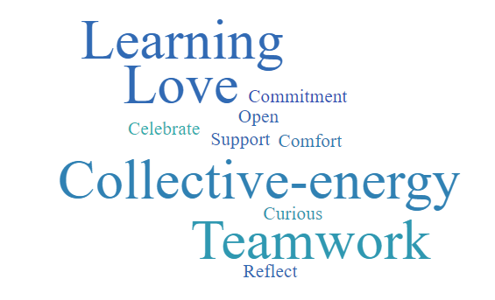
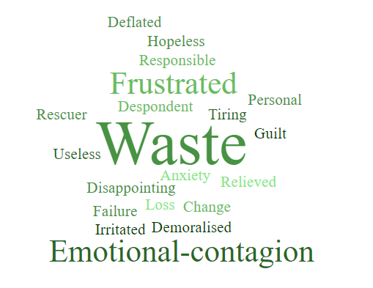

Fig. 10 – Q4 positive feelings and behaviours
Fig. 9 – Q4 difficult feelings and behaviours

- What support structures or tools do you turn to when you experience struggles or difficult emotions in improvement work? Is there anything else that helps? How do you learn from it?

- Improvers seek regular opportunities to connect with likeminded people and reflect on the struggles they face in QI. This is through support from their colleagues, peers or improvement networks and communities (Twitter, WhatsApp groups, coaches etc).

- Honest conversations about real feelings creates trust and emotional support and puts things into perspective.

- Sharing similar experiences also provides fresh perspectives and ideas for addressing such challenges.

- Personal reflection is also key, with some turning to structured approaches to support and reflection are found through before and after reviews and action learning sets.

        - Tools to help work through specific challenges with a project team were also identified, including mind mapping, De Bono’s Thinking Hats and Nancy Klein’s Thinking Environment.
“I have an email folder full of previous successes and comments from those I’ve supported to refill my bucket of joy”
@steve_daykin

        - A number of participants keep a scrapbook or folder filled with positive feedback and previous successes to revisit, to help overcome temporary feelings of failure or disenchantment.

6. What have you gained from participating in tonight’s tweet chat?
“I have gained a mental word cloud of all the emotions shared by everyone here & feel that we’re describing a much more real sense of what it is to be an Improver”
@mountain_medica
- Participants of the QI Hour welcomed the space to reflect, connect, and share experiences and ideas.

- Improvers felt reminded of purpose and passion, feeling refreshed, enthused and energised.

