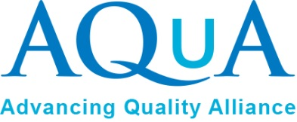
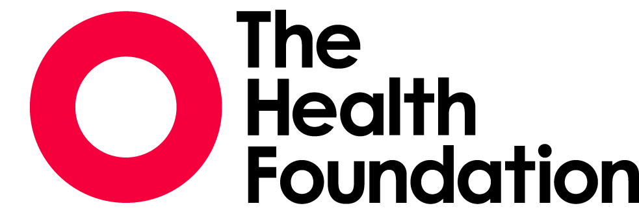

Q Community
Network &
‘Book Club’
Member Pack 2018

Welcome to the Health Innovation Manchester (HIM) Q Community Network Events and ‘Book Club’.
In partnership with Health Innovation Manchester (HIM), throughout 2018 the Advancing Quality Alliance (AQuA) will be hosting a series of five ‘Book Club’ sessions to support The Health Foundation’s Q Community members in Greater Manchester.
Each session can be attended either as a group or as a standalone opportunity. We do however hope that you will be able to join all dates as this will help you and the community form, working together in the spirit of all learn, all share.
The Book Club principles and practices embrace the aims of the Q community to develop and inspire, innovate and problem solve.
Our approach is structured to explore the key themes from the ‘Habits of an Improver’ (Health Foundation 2015). In the paper Professor Bill Lucas describes a perspective of viewing the field of improvement via 15 ‘habits’ which individuals like yourself regularly deploy. The following themes are the basis for each of our sessions:
- Learning
- Resilience
- Systems thinking
- Influencing
- Creativity

How Does ‘Book Club’ Work?
The Q Book Club will build upon the suggestions and involvement of you, our Q members. This includes the opportunity to suggest further articles and books for reading, which will shape the style and content of future events. Suggested reading titles already identified are listed overleaf. Book Club members will be provided with a blend of electronic books and hardcopy materials prior to each session.
At each session there will be a topical discussion followed by the Book Club, where members will share learning, thinking, suggestions, and advice to help us apply into our day to day roles. We will create a list of ideas and applications to help us and others improve our practice.
By using blogs, online voting, ’book reviews’ and social media we can also collectively reflect on our learning and share our thoughts with the wider Q Community, Greater Manchester, and the UK. Lunch will be provided at each event to allow some informal discussions and randomised lunch trials!

Pre reading prior to event one:

Habits of an improver (Health Foundation 2015)
Using communication approaches to spread improvement (Health Foundation 2014)

Examples of books on the proposed reading list:
Norman., Nola, T., Moen, R., Provost, L., Nolan, K. and Langley, G. (2013), The Improvement Guide, San Francisco, Calif: Jossey

Schein, E. (2014), Humble Inquiry. San Francisco: Berrett-Koehler Publishers Inc.

Syed (2015). Black Box Thinking. Chicago. John Murray

Vincent (2010) Patient Safety 2nd Edn. Wiley-Blackwell

Senge.P (2006)The Fifth Discipline 2nd Ed. New York. Random House Business

Peters.S. (2012). The Chimp Paradox: The Mind Management Programme to Help You Achieve Success, Confidence and Happiness. London. Vermilion

Fillingham, D. Jones, B. Pereira, P. (2016) The challenge and potential of whole system flow. London. The Health Foundation

All events 0930 – 1330 (inc lunch) Imperial War Museum, Trafford Wharf Rd, Stretford, Manchester M17 1TZ

Deli

For more information:
Charlie Woolley
Charlie.woolley@srft.nhs.uk
Telephone: 0161 206 0726

@theQcommunity
#Qcommunity

