Q Lab design canvas
Draft Version 1.0 – May 2019
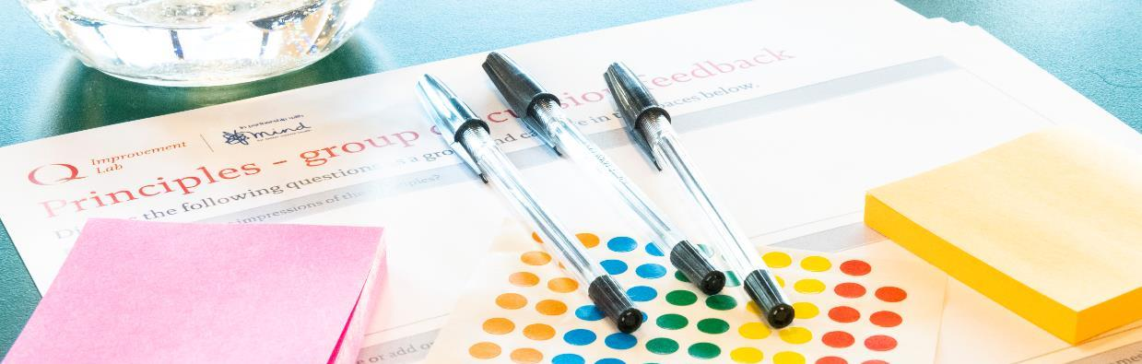
Photo: Q Lab

Q Lab design canvas

Introduction

What is the design canvas?
The design canvas is a resource developed by the Q Lab, to support you and your team to learn more about tools and methods you can use at each stage of a design process when developing and testing ideas to improve care. It brings together activities that have been used in many different industries, by different types of teams to solve social challenges, and presents them as a potential journey that you can follow.

Where have the activities come from?
The Lab uses methods from several different fields and approaches to create change. These include quality improvement, human-centred and service design, social innovation and systems thinking, among others. This document pulls together tools and techniques from these various fields.

How are the activities organised?
The activities are organised by a ‘triple diamond’ design process. The triple diamond is based on the ‘double diamond’ process originally developed by the Design Council. It reflects the notion that ‘every design specialism has a different approach and ways of working, but there are some commonalities to the creative process’ that can be conceptualised simply. Policy Lab added an extra diamond - that resonates with the Q Lab approach - that considers the work that needs to be done before defining a problem, such as building a team, and identifying what you hope to achieve.
Becoming a team
Investigate
Specify and test
Set objectives
Analyse insight &
create
Evaluate
Diagnose
Dialogue
Define
Discover
Deliver
Develop
Figure 1 Triple diamond

The triple diamond encapsulates three important ideas:
- Divergent and convergent thinking: the left-hand side of each diamond represents divergent thinking: opening up, getting inspiration, having as many ideas as possible. This is followed by convergent thinking (the right-hand side of each diamond): narrowing down, refining an idea, or selecting the best idea.
- Iteration: you won’t get things right first time and that is okay and part of the process. The process is displayed as though it is linear, but you will likely loop round parts of it multiple times.
- Valuing each phase: each of the six phases has a different focus and therefore adds a different value to your work and should be considered equally – for example ‘one of the greatest mistakes is to omit the left-hand diamond and end up solving the wrong problem’.

Who is the design canvas for?
The design canvas has been developed specifically for the organisations (‘testing teams’) who are working with Q Lab and Mind – the mental health charity - on the challenge:
What are the experiences of people living with both mental health problems and persistent back and neck pain, and how can care be designed to best meet their health and wellbeing needs?
We hope the design canvas will also be useful for other people who are working to improve health and care.

For each segment of the triple diamond we have identified activities that may be helpful for you to try (shown in the contents below). The activities we have included is informed by what we know about testing teams, but will also be relevant to others working in improvement or innovation. Note: some of the earlier sections refer to the kick-off meetings we had with testing teams. In the future we plan to remove these references and update the guide with information about what worked well.

Should the activities be completed in order?
There will often be a logical order in which to do the activities. There are six high-level stages of the design process and we have identified milestones in between each of the diamonds – in the context of the Q Lab work these are creating a challenge statement and selecting an idea.

However, some of the activities can be useful at multiple stages. For example, a journey map might help you think through the problems (during the ‘Diagnose’ stage) but also provide a useful way to think about the structure of a prototype (in the ‘Develop’ stage). We have included mapping in the ‘Discover’ stage to help you learn about the existing service.

The iterative nature of the design process means that, although the activities are visualised as a neat linear process, this is generally not always how it will feel. This might be a more accurate visualisation:
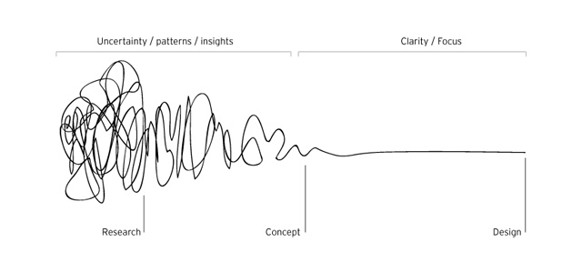
Figure 2 Process of design diagram, available at https://alchemyindesign.files.wordpress.com/2013/07/process-of-design.jpg
Should all the activities be completed? How should you choose?
It’s unlikely that all the activities will be relevant to your challenge and context. Hopefully some of the activities are relevant to you and align with what you’re trying to achieve. We’ve tried to select a diverse range of examples and included articles that might inspire you.
The number of activities undertaken will depend on how fast you want to move, the capacity you have available and the progress you can make with each activity. There is scope to do the activities in a light touch way with little resource.

Does the design canvas explain how to do the activities?
In this guide we explain why you might want to do the activities and provide guidance on how to do them and what to pay attention to.

Many of the activities are enduring methods that have been used in different ways. Each testing team may want to do the activities in different ways to each other.

Where detailed instructions are needed these are linked to existing, external resources. The only exception to this is activities that we have identified as being of benefit for all testing teams or where we couldn’t find suitable, existing instructions.

Take a look at the bibliography at the end of this document to learn more about some of the sources for this guide.

What isn’t in the design canvas?
There is a wealth of information about what it takes to run successful improvement projects. The design canvas focuses on methods to help develop your intervention – but it doesn’t include information on the other things that sit around this like good project management, stakeholder management and involving users.

Where can I get more information?
If you have questions about the activities that have been included or would like to find out more please do get in touch: Qlab@health.org.uk.

For all Q Lab testing teams we will use this design canvas to structure our ongoing work together. If you are interested in 1:1 coaching on any of the activities, or ideas on how to run them with your teams, please let us know.

Is the document finished? Does it cover all activities?
This is a living document that we will refine and add to over time, as a useful repository of methods.

It is by no means exhaustive. If you know of an activity that isn’t in it and you think it would be useful to share with others please let us know.

Contents
Becoming a team
Investigate
Specify and test
Set objectives
Analyse insight &
create
Evaluate
Diagnose
Dialogue
Define
Discover
Deliver
Develop
Iterative cycles
Agree challenge statement
Select an idea
Photo: Q Lab

Dialogue  - Build your testing team  - Agree relationship with Q Lab  - Stakeholder mapping | Diagnose  - Identify service and population / user group  - Systems thinking tools  - Root cause analysis  - What does success look like?  - Agree challenge statement | Discover  - Develop personas  - Conduct ethnographic research  - Map the journey | Define  - Generate ideas  - Review and filter ideas  - Capture and develop  - Select an idea to prototype | Develop  - Decide what to prototype  - Prototyping: paper  - Prototyping: storyboards and visuals  - Prototyping: role play  - Test a prototype with stakeholders | Deliver  - Early stage testing in practice  - Deliver your idea in practice  - Analyse findings and make decisions about how to proceed  - Share learning

Photo: Q Lab

Dialogue: Becoming a team
Becoming a team
Investigate
Specify and test
Set objectives
Analyse insight &
create
Evaluate
Diagnose
Dialogue
Define
Discover
Deliver
Develop

During this phase, teams will focus on understanding who will be doing the work and their relationships with each other. Some people within the testing teams might not have met before, and people within the same organisations may be working together for the first time. The team will look ahead and plan how they want to work together.

Build your testing team

Why
Some test teams may be coming together as a team for the first time which might include new partnerships. A lack of clarity about the requirements of partnership is one of the reasons that improvement efforts can fail. It is important that at an early stage you get to know each other (if you don’t already) and discuss how you will work together, including roles and responsibilities, as well as decision-making processes.
You and your test team are more likely to be successful if you include a range of people from your organisation who have a stake in the issue. Ideally the teams would include people with experience of using your service (although several activities are designed to understand user experience if this is not possible). Depending on the range of diversity in your team, you may need to pay particular attention to power and hierarchy – and how this could affect your work.

How
Meet as a testing team or, if this isn’t possible, coordinate smaller discussions before the kick-off meeting to develop a shared understanding of what everyone is bringing to the team and what roles and responsibilities will be. During the kick-off meeting we will take a little time to get to know each other and the roles we will play.
Within the wider Lab participant group there is a range of expertise and experience that you may wish to draw on. If there is specific input you would like to access, make a note of it.

Tools and templates
You may wish to consider using the RACI model: https://en.wikipedia.org/wiki/Responsibility_assignment_matrix

Further reading
https://media.nesta.org.uk/documents/Partnership-Toolkit-Feb-2019.pdf

Agree relationship with Q Lab

Why
Before you, your test team and the Lab begin working together, we need a shared understanding of how we will work together and how we can get most value from this relationship.

How
The Lab team will share information about our roles and responsibilities and how the Lab can support your work. The pre-kick-off meeting call (to discuss the overall approach), and this guide, will help us both agree activities and ways we can work with each other.

Outputs
We will then explore the relationship in more detail during the kick-off meeting, perhaps involving a short exercise to surface expectations and points of clarity.

Stakeholder mapping

Why
We know that the success of improvement efforts often directly relates to how teams influence and build support for their work.

How
Produce a map of your stakeholders to understand who will be influential in the success of your work and how they will be engaged and kept informed.

Tools & Templates
- Stakeholder mapping activity on page 11 https://s20056.pcdn.co/wp-content/uploads/2017/08/Q-community-CAPS-toolkit-2017.pdf
- Stakeholder mapping poster http://www.servicedesigntoolkit.org/assets/posters/workposter_stakeholdermapping_a1.pdf
- Stakeholder analysis tool from NHS Improvement https://improvement.nhs.uk/documents/2169/stakeholder-analysis.pdf

Outputs
A stakeholder map which we could use at the kick-off meeting to understand key activities needed.

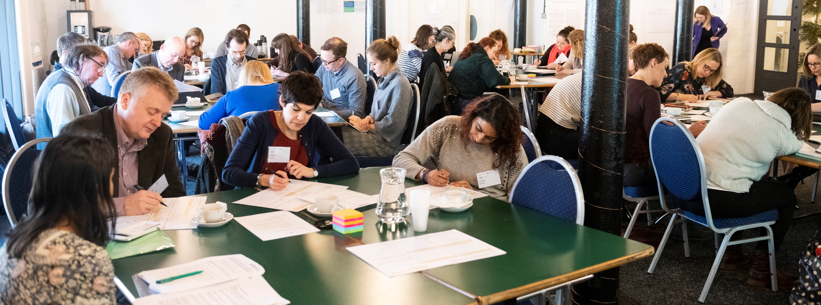
Photo: Q Lab

Diagnose: Set Objectives
Becoming a team
Investigate
Specify and test
Set objectives
Analyse insight &
create
Evaluate
Diagnose
Dialogue
Define
Discover
Deliver
Develop

During this phase teams will interrogate and refine their understanding of the challenge they’re working on. They will converge on a set of statements that set out what they will work towards.

2.1 Identify service and population/user group

Why
To enable you to scope your work, you need to decide the service and / or population group that you will be working with. This will set the parameters for the research and focus of the work you’ll be doing.

How
Having quantitative data on how people do, or don’t, interact with services, and how they experience issues can help identify the users you may like to focus on and work with. The following questions may help guide your exploration:
Current and potential users
- Who is using the service? What do you know about their characteristics, ranging from age, gender, socio-economic status, ethnicity?
- What other services are people accessing?
- What medications are people taking or being prescribed?
- Are there local or national statistics around unmet needs that are relevant?
- Is there under or over representation from certain groups?

Service metrics
- Where is the service delivered?
- What is the average waiting time?
- How are people finding the service?
- What is the wait time?
- How many missed appointments are there?
- What are the range of outcomes from the service?
- Do certain groups of people have a better or worse experience than others?

Outcomes and experience metrics
- How are experience and outcomes measured and recorded, and what data is readily available?
Drawing on as much data as you can, decide the service or population group based on the initial problems that the team have identified, who you have involved in the testing team, your agency to support change and the feasibility of testing work.

Tools and templates
There are so many ways you could collect data to inform your decision making, and in all likelihood, this will need to be customised to meet your needs.
- Population/service user group template: https://diytoolkit.org/tools/target-group/

Outputs
Definition of your population/service user group

2.2 Use systems thinking tools to understand the wider context

Why
Systems thinking is a discipline that aims to help us acknowledge and navigate complexity. Often, we are trained to focus only on those things that are directly in our control, or those things that represent the top of the iceberg – the aspects we can see but are ultimately connected to much that is under the surface. It is important however to seek to understand what else is going on, what else you work is connected to and how that will ultimately influence your success.
Understanding how your work fits into the wider systems can help you make decisions that will lead to your work being able to spread and scale more effectively.

How
Having structured conversations about the wider context and making decisions about which things you may seek to influence and/or areas of focus to avoid, is important. Two suggestions include:
- Cluster mapping – supporting a group of people to quickly share information about the problems we can see and their interconnections.
System mapping – a way to visualise the different organisations, people, money and information flows that interact with your service. Understanding this can help you to see strong relationships and flows (that you may want to build on and learn from) and weaker relationships (that you may want to address and improve).

Outputs
Identify the key areas of interconnection and seek to define three new insights that have emerged as a result from your work to understand the local ‘system’.

Tools and templates
- Cluster mapping activity: This activity is from Disrupt Design and is explained here: https://medium.com/disruptive-design/tools-for-systems-thinkers-systems-mapping-2db5cf30ab3a
- System mapping: This activity is from the Better Services by Design website here: http://www.bsbd.org.uk/cards/system-map/

Further reading
- Article ‘From service design to systems change’ by Adam Groves: https://medium.com/@adam.d.groves/from-service-design-to-systems-change-72fa62b1714c
- Template: https://docs.google.com/drawings/d/1RXvxrr0T4-aPiRztfjT_K95wjjnJPA-p3T7Dr-TQKN4/edit

2.3 Root cause analysis

Why
Often a visible problem will be a symptom of an underlying problem, or a ‘root cause’. Without addressing the root cause of a problem, future problems will continue to emerge and any solutions will likely be short term. Therefore, seeking to peel back the layers of a problem can be an important step.

How
Tenacity to keep seeking to understand what is really causing an issue is a key attribute for this work, and this is likely to be an interactive process! Asking ‘why?’ five times can be a simple and effective way of exploring the layers underneath the visible problem

Tools and templates
- 5 Whys – http://www.ihi.org/resources/Pages/Tools/5-Whys-Finding-the-Root-Cause.aspx
- Causes Diagram - https://diytoolkit.org/tools/causes-diagram/

Further reading
- https://www.jstor.org/stable/25062196?seq=1#page_scan_tab_contents
- https://www.mindtools.com/pages/article/cynefin-framework.htm

2.4 What does success look like?

Why
It is important that before you begin developing ideas, you have a shared understanding of what you are trying to achieve. At this stage, this is not about agreeing metrics or measurements – as this will vary depending on the idea you decide to take forward – but is about the overall aim or outcome that will guide your work.

How
You may wish to use the quadruple aim for health and care as the organising structure for these discussions. Although this framework was originally intended to guide the redesign of health care systems and the transition to population health, we think at a more granular level it can act as a helpful guide, supporting teams to think through aims for their patients/user group as well as their organisation and workforce. Here is how we have interpreted the NHS quadruple aim in terms of current Lab project:
- Improving citizen experience: Improving experiences and quality of care for people with mental health problems and persistent back and neck pain.
- Improving population health: Supporting better health for people with mental health problems and persistent back and neck pain.
- Reducing costs: Delivering sustainable care in your health and care context
- Staff and carer wellbeing: Improving organisation and supporting health care professionals to deliver high quality and holistic care.
In preparation for this discussion we recommend that you gather expectations from people who will not be at the kick-off meeting and who you have identified as important stakeholders for your work. What do these aims mean to them? What will they be hoping to see, in order to support your work?

Outputs
In the kick-off meeting, each person in the testing team will be asked to share their sense of what success looks like – bringing in what they have learned from others they have spoken to. This session will likely be best facilitated by a member of the testing team – and the Lab team will play a supporting role to ensure you reach a shared agreement that balances ambition with realistic expectations for the next six months.
After the workshop, we recommend that you discuss and refine the outputs with a small number of your key stakeholders.

2.5 Agree challenge statement

Why
Through the activities that you have completed you should have a good understanding of the problems that exist in and around your setting. Before moving into activities that ask people to generate ideas, it’s important that there is a scope and aim of the work, connected to the problem.

How
As a team, agree the problem or problems that seem most relevant to your work and use this to develop a challenge statement. Your challenge statement will define the scope of your project in a succinct way. This includes answering the following key questions:
- Headline (the challenge described in a sentence)
- What is the problem?
- Who does it affect? And how?
- Why does it matter?
- What does success look like? (What’s different? How has life changed and for who?)
- What is focus for the first testing cycle?
The challenge statement is not set in stone. You might want to set a challenge statement for the overall project in this cycle, and then break that down into a smaller challenges that you will focus on for the next testing cycle.

Outputs

We’ll be aiming to agree a challenge statement by the end of the kick-off meeting. Further reading
- ‘The actual problems to be solved’ by Kate Tarling and Ayesha Moarif https://docs.google.com/presentation/d/1fclyNbuiK7EicRkmcF7fO4PCQdQ8PKwFiWYnFtqOwTY/edit?usp=sharing (note there are also slide notes with more explanations)
- Problem definition https://diytoolkit.org/tools/problem-definition-2
- ‘How might we…?’ questions Stanford D school http://crowdresearch.stanford.edu/w/img_auth.php/f/ff/How_might_we.pdf

Photo: Q Lab

Discover: Investigate
Becoming a team
Investigate
Specify and test
Set objectives
Analyse insight &
create
Evaluate
Diagnose
Dialogue
Define
Discover
Deliver
Develop

During this phase, test teams will gather data and look at their challenge in different ways to build new understanding and insight about how to address the challenge statement.

3.1 Develop personas

Why
Any ideas that are tested should be grounded in the needs, strengths and capabilities of the target population/users. Keeping this present and represented whilst coming up with ideas is a good way to ensure that ideas respond to actual need.

How
Personas are fictional profiles representing a particular group of people. They should be based on research and often represent a group of people with shared interests or common behaviour patterns. Personas are ‘characters’ with which design teams and organisations can engage. They should include both information about the person and information about how they currently access and use the existing service.
If you already have a good amount of data about the people who are likely to use your service, then you may be able to begin developing some personas.
The personas will be used in the ideation session to help those generating ideas quickly understand who they are designing for, as well as providing inspiration for this.
You can use a persona template or create your own template.

Tools and templates
- 100% Open Persona toolkit: https://www.100open.com/wp-content/uploads/2017/04/8.-Personas-1.pdf
- DIY toolkit simple persona template: https://diytoolkit.org/tools/personas/

Further reading
- Articles explaining more about personas: https://www.cooper.com/journal/2001/08/perfecting_your_personas https://www.uxbooth.com/articles/creating-personas/
- Example personas: http://www.servicedesigntools.org/tools/40

3.2 Conduct ethnographic research

Why
In order to improve services, we often need to test our understanding about the issues at play – it can be easy to pick up engrained information that’s passed between people in an organisation rather than drawing from evidence. There are some short ethnographic activities that are designed to help with this, that allow you to quickly collect information from light-touch and quick observational studies – that immerse you in a setting. This will provide a different richness to the information that you may get from speaking to a clinician or reading about the service model.

How
Undertake the Guided Tour or Experience Tour activities below. You may also want to undertake a Service Safari on other services – to get a different sense of what ‘good’ looks like.

Tools and templates
- Guided Tour exercise developed as part of the Ideo Design Kit: http://www.designkit.org/methods/46
- A day in the life (page 13): https://s20056.pcdn.co/wp-content/uploads/2017/08/Q-community-CAPS-toolkit-2017.pdf
- Experience Tour from Nesta’s DIY toolkit: http://www.100open.com/toolkit_2/service-safari/
- Service Safari - see more information from the Design Council on page 14 of this document: https://www.designcouncil.org.uk/sites/default/files/asset/document/Design%20methods%20for%20developing%20services.pdf
- Contextual interview method from This is Service Design Doing: https://www.thisisservicedesigndoing.com/methods/contextual-interview

Further reading
- Watch this BBC Global Experience Language video explaining design research: http://www.bbc.co.uk/gel/articles/what-is-design-research

3.3 Map the journey

Why
Mapping the journey of people using your service can help you make sense of data you have collected and is a more visual way of presenting this information. It can illuminate aspects of the journey that are value-adding, as well as those that result in poor experience.
This information will help you understand the areas that are well placed for improvement. Structuring what you are learning and testing will make it easier for others to understand what you have done when sharing your learning.

How
Journey maps are a flexible tool. They can be simple as well as very complicated. You can map single journeys individually or the whole service together in one map. They can be used to structure qualitative insights from research or quantitative data you have. Developing an ‘as-is’ journey map will provide a base for considering improvements.
First you’ll need to decide what journey you want to map. If you’re trying to improve an existing service, mapping that would be a good starting point. If not, you may want to map a user or potential users journey over many months, identifying different services they interact with.
You’ll need someone with a good understanding of the service. If you’ve conducted ethnographic research into the service you can use the data you collected in that activity.
It’s useful to do some reading about journey maps and appoint one person to oversee creating the map. This person should learn a bit more about the types of journey map and be responsible for creating the basic structure of the map and inputting the content.

Tools and templates
- An in-depth guide from Adaptive Path to journey maps (experience maps) and how to create them can be found here: http://adaptivepath.s3.amazonaws.com/apguide/download/Adaptive_Paths_Guide_to_Experience_Mapping.pdf
- Q Community CAPS cards: https://s20056.pcdn.co/wp-content/uploads/2017/08/Q-community-CAPS-toolkit-2017.pdf
- See below for a shorter article from Adaptive Path - The Anatomy of an Experience Map: https://www.adaptivepath.org/ideas/the-anatomy-of-an-experience-map/

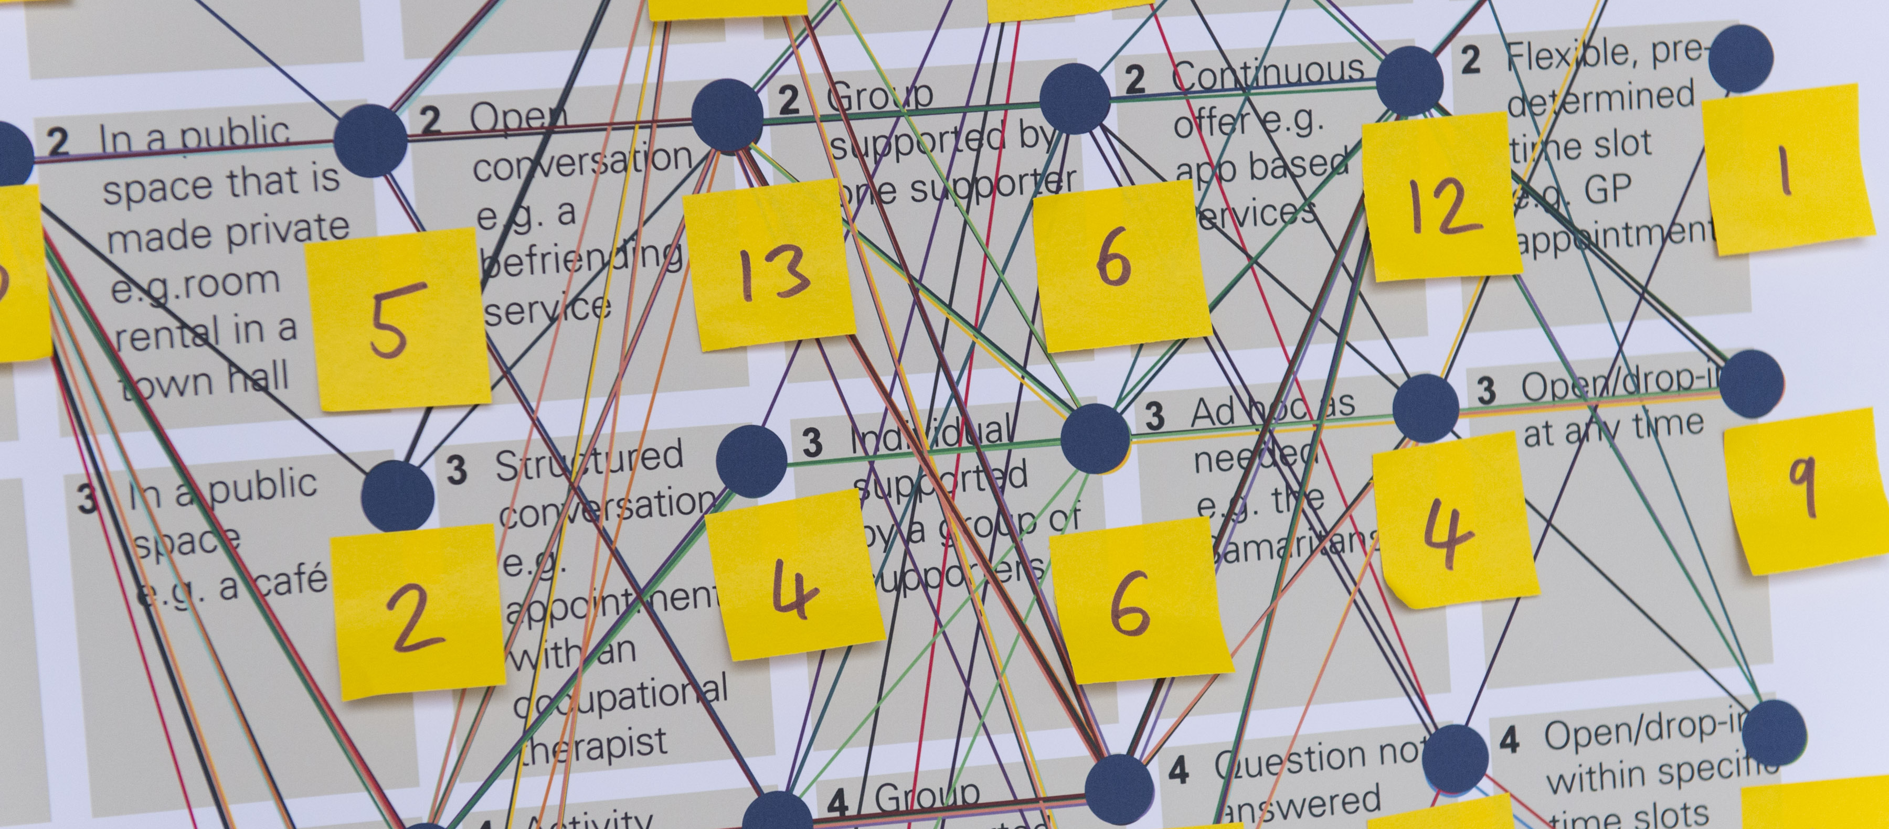
Photo: Q Lab

Define: Analyse insight and create
Becoming a team
Investigate
Specify and test
Set objectives
Analyse insight &
create
Evaluate
Diagnose
Dialogue
Define
Discover
Deliver
Develop

During this phase teams will analyse what they have found and use it to generate ideas for addressing needs. They will end the phase by turning the most promising ideas into a concept.

4.1 Generate ideas

Why
“By coming up with ideas you’re moving away from research insight to (informed) assumptions. And towards ways to test how right or wrong you are.”
The aim of this phase is to develop a concept that you can test. The first step is generating ideas. The aim of this step is to open up your thinking to capture a wide range of ideas. These can then be reviewed and thinking strategically you will reduce this down to the best options.

How
There are lots of different methods for facilitating the generation of ideas and there are links in the tools section. Below are some points to bear in mind.

Capture ideas as you go and bring to group discussions
It might be that ideas naturally fall out of the work you are doing and so you can make a note of them as you go. It’s likely that you’ll still want to run an idea generation workshop to provide the chance for others in your team to respond to what you’ve learned about user needs and capture different ideas.
Ground ideas in research
In the previous phase you’ll have learned about the needs of users, how your service is understood, the other services users access and what needs are not being met. This knowledge acts both as inspiration for coming up with new ideas and reduces the risk that the ideas don’t reflect the real needs of those using and providing services. If there are people in your team who weren’t involved in the research it should ideally be brought into idea generation sessions and presented in digestible ways.
Building on what others have done
You may have identified needs for other services which have already developed successful solutions – either locally or further afield. The Lab participants group provides a wealth of knowledge about what others are doing in the UK and may be a useful way to learn from other successful situations. The Lab team will also aim to bring in examples from research.
Expand your horizons
Design thinking acknowledges how often we spend our lives editing ourselves to check that what we are doing or saying is appropriate. When you’re coming up with ideas this can be actively unhelpful – as you want to encourage people to be limitless in their thinking and to come up with as bigger range of ideas as possible. Each of the activities should help with this, for example the ‘brainstorm rules’ created by the design company IDEO below.
Be visual
Being visual and sketching out your ideas can add another dimension to exploring and communicating ideas. ‘Sketching provides a unique space that can help you think differently, generate a variety of ideas quickly, explore alternatives with less risk, and encourage constructive discussions with colleagues and clients.’

Tools and templates
- IDEO brainstorm rules: http://www.designkit.org/methods/28
- https://library.gv.com/the-product-design-sprint-diverge-day-2-c7a5df8e7cd0
- This is Service Design Doing: Sketching https://www.thisisservicedesigndoing.com/methods/sketching
- This is Service Design Doing: Ideation based on analogies and association https://www.thisisservicedesigndoing.com/methods/ideation-based-on-analogies-and-association
- DIY toolkit - Fast idea generator - https://diytoolkit.org/tools/fast-idea-generator/
- Article on sketching - https://alistapart.com/article/sketching-the-visual-thinking-power-tool/

4.2 Review and filter ideas

Why
You will need to decide which ideas to progress and which to set aside. It will be useful to have a set of criteria to make these decisions. This criteria will help you to filter your initial ideas, and can be used later in the process to decide which developed ideas to prototype and test.

How
A simple and useful criteria to consider is impact versus feasibility – which allows you to plot impact on solving the challenge versus how feasible it will be to deliver in practice. You can assign each of these criteria to axes on a graph and plot the ideas you have generated to agree which ones have both high impact and high feasibility.
Deciding the impact and feasibility of an idea is complicated and will require you to have a shared understanding of impact and feasibility. Revisiting the success criteria that you developed earlier in the process will help you to do this. For example, here are suggestions based on the NHS quadruple aim:
- Improving citizen experience and population health are about value for service users. What did you describe in your success criteria and challenge statement about the impact you are aiming for? Are there existing descriptions of high quality care that you can use – such as organisational values or the draft Q Lab service principles? Are there specific user needs from your research that you can use?
- Reducing costs and staff and carer wellbeing relate to feasibility. What might be relevant from your organisational context to consider? For example what are the capabilities of your team to do the work? What data is available? Who would you need to work with? Are there any ethical or quality criteria that is relevant to your service?

Another important consideration is clarifying your ambitions around system change. For example, are you aiming to focus on local parameters (staffing and service standards), or aiming for more significant redesign of a system (such as information flows and lines of accountability) or a paradigm shift (changing goals, mindsets and values). The article below by Adam Groves introduces a framework for codifying ideas in terms of their ambitions on system change and the stage in the pathway that the intervention is focussed. This is a tool we are considering using across testing teams.

Tools and templates
- Idea portfolio: https://www.thisisservicedesigndoing.com/methods/idea-portfolio
- Article ‘From service design to systems change’ by Adam Groves: https://medium.com/@adam.d.groves/from-service-design-to-systems-change-72fa62b1714c
- Template: https://docs.google.com/drawings/d/1RXvxrr0T4-aPiRztfjT_K95wjjnJPA-p3T7Dr-TQKN4/edit
- Six questions to help prioritise concepts from Bromford Lab: https://docs.google.com/document/d/1MkjyOlmBee4mv9ptdJVDNiO3YAoq_l95TrpzfheSzgU/edit
- Circular design guide (Ellen Macarthur foundation) concept selection matrix: www.ellenmacarthurfoundation.org/assets/design/Concept_Selection_Final.pdf
www.circulardesignguide.com/post/test-your-assumptions

4.3 Capturing and developing ideas

Why
To develop your ideas, getting input from others is essential. You need to ensure that each idea has enough information to allow them to be judged and compared – with a clear sense of the proposed scope and potential impact against your success criteria.
In the early, fast-paced stages of generating ideas it’s necessary to be unfussy about the format of ideas. However, as you start to narrow down options you’ll want to be more rigorous about how ideas are being captured.

How
Capturing: You could use a sketch template to do this – to ensure you capture the basics for each idea such as a title, description, and drawing. Capturing each idea and relevant information about that idea in a consistent way will help you develop and make decisions about them in a more objective way. These are some of the questions you should consider answering:
- What is the idea? (Title and describe it)
- What need does this idea satisfy?
- What impact does it aim to achieve?
- What problems does it address?
- At which point(s) in the user journey is it relevant?
- Are any assumptions being made that have not been investigated?
- How feasible is it? (The level of effort could be estimated using a relative scale such as small, medium or large)
- What are the organisational implications?
- Is it part of a wider theme or group of related ideas?
- What evidence do we have that makes us believe in it (data, information from research, quotes from potential service users, etc)
- Which actors is it relevant to (users or people whom the idea will affect)?
Developing: The process of developing ideas might include combining multiple ideas and dividing them. It might require you to go through several iterations before arriving at something that has enough potential to consider for testing.
View in the user journey: There might be several different components of your idea or you might need to think about several steps in the journey that the user takes for it to make sense to others.
Getting feedback from others: At this point it’s useful to ask a range of people who will be impacted by the ideas, for their thoughts on what you have developed.

Tools and templates
- 100% Open Idea Frame https://www.100open.com/toolkit_2/idea-frame/
- IDEO Design Kit, creating a concept: http://www.designkit.org/methods/31

4.4 Select an idea to prototype

Why
In order to move into the next phase of testing work you need to agree which idea(s) you are going to test.

How
You will have already done some work to narrow down the number of ideas you are considering. If none of the ideas you have developed satisfy your criteria, or failed to get support from relevant stakeholders, you are not ready to start prototyping. You may have been through several iterations of each of the previous steps to get to a small number of ideas that you and others believe in.
If all the concepts equally satisfy your criteria and received support, you can simply choose which one you’d like to prototype. In this case, factors relating to your team’s capabilities and more circumstantial factors may be help make the decision. If not there should be a clear front-runner.
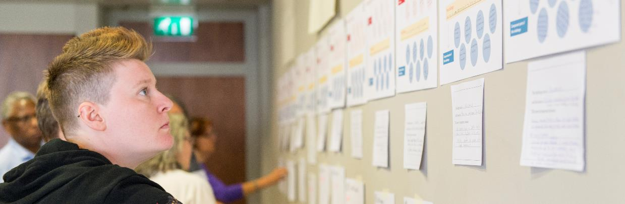
Photo: Q Lab

Photo: Q Lab

Develop: Specify and test
Becoming a team
Investigate
Specify and test
Set objectives
Analyse insight &
create
Evaluate
Diagnose
Dialogue
Define
Discover
Deliver
Develop

During this phase teams will be focused on testing the concept they have selected. They’ll visualise or prototype it with relevant stakeholders and people for whom it has been designed.

5.1 Decide what to prototype

Why
A prototype is a provisional version of the idea you are developing – for example a drawing of a website interface, or a storyboard to show a new service pathway.
A prototype should be simple and quick to develop, in order to mitigate the risk that you will invest in implementing something that doesn’t add value or doesn’t work.
Prototyping helps you to develop and understand the value of your idea, communicate it to others and get feedback from the people you are designing for. The aim of prototyping is to learn – ‘with any prototype – service design included – you’re looking to spend a little (effort and money) to learn a lot.’

How
Agree the purpose of your prototype and choose a method: There are several different ways to prototype ideas – that will work in different contexts. In sections 5.2-5.4 you can find out more about paper prototypes, storyboards and role playing.
Read through these sections to decide what is most relevant to your idea and what you want to learn.
Some questions to consider are:
- Are you hoping to learn whether your idea has value – or whether it’ll deliver the intended value?
- Is your idea focused on a single ‘touchpoint’ such as a leaflet, website or conversation, or is it a larger experience that consists of multiple touchpoints?
- Is there an aspect of your idea that you are most uncertain about?
Develop a prototype plan: Once you have reviewed the prototypes and questions above, work with your team to complete a prototype testing plan, using one of the tools below. This process includes surfacing the main elements of your idea, the questions you’d like to answer and who you’ll involve.

Tools and templates
- IDEO Design Kit, determine what to prototype: http://www.designkit.org/methods/34
- DIY toolkit – prototyping testing plan: https://diytoolkit.org/tools/prototype-testing-plan/

Further reading
- Nesta – testing concepts through prototyping PDF p.51: https://media.nesta.org.uk/documents/nesta_ideo_guide_jan2017.pdf
- https://blog.wearefuturegov.com/a-guide-to-different-types-of-prototyping-9866e8ff0f7b
- IDEO Blog, 3 tips to help you prototype a service: https://www.ideo.com/blog/3-tips-to-help-you-prototype-a-service
- An example of a project in a health context that has taken a design approach in- depth look at project:
http://www.abetteraande.com/#homepage and video -http://pearsonlloyd.com/a-better-aande/
- Airport project case study: https://www.hellon.com/project/we-made-passengers-want-to-change-planes-at-helsinki-airport/#top

5.2 Prototyping: paper

Why
Paper prototypes are most commonly used to mock up digital interfaces, as a way to test them quickly with users. Often this is simply using pen and paper to draw the pages that you would see as a user when accessing a website or app. It’s the quickest and cheapest way of getting something believable that you can test with potential users.
You can also use paper prototypes for other types of ideas, using paper and other resources you have to hand. The aim is to build something quickly and cheaply, that can be a bit messy and imperfect, but still gets your idea across.
You can use paper prototypes to test your idea on different levels. Whether it has value (does somebody want it) and effectiveness (can somebody use it).

How
Once you have an idea and know what you want to learn, it’s best to move quickly to trying to make it. Here are some ideas as to what you could quickly mock up:
- Websites (for phones or computers)
- Apps
- Letters
- Leaflets
- Conversations or call scripts

Tools and templates
- Paper prototyping guide from This is Service Design Thinking (focused on digital interfaces) https://www.thisisservicedesigndoing.com/methods/paper-prototyping
- User research in government – evaluating content https://userresearch.blog.gov.uk/2014/09/02/a-simple-technique-for-evaluating-content/

Further reading
- FutureGov blog on a guide to different types of prototyping: https://blog.wearefuturegov.com/a-guide-to-different-types-of-prototyping-9866e8ff0f7b

5.3 Prototyping: storyboards and visuals

Why
If your idea consists of many different steps then you might want to get feedback on the overall experience you are trying to develop. Creating a storyboard of someone experiencing your idea will enable you and your team to be clear about the different steps, and how this would integrate with your existing service or model.
You’ll be able to get more realistic feedback from people by showing them the whole story of how your idea is trying to improve someone’s experience. Storyboards are useful for testing the value or proposition behind your idea because people aren’t just seeing a small part of the idea in isolation. They are also quicker to produce than creating a more comprehensive prototype that would aim to simulate what you are representing in the storyboard.

How
Before you can develop your prototype, you’ll need to have identified the main steps of your idea and how these will fit with any existing services or pathways.
The aim of your prototype is to allow someone to better understand how your idea is adding value. There are a few methods below that should help with this.
- Storyboard. Storyboards are a sequence of illustrations (with accompanying narrative text) that tell the story of what is happening at each step of a service user’s journey through a service. They work best when they show people interacting with each other and any of the touchpoints relevant for your idea. You can include thought bubbles in which the people in the story can reflect on the intended outcome of your ideas. These will be based on insights you have gained earlier in the process about what will be valuable for service users and staff.
- Service advertisement. This could be a mock-up of an advert like a billboard. It could also be a real advert – depending on what your idea is. The point of creating the advert is to communicate the value that your idea is meant to deliver. You can use it to find out if people want what you are planning to develop.

Tools and templates
- Service advertisement https://www.thisisservicedesigndoing.com/methods/service-advertisement
- Ideo design kit storyboard - http://www.designkit.org/methods/35
- Storyboard http://www.servicedesigntools.org/tools/13

5.4 Prototyping: roleplay

Why
Many ideas for improving health and care services will involve changes to how people interact with one another. It can be common to go straight from having an idea on paper, to implementing the idea in practice. However, it is also possible to simulate your idea. This will allow you to learn more about it, in a safe environment, before recommending that people change their practice or trial it in a real-life scenario.
“People need to experience a service or touchpoint before they can begin to tell you their reactions… we need to lean into the subjective, the emotional... After all, instead of testing objects themselves, we’re often testing the negative space between things — moments, conversations, the evidence of intangible services.”
Simulation is the closest that we can get to experiencing something, before it exists. It can therefore act as a useful training exercise for your team, to surface your confidence and skills to deliver your idea in practice.

How
The approach you take will depend on your idea and what you want to learn. You can use roleplay as your only prototyping method, or you can use it in combination with the other prototyping methods.
If you are testing a person to person interaction we recommend reviewing the theatrical methods in the This Is Service Design Doing links below.

Tools & Templates
- This is service design doing – introduction to theatrical methods https://www.thisisservicedesigndoing.com/methods/theatrical-methods-an-introduction
- This is service design doing – investigative rehearsal https://www.thisisservicedesigndoing.com/methods/investigative-rehearsal
- This is service design doing – cardboard prototyping https://www.thisisservicedesigndoing.com/methods/cardboard-prototyping
- This is service design doing – subtext https://www.thisisservicedesigndoing.com/methods/subtext

Further reading
- IDEO Design Kit, ‘Make it’ mindset video: http://www.designkit.org/mindsets/2
- Article on service prototyping: https://medium.com/@jonbarnett/what-makes-service-prototyping-unique-8fa7d0af5149
- Experience prototyping article: https://medium.com/apegroup-texts/experience-prototyping-is-a-great-methodology-when-looking-into-a-context-885cb27aca52

5.5 Test a prototype with stakeholders

Why
You should now be able to test your protoype with a broader group of stakeholders. Depending on the idea, the stakeholders may include staff, or service users, or both.

How
Each prototyping method lends itself to different methods of testing. For some prototypes testing is intertwined in the prototype itself, for example roleplay and some service advertisements. However, others, such as paper prototyping and storyboards, need separate testing sessions to take place to gain feedback.
Some principles to bear in mind:
- How real do you need the prototype and experience to be to get the feedback you need? People often give better feedback when they believe something is real. It can take a lot of work to make something real. There is a lot you can do with manual work arounds for all types of services that can save lots of time.
- Work iteratively and improve. You should expect to develop and iterate your prototype with each new person or group of people that you test it with.
"Don't think of it as failure, think of it as designing experiments through which you’re going to learn." Tim Brown, IDEO.
“What an iterative approach affords us is that we gain validation along the way... because we’re hearing from the people we’re actually designing for.” Gaby Brink, Tomorrow Partners
Analyse results
Each round of prototype testing should provide you with new information and insights on your intervention. You may want to use this immediately to refine your idea, or you may want to ‘park’ these for development at a later date. The decisions that you make should always relate back to your success metrics and intended impact.

Tools and templates
- How to Test Prototypes with Customers: The Five-Act Interview, Google Ventures: https://library.gv.com/how-to-test-prototypes-with-customers-the-five-act-interview-80305d98c407

Further reading
- Suspension of disbelief: https://medium.com/swlh/prototyping-and-the-suspension-of-disbelief-d3a9792eba11

Photo: Q Lab

Deliver: Evaluate
Becoming a team
Investigate
Specify and test
Set objectives
Analyse insight &
create
Evaluate
Diagnose
Dialogue
Define
Discover
Deliver
Develop

During this phase, the teams will be delivering the idea in real-life environments, collecting data to understand the impact and evaluating what has been learned. It’s likely that this will prompt the team to want to go back and refine the concept or to learn more about a need or to try out another idea.

6.1 Early stage testing in practice

Why
The closer your idea gets toward implementation the harder it is to change it. Regularly getting feedback from those who will use it means you won’t have a big surprise if it turns out not to go the way you were expecting.
The traditional approach can be to designate a fixed pilot period and collect and analyse data at the end to review your success. But even running a one month pilot uses up a lot of resources and may miss opportunities to get feedback quickly and improve the intervention when it is first being implemented, so that it can work for more people going forward.
Planning shorter and more iterative rounds of testing will reduce the risk of developing and implementing something that doesn’t address the problem you want to solve. You can undertake further, more long-term implementation and data collection cycles once your idea is stable.

How
There are several ways to test your idea in practice before you implement it fully.
For example, you can ask participants to trial the idea with one person or in one clinic – and use data collection techniques to test its success. This could include:
- observing the interaction and whether it went as expected
- asking participants to complete a short survey or debrief interview after the interaction, to share their experience and evaluate its success.
- trying the Think Aloud technique, which enables you to understand how someone is experiencing your idea by asking them to voice what they are seeing, thinking, doing, and feeling.

Things to bear in mind:
- Ethical considerations: a lot of the principles of doing user research such as ethics, also apply to testing an idea which you will need to take into account.
- You will need to decide as a team what ‘success’ would look like from early stage testing – and how you will review the data and decide to expand the scale of testing. This decision-making should ensure safety of staff and service users at all times.

Tools and templates
- https://en.wikipedia.org/wiki/Think_aloud_protocol
- https://www.gov.uk/service-manual/user-research/using-moderated-usability-testing

Further reading
- https://blog.wearefuturegov.com/failing-fast-when-failing-is-not-an-option-37edd94e6b27

6.2 Deliver your idea in practice

Why
Unless you know your idea will definitely work, you should test it in a contained way before implementing it.
“Getting it right on the first try isn’t the point at all. The point is to put something out into the world and then use it to keep learning, keep asking, and keep testing. When human-centered designers get it right, it’s because they got it wrong first.” Tim Brown, IDEO

How
A lot of the how will depend on the service you provide and the idea you have developed. Here are some things to bear in mind:
- Timeframe: How long do you need to run the test for to learn what you need to?
- Number of users: How many people do you need to test with to learn what you need to? Often starting small and increasing later will make more sense.
- Support: Think about what you need to put in place to make it real. You can still use manual work arounds if you need. You might need to train your team or build in additional support in the early stages.

Further reading
- Live prototyping - http://www.designkit.org/methods/18

6.3 Analyse findings and make descisions about how to proceed

Why
Testing is an iterative process; the results of testing won’t always be a binary ‘yes it worked' or ‘no it didn’t’. There will be more nuanced learning that may require some time to analyse and reflection time to work out what to do next.

How
Revisiting objectives: Earlier in the process you defined objectives and ways of measuring whether they have been achieved. Whilst some may be longer-term objectives are you able to see signs that what you are testing is contributing to achieving these objectives?
Using a framework: Doing analysis of your data and insights from testing as a group in a transparent way helps people understand why decisions are being made. Use an analysis framework such as POINT (P – problems, O – opportunities, I – insights, N - needs, T – themes) to identify important themes and give structure to what you have learned.
Roadmaps: If you are working on multiple ideas, using a roadmap to keep track of what you are working on and its status can be useful.
Iterating: The feedback you receive may highlight some obvious improvements that you can integrate into the next round of testing or a significant gap between your hypothesis and what you found in testing may emerge. At this point, you may need to move back further in the process and do more exploratory work for example.
Stopping: You might find that your assumptions were wrong and what you tested didn’t bring the benefits you expected or didn’t work as planned. Consider this a success – you now know what doesn’t work and won’t waste time on implementing the idea further. Learn what you can from it and don’t be afraid to stop the project if that’s the right thing to do.

Tools and templates
- Template to capture learning from a prototype: https://www.100open.com/toolkit_2/prototyping-techniques/

6.4 Share learning

Why
As part of your involvement with the Lab we’ll be helping you share what you are doing with other testing teams and people who are interested in the topic.
In addition, people outside of your immediate team are likely to be interested in what you are doing. They might be interested in ideas you are testing, or the ways that you are implementing change. They might be an important stakeholder that’s helping your ideas progress. They might be interested in the process you are taking and the methods you are using.

How
Although this activity is in the final phase, you don’t need to wait until you have tested something. Sharing what you are doing at the earlier stages will increase buy-in from people as they will feel involved and potentially have the chance to influence what you are doing earlier on. Here are ways to consider how you capture and share what you are learning:
- Keep learning diaries: Leading improvement for many people is a developmental experience and you will learn lots by doing. It can be helpful to keep a diary or log to record challenges you are facing and success you are making – in order to support your own reflective practice, and to be able to share themes later down the line about how you made the progress that you did.
- Record design decisions: You will constantly be making decisions about how you are developing your intervention. Try getting into the practice of recording all of the decisions that you have made at the end of your team meetings or important milestones. This will help you to distill your idea and will be useful when you are thinking about adapting the intervention to other contexts.
- Show and tells or reviews: Show things you have already created as part of the work you are doing where possible. This could be on noticeboards, in staff rooms or waiting areas, or at regular drop in times for people who are interested. Aim to create the least possible work for yourselves by using products that you have already developed as part of your testing work.
- Writing blogs: Writing a blog can be a good way to reflect on what you are learning and a way to share this with others.

Things to consider:
- Use quotes: Using quotes from service users and staff can be a powerful way to communicate with stakeholders.
- Be visual: Where possible try to capture photos and videos of what you are doing and learning, to bring the work to life and explain the process.

Further reading
- A story about engaging unengaged stakeholders: https://mojdigital.blog.gov.uk/2014/07/28/getting-stakeholders-more-involved-in-sprint-reviews/

Bibliography
There are many toolkits, guides, books and articles written about methods to bring about change. We’ve tried to make use of as much existing content as possible while writing this guide.
Here are some of the sources we’ve used and referenced in the document. We explain a little about what we believe the strengths of each to be:

This Is Service Design Doing: Methods
This is a guide to doing service design. It’s a book that has a comprehensive web based toolkit. They have detailed instructions for each of the methods they cover. They’re particularly good at providing lots of alternative methods that consider how you might involve different audiences when using a method. The ‘theatrical methods’ are particularly interesting given that lots of healthcare is about interactions between people.

Nesta DIY Toolkit
This guide was created for an international development audience (DIY = Development Impact and You). It’s extremely accessible, there are videos explaining how to use each of the tools. They’ve done a lot of work to make the tools as simple and practical as possible, for people that might not be experts in the fields in which they are drawn from: innovation, design, and business development.

Ideo Design Kit: The Human-Centered Design Toolkit
Ideo is one of the most well-known names in innovation. Their toolkit is extensive and includes mindsets, methods and case studies. The mindset section is worth visiting for the videos. These talk about some of the philosophies behind Ideo’s approach to design in the sense that the way you think about design directly influences your success.

Government Digital Service
The government digital service publishes extensively about how they are using design in their service manual and on their blog. There is a wealth of knowledge from people doing work on the ground. Although it is centred on digital services a lot of the principles and insights are relevant to non-digital services.

Design Council
The design council publish case studies and reports that contain a lot of insight about using design in different contexts. They’ve funded several programmes that use design to solve health challenges. We’ve linked to some of their articles throughout the document.

Design consultancies
Design consultancies often publish toolkits on their websites. We’ve linked to some of them in this document.
Adaptive Path https://www.adaptivepath.com/guides/ Another well-known design and innovation company, now part of the bank Capital One but they have kept their collection of articles available online and still organise design conferences.

100% Open (https://www.100open.com/toolkit/) – they include a worked example for all their tools. Many guides don’t do this so it’s much appreciated.

Endnotes:

The Design Council, “The Design Process: What is the Double Diamond?” https://www.designcouncil.org.uk/news-opinion/design-process-what-double-diamond
The ‘triple-diamond’ was reportedly created by Policy Lab (this Nesta blog describes it’s use: https://www.nesta.org.uk/blog/using-design-principles-foster-innovation-policy/) https://openpolicy.blog.gov.uk/category/policy-lab/
The Design Council, “The Design Process: What is the Double Diamond?” https://www.designcouncil.org.uk/news-opinion/design-process-what-double-diamond
Mary Dixon Wood et al describes this well in the lessons learnt from evaluating Health Foundation programmes https://qualitysafety.bmj.com/content/21/10/876
Bill Lucas, Hadjer Nacer, “The habits of an improver”, October 2015 https://www.health.org.uk/publications/the-habits-of-an-improver
Kate Tarling and Ayesha Moarif, ‘The actual problems to be solved’, March 2017 https://docs.google.com/presentation/d/1fclyNbuiK7EicRkmcF7fO4PCQdQ8PKwFiWYnFtqOwTY/edit?usp=sharing
Mike Rohde, “Sketching: the Visual Thinking Power Tool”, January 2011 https://alistapart.com/article/sketching-the-visual-thinking-power-tool/
Ideo, Design for Europe, Nesta, “Designing for Public Services”, January 2017 https://media.nesta.org.uk/documents/nesta_ideo_guide_jan2017.pdf
Melanie Bell-Mayeda, 3 Tips to Help You Prototype a Service September 2018 https://www.ideo.com/blog/3-tips-to-help-you-prototype-a-service
Jon Barnett, “What Makes Service Prototyping Different?”, May 2018, https://medium.com/@jonbarnett/what-makes-service-prototyping-unique-8fa7d0af5149

