Psy4I QI hour thematic analysis

- Introduction

There were 555 tweets over 60 participants during the QI hour itself, with a total of 805 tweets and 121 participants over a 24 hour period from when the chat began.

Responses have been thematically analysed, and themes broken down under each of the questions posed during the QI hour.

Responses sometimes contained different themes or ideas within the same tweet, responded to multiple parts of a question, or were general rather than a specific response. Some of the ideas shared below are therefore reflected below as quotes rather than whole tweets verbatim.

For a verbatim summary of the QI hour, see https://wakelet.com/wake/bsIsX5GGMCtWnZ89YkNod

- Key themes

Q1. What is your understanding of psychology for improvement and how important do you think it is?

- While often seen as the ‘softer’ side of QI, psychology for improvement is integral to QI, and is for many the most challenging side.

- Connecting people, and relationship building is fundamental to improvement success.

- Understanding why change fails, in order to address these challenges in improvement work.

- Building the will for change and understanding people and their values and motivations as a key feature of improvement success.

- Self-reflection and awareness of one's own motivations, feelings etc as a key factor of Psy4I

Q2a: What are some of the feelings you have as you engage with improvement? How can our feelings be part of the conversation about improvement?

- People listed positive emotions, in particular excitement, enthusiasm and hope.

- Others shared a range of negative emotions, with anxiety, frustration and anger most frequently mentioned.

- Improvement work can lead to the full spectrum of emotions to different people or at different points in the improvement journey.

- The importance of understanding and talking openly about feelings was discussed as key to being able to overcome difficult emotions, and in helping build psychological safety.

Q3a: What are the psychological barriers for quality improvement practice?

- Fear, including fear of blame, failure, change, loss and the unknown.

- Egos and being inner rather than other focussed were mentioned.

- Change fatigue, and the need to have time to stop and reflect.

Q3b: How do you create psychological safety?

- Encouragement to contribute and be involved in QI.

- The importance of openness and honesty, and the need to build trust.

- Reflections on learning from Covid-19 and the rapid change we’ve seen influenced by an external threat.

- The impact and importance of good leadership behaviour on creating psychological safety.

- The need to foster a culture that supports failure, learning and innovation.

- The benefits of sharing innovation, celebrating small wins and learning.

- The importance of listening and engagement, in being able to understand the mindset and power dynamics of those involved.

- The need for coaching skills.

- Looking for ways to embed psychological safety into daily processes.

- Educating people on the QI initiative.

Q4: What tools and techniques are you using to support the psychological part of improvement? How do you know they work?

- Social proof - using informal networks, key ‘influencers’ and enthusiasts to spread ideas (but acknowledging we often lean towards these ‘go-to guys’)

- Building and mapping relationships and networks

- Establishing ground rules for a QI session

- Creating shared ownership and input through co-production

- The importance of asking questions, active listening and appreciative enquiry

- Ideas around mind mapping and similar tools for idea generation

- Storytelling to build will and understanding

- Measurement for improvement

- Our expertise and passion as QI leads

- A number of specific tools, models and approaches were shared, with people using different models according to the situation

Q5: What would help you include more about psychology for improvement in your learning and improvement projects?

- Sharing experiences and successes

- Practical tools, training and resources

- Building psy4I into our environments

- Mapping relational coordination

Q6: What have you gained from participating in tonight’s tweet chat? What will you do differently as a result?

- Learning new things

- Connecting with new people

- Further reading and learning as a result

- Breakdown tweets / quotes by theme

- What is your understanding of psychology for improvement and how important do you think it is?
Theme 1: Psychology for improvement is integral to improvement
“Often seen as the soft stuff”

“Fundamental to think about improvement as wider than just tools and techniques”

“For me it's the most challenging aspect”

“The “soft stuff” is not easy. I’m always intrigued about why this term is often used as a way of making it sound like it’s not as important”

“Psychology is part of improvement, as signalled by being 1 of the 4 elements of Deming’s system of profound knowledge”

“Not sure how helpful it is to separate out psychology as a 'part' of improvement. It's intrinsic to all aspects of improvement”

“Understanding human behaviour is one of the pillars of quality improvement. Described by Deming as one of the four aspects of profound knowledge”

“Brings together improvement and psychological theories to 'improve improvement’”

“P4I brings together improvement and psychological theories to 'improve improvement'. This area is often overlooked when undertaking QI and I believe it plays a major component to those engaging/engaged in QI”
Theme 2: Connecting people and relationship building is fundamental
“Connecting with what people care about”

“If we don’t connect with people, the improvements are more challenging to implement”

“We can’t understand our systems without taking account of people”

“The interactions and relationships - this is the best part of my day!”

“Winning hearts and minds so that QI is done with, not done to”

“Relationships with one another is key ♥”

“Bring people along on the journey”

“Build relationships with one another – Leaders, peers and patients.”
Theme 3: Understanding why change fails
“80% of reasons for failure of improvement projects is due to emotional, relational + psychological factors, not technical”

“Understanding the emotions that are blockers to change”

“Without asking how we & others feel about change ensures failure”

“We are complex beings and our inter subjectivity is often implicit, making lots of room for misinterpretation”

“Distinguish between psychological factors that aid improvement on a QI project and the psychological factors that dampen or amplify change within a whole organisation”
Theme 4: Building the will for change
“Cultivate a growth mindset”

“It all starts with a person deciding to make change, however small”

“activating agency, desire, enthusiasm and belief that you can make change happen”

“At a team level an understanding of how you can create shared purpose and what is needed to sustain it”
Theme 5: Understanding people - values and motivations
“An awareness the values, motivations, personality types and action logics of people”

“Find what someone is passionate about and build from there”

“The heart of the how and why's”

“Systematic understanding and support for the people who want/should do change”

“Winning hearts and minds so that QI is done with, not done to”

“Our values and beliefs and mental models and ... are all part of the systems we seek to change”

“Meeting diverse views & needs”

“Need diversity of perspective to build a truer picture of reality. But it’s harder not to be part of the ‘group think’.”

“Understanding and supporting people seems vital”

“How do we get to know what the values and motivations of others are? Participation and engagement from those who the improvement will involve can aid the process.”

“What we currently lack in improvement is understanding and support for the people who want/should do change, I guess ... I mean in a systematic way, not by chance.”

“Understand motivation of all to improve”

“Understand why people might not want to change”

“Cognitive diversity needed”

“Fighting for equity is a powerful motivation and resonates strongly with others”

“On individual level I think it’s about activating agency– desire and enthusiasm and belief that you can make change happen”

Q2a: What are some of the feelings you have as you engage with improvement?
Theme 6: Negative emotions engaging with improvement
“When projects don’t go so well or stall or end before you feel they should, there is a feeling of dismay or sadness”

“Anxiety, frustration, anger (mentioned several times)”

“I have a preference for new and exciting things, so generally love improvement. It’s harder when not in control or being “encouraged “ to make changes”

“My driver is anger at injustice. Patients are people at their most vulnerable”

“Occasionally it’s dread as we have to work with folk who just prefer to say ‘no’ as opposed to ‘yes’”

“The depression early success can generate. Lacking psychological safety people get terribly afraid because they have an achievement to lose”

“Cynical attitudes can be hard to deal with.... especially day after day”
Theme 7: Positive emotions engaging with improvement
“Excitement, enthusiasm, passion, satisfaction, joy and pride were commonly noted

“Excitement for the challenge”

“A sense of optimism and hope”.

“Inquisitive - “how can I help solve this problem/help others solve this problem? Let’s find out together””

“Excitement going into a service you don’t know much about. Joy when you see those not so sure about the QI then getting that it ain’t all that bad or when the measurements show an improvement”
Theme 8: A wide range of emotions engaging with improvement
“Kubler-Ross curve for the range of emotions change can bring about!”

“Emotions/feelings can also rub off on you”

“Everyone goes through this emotional rollercoaster at direct times and speed”

“The full spectrum of emotions, usually driven by a need to make sense of what’s happening”

“Different emotions along the QI journey and it’s important to recognise these, perhaps even to map them or journal these.”

“We often bring our emotions with us whether we say them or not”

“Not everyone feels the same. So to have permission and space to talk about the diversity of feelings in a team without judgement or pressure of time is important.”

“Different people trigger us in different ways. The art for me is understanding what the trigger has been and how that connects with past experience”
Q2b: How can our feelings be part of the conversation about improvement?
Theme 9: Importance of understanding and talking about our feelings in helping build psychological Safety
“Too little 'bringing your whole self to work' for real feelings to be a regular part of workplace conversations”

“Truly feeling safe to fail and learn and not give up when it becomes hard”

“By talking about these openly feeling safe to do so with all involved can sometimes unlock the issues”

“We have to establish a safe environment where people can be their authentic selves”

“Being honest about these feelings creates openness and psychological safety”

“Trust is so important”

“Team health and trusted safe environment should always be part of your change process.”

“team health and trusted safe environment should always be part of your change process. If you start with respect for staff and listening, then I find you always start on the right foot”

“Feelings shouldn’t be dismissed. Lessons can be learnt from all involved with improvement when feelings are listened too”

“Having space to discuss and reflect feelings could support those leading or engaging QI to develop and share an appreciation of QI.”

“All Qs both to ourselves & others should fall into 3 parts, what do we think, how do we feel, & what are we going to do about it. If we don’t cover all 3 we leave ourselves & others behind”
Q3a: What are the psychological barriers for quality improvement practice?
Theme 10: Fear as a barrier
“Fear of blame”

“Fear of failure, exposing vulnerability of not being listened to”

“Fear of change, especially if there is an embedded “comfortable” system”

“Change requires mental effort which people tend to avoid - easier just to do what they have always done”

“Fear of the unknown. Change can be an unknown quantity.”

“Fear! Fight or flight response kicks in. People don’t share good ideas if they’re afraid of being wrong, and don’t highlight issues if they’re afraid to get in trouble”

“Fear of loss.”

“Fear of repercussion if the piece of work ‘fails’. Organisational top down approaches, limiting staff volition to create change in their own systems and processes. The feeling of vulnerability when exploring/testing the 'unknown”

“Fear of the unknown and sitting with uncertainty can be very uncomfortable feelings for many. Sometimes reminding what will stay the same can help”

“Committing ourselves to a small change, even one that is unmistakably in our best interest, is often more frightening than ignoring a dangerous situation.”

“Maybe the QI technical language amplifies this fear and puts people off getting involved?”

“It's a myth that people dislike change. Who doesn't want a better phone, home or kids? What people fear is change for the worse. They need to trust that the change will be an improvement”

“There’s a sort of 'culture of niceness', faux Psychological Safety which can be damaging”
Theme 11: Egos as a barrier
“Egos, in terms of making things difficult and getting in the way of trust”

“Eckhart Tolle talks alot about ego”

“Being ‘other focussed’ not ‘me focussed’. Constantly asking what I can do to help others”

“A big barrier is lack of self-awareness, so projecting all problems out onto other people, structures. Profs Kegan/Lahey's overcoming 'Immunity to Change' exercise is great to use to grow self-awareness and enable change. Can be done with groups too.”
Theme 12: Change fatigue
“‘Exhaustion’ with organisation exhalations to get involved continuous change/transformation/innovation”

“‘Standing still’ or pausing for breath never seems to be built in”

“Build in time for stopping and reflecting”
Q3b: How do you create psychological safety?
Theme 13: People need encouragement to contribute
“Encourage creativity and have fun, to be enthused breeds enthusiasm and engagement”

“Actively encourage others and assure them that everyone has a part to play in improvement and change, no matter how big or small their idea is.”
Theme 14: The importance of honesty and trust
“Be open and honest - let your people know - communication is key. Talking, listening and responding”

“Lack of trust & belief in the process, along with trusting yourself, others & organisations to carry it through can stop change even starting.”

“Having open honest conversations.”

“Actual improvement requires trust and real collaboration”

“Show my own vulnerability”

“We need to create a culture of safety & openness where speaking up is enabled and expected”

“Honesty - not promising things we can’t deliver”

“Look where you still have trust. Identify strong relationships acknowledging the issue. Be upfront, don’t hide or blame. Look for solutions within the skills & culture you have first.”

“Create hope and trust”
Theme 15: Reflections on the change we’ve seen during Covid-19
“There's been so much change in the last 3 months. It's been inspirational how NHS staff have come together under challenging circumstances to provide the best care possible. A clear sign that external factors influence internal drive”

“It’s important to reflect on what we have learnt about our organisations, our teams and ourselves”

“We saw successful change and enthused staff during COVID but we are also seeing despondent teams from less successful approaches”

“Interesting that an external threat brings out such deep collaboration and appreciation of our collective endeavour.”

“It’s interesting to use [Kubler-Ross] to reflect on the big changes we have all been through recently”
Theme 16: The impact and importance of good leadership qualities
“Leadership and developing leaders within your team”

“Leadership behaviour. A recent systematic review found transformational, ethical, change oriented and shared leadership styles were found to lend themselves to psychological safety more than others.”

“Resilience is a good thing as it shows us the change through a new lens”

“Distributed leadership”

“Compassionate leadership”

“Servant leadership”

“A good leader, will listen, reflect and address feelings”
Theme 17: The need to foster a culture that supports failure, learning and innovation
“We need to applaud the bravery to innovate. And if it doesn’t work we need to capture and embrace the learning”

“Encourage and lead an organisation wide appreciation of learning from failure”

“Feeling safe to fail is paramount”

“Foster a culture where mistakes are not just seen as errors but that we can learn from them.”

“Creating the conditions and culture where it is the norm to speak up and know you’ll be listened to”

“Give people a safe space to express and explore their concerns”

“We need to think about what we can do to reduce the interpersonal risk that necessitates PS in the workplace. Get upstream of the issue”
Theme 18: Sharing learning and successes as part of the QI approach
“Very purposefully focus on and celebrate the learning in QI”

“Share the QI learning experience when facilitating a project”

“Celebrate the small wins along the way”

“Using measurement is an effective way to support the behaviour change aspect of QI”

“Sharing innovation encouraged”

“I can always remember seeing Staff see their change ideas displayed up that their ideas are listened too and displayed up then put into testing them”
Theme 19: Listening and engagement skills
“Active listening between partners”

“Staff engagement is crucial to tackling those fears.”

“Listening, making space, investing in relationship, cake”

“Listen to understand rather than respond”

“Use active listening & communication skills.”
“Helping people “love what they hate” unpick & break problems into smaller manageable ones to reduce being overwhelmed. Understand the power dynamics of those involved. Listening skills.”

“We often don't pay enough attention to the mindset and psychology of those around the QI project - how will others see your work? Will they come along? Why would they? Need to build this in from start”
Theme 20: Coaching skills
“Coaching & consultation skills help”

“I think there is a lot to be said for coaching for improvement and part of being a coach is learning about psychological states and needs”

“Regular coaching & going back to the 3 questions based on think/feel/do.”
Other ideas
“Education on the quality improvement initiative”

“Embed this in daily processes such as safety huddles to help it stick”

“An approach for psychological hurdles is empowering everyone to suggest change ideas for PDSA testing. I gave a midwife a PDSA workbook to record their ideas & bring to multidisciplinary meetings. Lots of ideas were suggested to consultants & senior managers. By giving the PDSA structure and QI theory within a booklet- she felt the authority to share ideas and was listened”
Q4: What tools and techniques are you using to support the psychological part of improvement? How do you know they work?
Theme 21: Social proof - using networks and enthusiasts to spread ideas
“Don’t waste too much time on laggards.. use those in the acceptance phase to bring others along with you – social proof!”

“Use informal networks – change is a social movement”

“Unmissed enthusiasts. Important to know your people. Also linking in with your 3% superconnector”

“The influencers aren’t always those in charge… find them!”

“The paradox is that we often pile stuff onto those ‘go to’ guys that’s are enthusiastic and seem to have endless energy”

“Enthusiasm and passion from us. No matter what else we do, if we aren’t excited about QI no one else will be!”

I'm reminded that our role is as enablers of success. We there to inspire, support, unblock, upskill & empower others. It's not about us!
Theme 22: Building and mapping relationships
“Developing positive relationships”

“Relationship building”

“Considering who you're working with & finding the best person to be the key relationship manager for that team. Each team needs something different from their QI support”

“Relationship mapping. I think it's an untapped area for some of us”

“Network maps to see if 'Relational Coordination' has improved or even if QI pros can become more energising”
Theme 23: Establishing ground rules for a QI session
“No hierarchy, all opinions and input is equal, there is no judgement or silly questions. Maybe groups can create their own ground rules for a safe space”

“We need more scene setting at the beginning rather than just ice breaker exercise. Create a safe space together with ground rules and focus on developing trust and relationships”
Theme 24: Creating shared ownership and input through co-production
“Co-design, developing of ownership”

“Working to make the QI as shared an experience as possible.”

“Staff & service user engagement is important to help design, produce and establish any improvement project”

“Finding shared experiences - agreed clear goals”
Theme 25: The importance of asking questions, active listening and appreciative enquiry
“Active constructive listening, listening with fascination, then influencing”

“Asking "what matters to you?" - simple but effective”

“Honesty, clarity, listening”

“Find appreciative approaches work well - assets and growth oriented, activates agency, generates connection etc. And sometimes just ‘be’ with what emerges, rather than try to go for”

“Some of the most powerful improvements, particularly at a system level, have come when I’ve used Appreciative Inquiry. Creates such good energy”
Theme 26: Tools for ideas generation
“Silent brainstorming enables psychological safety - encourages engagement - dotmocracy works - Making QI fun”

“When you do a mind mapping exercise, make sure to write down all the ideas onto the board. To keep encouraging ideas. Then have a discussion afterwards about which ones fit where”

“Some of the best ideas come from the dreaming stage”

“What other ways can we use to help people share ideas? Post it's, writing things down rather than speaking up.”
Theme 27: Storytelling
“Story-telling.... Powerful stories told with bravery, honesty and conviction are a powerful tool to activate people’s will to change things and move from status quo”

“Stories foster learning and understanding”
Theme 28: Measurement for improvement
“using measurement is an effective way to support the behaviour change aspect of QI. Giving people feedback on the changes they are making. Nudge nudge to help the change be sustainable”

“#Measurement4Improvement helps. But it only helps if it is not perceived as performance measurement. Started a QI initiative once and initially our nurses thought that this "is just another way of beating them up". Took a while for them to feel safe to learn. We jointly agreed to stop celebrating individual successes and focus on learning. So we started to replace the original aim (reduce ... blah ... within 6 month) by "as a team, we will make each mistake no more than once".”
Theme 29: Our QI passion and expertise!
“Enthusiasm and passion from us. No matter what else we do, if we aren’t excited about QI no one else will be!”

I'm reminded that our role is as enablers of success. We there to inspire, support, unblock, upskill & empower others. It's not about us!
Theme 30: Specific tools, models and approaches
“Found Schwartz Rounds impressive to support mutual understanding if things go wrong.”

“The power of Human Factors. Accepting that to err is human, magically opens the discussion to improving systems of care.”

“Tools that enable people to communicate, understand & support each other. Thinking Spaces and Liberating Structures. Working Styles exercises to understand each other and Action Learning is useful to share problems and find solutions.”

“Use 'Big 5' assessment, Values Modes, even the Enneagram [to understand motivations]... There are tons of assessments out there. A mix of vertical and horizontal assessments is best”

“‘Hidden in Plain View: Barriers to Quality Improvement’ Physician Ldshp J.”

“William Bridges in his book on bridges - the graph showing where people are in their mindset on a change”

“Reflective practice, appreciate enquiry and open learning”

“I draw on the work of Locke & Latham - Goal Setting Theory. Breaking improvement down into manageable yet stretching goals to create momentum and maintain energy”

“Rick Maurer model of resistance to change - “I don't get it" - don't understand the what, why, how?; "I don't like it" - an emotional / fight or flight response, leads to shutting off; "I don't like you" - dislike or distrust of leadership (or what leadership represents)”

“I base my approach on a mish-mash of several different models...Kotter's 8 step model, Kubler-Ross change curve model. I don't follow any one particular model. I try be adaptive to the change I want to accomplish and different personalities”

“Liberating Structures build Psychological Safety”

“De Bono’s thinking hats. Work by provoking creative thinking”

“QI can perhaps learn from the shift from Diagnostic OD to Dialogic OD”

I love the behaviour change wheel - it gives a really thorough structure to think about change pragmatically. What are the key elements we need, or might be missing?

“'The Character of Organizations - Using Personality Type in Organisation Development' - William Bridges”

“Profs Kegan/Lahey's overcoming 'Immunity to Change'”

“Bridges model of transition”

“I like the 4N's 'chart' from @SimonRDodds - focusses people's feelings about current and future states”

“I'm not sure Amy Edmondson's book on it was a real handbook/playbook for making it happen. Kegan/Lahey's book on 'Growth Cultures' called 'An Everyone Culture' has the same effect, but is a bit of a leap for the NHS.”

“I’m also hugely influenced by @BreneBrown work on embracing vulnerability and being brave. Vital for creating the psychological safety necessary for teams to be innovative”

A systematic review of factors enabling Psychological safety
https://academic.oup.com/intqhc/article/32/4/240/5813852#.XuNwQM62HKI.twitter

Kings Fund - encouraging cognitive diversity
https://www.kingsfund.org.uk/blog/2019/01/encouraging-cognitive-diversity
Q5: What would help you include more about psychology for improvement in your learning and improvement projects?
Theme 32: Sharing experiences and successes
“Hearing of impact others have achieved by using more psychology for improvement in QI education/training programme”
Theme 33: Practical tools, training and resources
“A better understanding of when approach X might work over approach Y.”

“Having all the resources in one place to dip in and out of”

“Help concerning how to operationalise the application of a psychological concept like psychological safety”

“Should we get QI psychology tools into that same shareable, usable format [as Liberating Structures]?”

“We deliver an interactive session on the psychology of change as part of the QI programme”

“Collated and succinct resources, for example videos, how to guides and tools.”

“Would appreciate help concerning how to operationalise the application of a psychological concept like psychological safety"
Other ideas
“Building into our environments. Reminds me of how good architecture can help to improve care in mental health inpatient”

“The Ralf Stacey complexity model & Kubler Ross management of transition/grief tend to engage people more then any technical model slide”

“Before-and-after assessments should be used in projects. Are people growing an internal 'Locus of Control', moving from unilateral power to mutuality etc?”

“Mapping 'Relational Coordination' (see Jody Hoffer Gittell's work) and the 'Relational Society' project being led by Q members in Cumbria.”

“It would be helpful to frame some expectations of what we hope to offer ie safe collaboration, even at pace, and work out what an unsafe environment feels like for us and others and hold ourselves accountable to remedy or prevent it with good quality check ins”
Q6: What have you gained from participating in tonight’s tweet chat? What will you do differently as a result?
Theme 34: Connecting
“Connecting with new people”

“Reconnection with some amazing folk and sharing of ideas & resources”
Theme 35: More reading and learning
“I’ll be reading and understanding more on Psychology 4 improvement”

“Learning some new things and being reminded of things I’d forgotten.”

“Time to go away and do some reading! some new models, ideas and perspectives shared, things to ruminate on..”.

“Overwhelmed with thoughts, ideas, reflections. Need to process!”

“Feeling positive that learning more about psychology and the psychology of change can only help. As others have said...much more reading around the subject”
Other ideas
“I will take a different lens to think psychology at the start of facilitating/programme managing QI project - seek 2 understand motivation or lack of all stakeholders: aside of influencing/engagement tools & will be reading”

“Definitely person centred facilitation. Look after the person's psychological safety as much as the improvement itself. Fostering relationships and also taking into account the whole element even in reflection.”

“We need to bring together technical skills with an understanding of psy change in a blended approach, helping people feel safe can’t be taught it has to be demonstrated through our behaviours”

“Maybe we can teach people how to pay attention to helping people feel safe through their behaviours?”
Appendix: Images shared
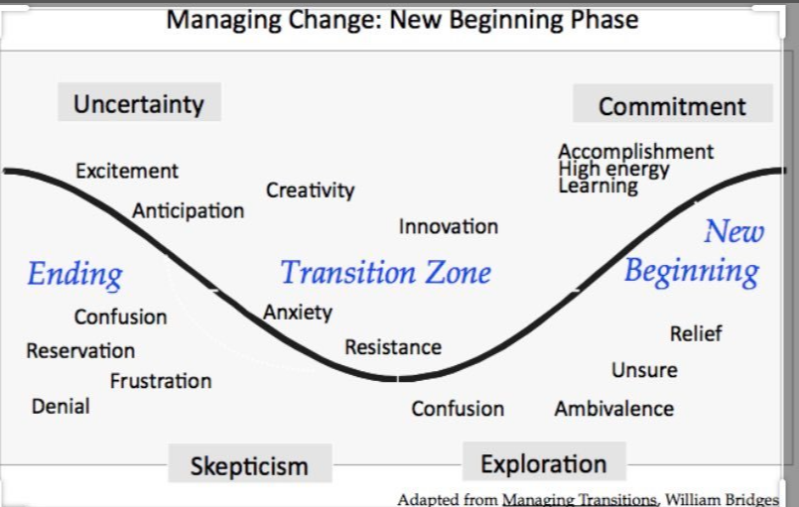
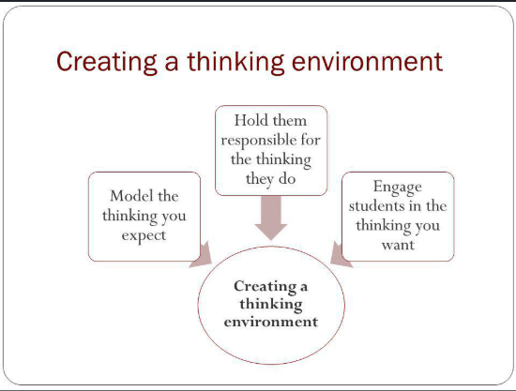
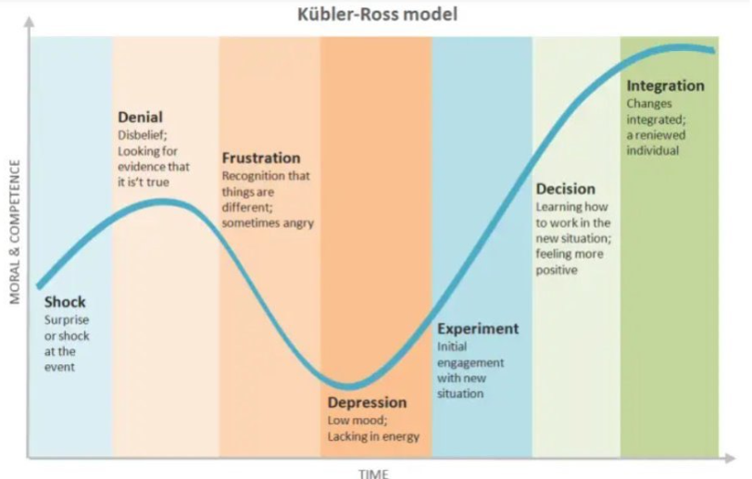

Author: Emma Scott, Quality Improvement Coach, Camden & Islington Mental Health Trust
Date: 23 June 2020

