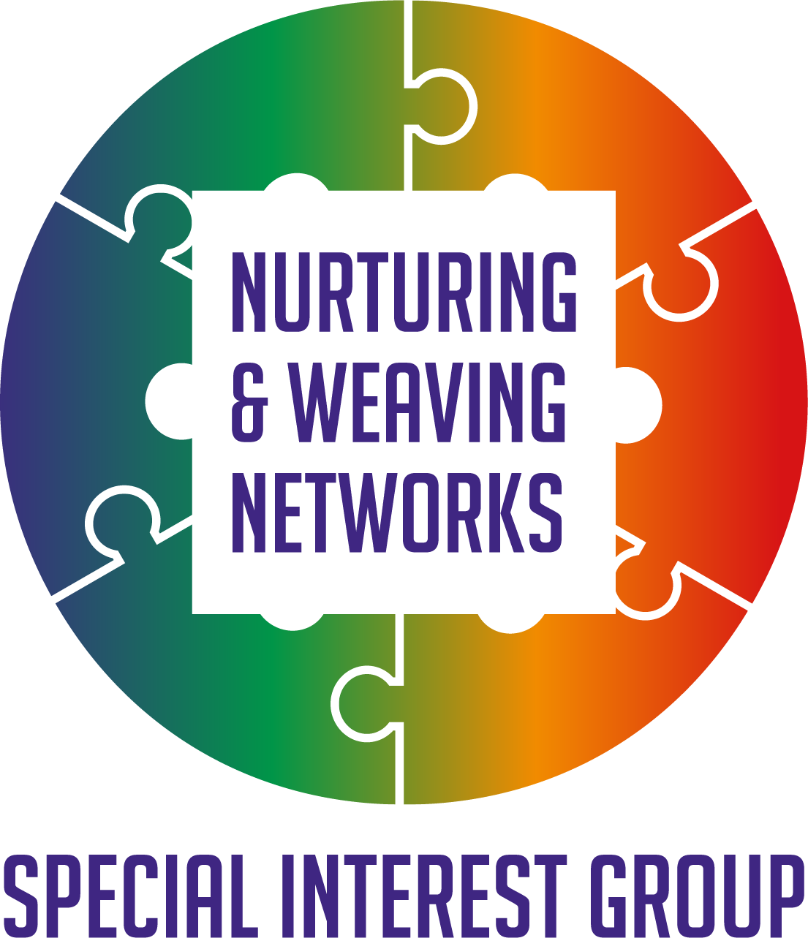
The value of network weaving in supporting integrated care pathways
In Partnership with the 3rd Sector SIG Sept 2023

Reflections

Background and context to the session.
The Nurturing and Weaving Networks Special Interest Group was set up following the Network Weaving Learning sessions offered by Q. The ideas and resources shared during that learning it was felt would be of interest to others. With June Holley’s permission and working with others a new set of resources went into co design to share. For more information on the work of June Holley and colleagues check out Network weavers
Through many events, conversations, active learning sessions a suite of resources were produced to help support networks and network leaders. We would like to thank Supporting Q Connections Fund for their support in enabling this to happen and to everyone who helped us get to this point and to all those who will go on and use the materials. You can download the materials HERE
This session delivered in partnership with the 3rd Sector SIG Link aimed to explore how the principles of network weaving can support integration.

An overview of the suite of resources to support networks and network leaders.
The Curiosity poster
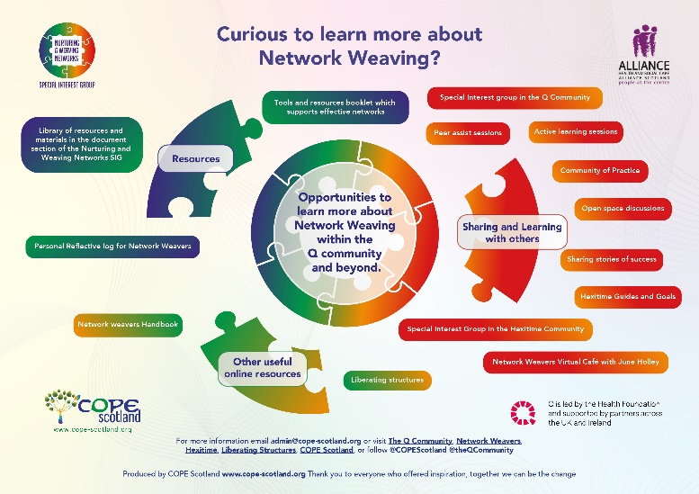
A simple tool to invite curiosity about learning more about network effectiveness, network leadership and network weaving. Full size PDF is in the download of materials.
A validated self-assessment to help identify areas for action.
This assessment is available online HERE It is an editable PDF which you can complete, save and then refer back to at a later date, if this has meaning for you.
The self-assessment was developed using the most common network challenges which emerged from conversations with many stakeholders. However, you may have one which is not included and there is space to add that if this has meaning for you.
We are showing Jpeg images of materials here, online they are full size and can be enlarged.
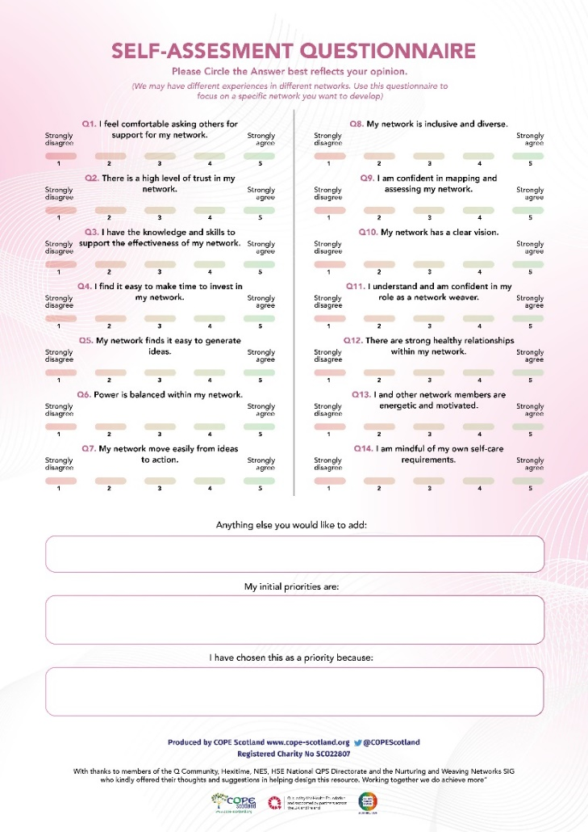
A tools and resources booklet offering ideas on places to find out more about the issues identified. This includes.
Curious to learn more about Network Weaving?
Building relationships
Evaluating your Network
Finding the time
Generating Ideas
Hassles with Hierarchies
Ideas to action
Inclusivity and Diversity
Network Mapping
Peer Support asking for and receiving help as well as offering it.
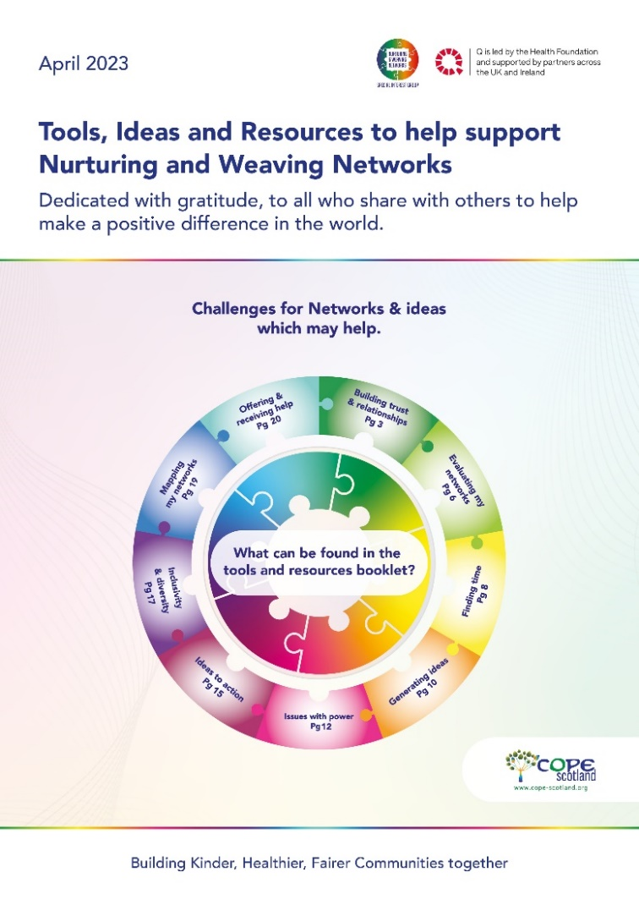
A reflective workbook offering a CPD log for those leading networks. Contents include.
Chapter one: Ideas on how to use this workbook.
Chapter two: Understanding my role as a Network Weaver
Chapter 3: Relationship with myself and others
Chapter 4: Understanding my Networks
Chapter 5: Motivating & energizing my Networks and me
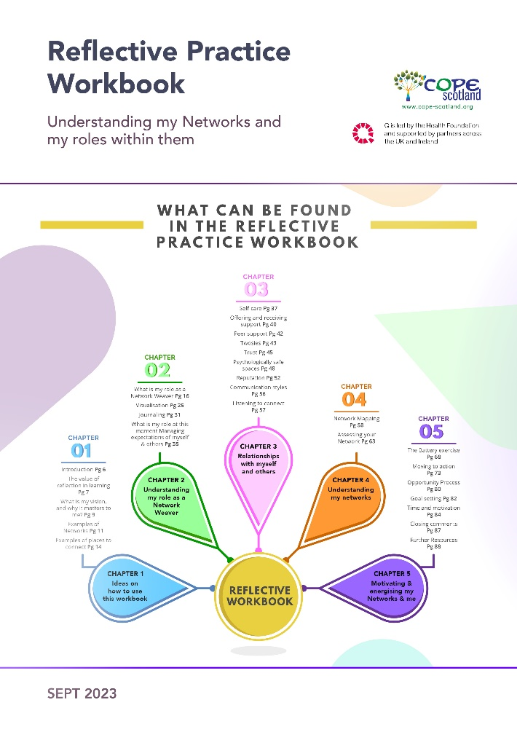
Self-care
Working with others is not always easy, it takes time to build relationships and understandings. Making time for self-care is important. We started the session with an exercise of being in the moment. A recording of this and other ways to be in the moment are available at www.cope-scotland.org e.g. Living in the Now

Who was in the zoom session?
The session was attended by people across different sectors and nations and regions within the UK.
There was a suggestion the session should be called:
‘’ 'Network weaving as the integrated care pathway'’’
This prompted an interesting discussion around how do we create a culture within health and social care where the application of tools such as liberating structures, and network weaving is accepted as the norm. A topic for a future conversation!
Working together makes sense.
‘’People and communities are at the heart of everything the NHS does. Working with people and communities is critical if we are to create a health and care service which offers personalised care, is tailored to the needs of each individual, and which works for everyone.
The Health and Care Act 2022 is designed to enable a more joined up, collaborative system. System leaders from across health and local government told us they wanted to work better together to tackle the big challenges in health and care. The Act ensures that every part of England is covered by an Integrated Care System, which brings together NHS, Local Government, and wider system partners to empower them to put collaboration and partnership at the heart of planning. To achieve real impact, we need systems to look beyond those who are typically involved – building partnerships across traditional boundaries and working with people, communities and those who represent them to create real change.’’
Edward Argar, Minister of State for Health

Yet while the focus is on working together and across nontraditional boundaries, sometimes collaborative efforts are not as effective as they could be.
To explore this further we used the Liberating Structure TRIZ. For more information on this and other liberating structures follow this LINK
The session broke into groups and using Jamboards, joined in the following activity:
- Say hello and introduce yourself (2min)
- Make a list of all you can do to make sure that you achieve the worst result imaginable with respect to working with other sectors (use Yellow post its) 8min.
- Go down this list item by item and ask yourselves, ‘Is there anything that we are currently doing that in any way, shape, or form resembles this item?’ Be brutally honest to make a second list of all your counterproductive activities/ programs/procedures. (change the post its you identify with /new ones you may add to pink) 8min.
- Go through the items on your second list and decide what first steps will help you stop what you know creates undesirable results? (change the post it’s of the items which are currently pink to green) 12 min.
.We are grateful for everyone’s contributions,
The following shares the points captured from the Jamboards.
This is the LINK to the Jamboards which were used (and thanks to Maria Dorthea Skov from the Q team for technical help. Appreciated)
What emerged were things we can change, here are some of those ideas:
Group one
- Welcome everyone and appreciate diverging perspectives.
- Clear agenda and ways of working and stick to them.
- Take enough time and commit enough resources not to be tokenistic. (Including funding and attendance allowance for example)
- Strong and effective facilitation skills.
- Invest in pre work e.g., terms of reference and representation.

Group two
- Get the engagement, right at the start.
- Have continuous feedback.
- Recognize that identifying a challenge is the first step in overcoming it.
- Easy language.
- Create psychological safety.
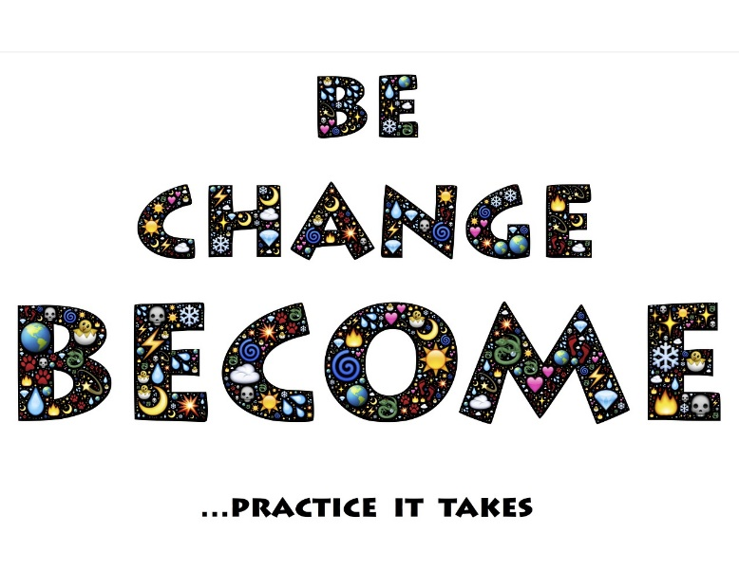
Group three
- Time constraints may unintentionally lead to non- availability. To overcome this, planning is needed, be realistic and delegate.
- Intentional design of communication structure and facilitation techniques.
- Agree a set purpose, establish a group goal, and use it as a guiding principle.
- Agree on tools to share information after meetings. Update files on shared drives for people who miss the meetings.
- Set accountability when setting actions.
- Make sure you get the right stakeholders involved.
There were other things which those attending had noticed which got in the road of collaboration. Given the time at the session these may not all have turned pink, but there was a sense, we can do something about this. Examples included:
- Thinking others don’t understand.
- Not committing to action.
- Not being committed to connecting.
- Giving people different tasks to work on depending on their sector, rather than working together on common areas.
- Multi-tasking!
- Silo working.
- Not understanding what each partner can bring to the table.
- Focusing on hierarchy.
- Create a bureaucracy of paperwork.
- Being judgmental and rude
- Not understanding each other’s priorities and drivers.
- Not listening to others concerns.
- Using NHS jargon and terminology.
- Interpersonal conflict.
- Unwillingness to collaborate.
- Hierarchical rather than network behaviour.
- Time pressures, so revert to usual suspects.
- Hidden agendas.
- Misaligned goals.
- Not considering resource implications for sustained impact.
- Being a member of a partnership just to keep an eye on what others are doing, but no commitment.
- Rely on representative organizations.
These are just some points, please visit the Jam board to see the posts from the day.
What changed?
At the end of the session, participants were invited. to complete the following sentence.
One thing I will do from today to improve working across sectors will be…….
Responses included:
- Pause and question before making assumptions.
- Focus more on identifying partners with shared goals.
- Ask the question to those around me- see what their ideas are.
- Remind myself of core principles of inclusive networking and apply them.
- Be more mindful of other people's perspectives, how they are and what would joint working do to help them.
- To remember that each organization has its own level of psychological safety and not to assume that that level of comfort will necessarily transverse across when you bring people together.
- Be more intentional when engaging with VCSE colleagues and providing a space that nurtures relationships and enables divergent perspectives / voices to be heard.

What next?
There was interest in continuing to explore the conversations which started with TRIZ. To perhaps explore further using the liberating structure 15% solutions LINK
For more information on the nurturing and weaving networks SIG contact Hilda Campbell The SIG offers regular active learning and peer support sessions. One session planned for 9th November 2023, 12-12.55pm, Register here. Includes guest speakers and will be exploring value creation. More information on this HERE
For more information on the Liberating Structures SIG follow this LINK Their next session is planned for 5th oct 12-1 For more information and to Register
We know working together makes sense, and yet, we do not invest enough time in building the conditions and relationships which enable us to achieve all that we can. Network weaving is one set of tools that can help. Who we are as people and the passion we have to make a difference is what drives change. We can all be network weavers and help bring about the change we know the world does need to see.
