Nurturing and weaving Network weaving SIG reflections. Flash report
March 2023

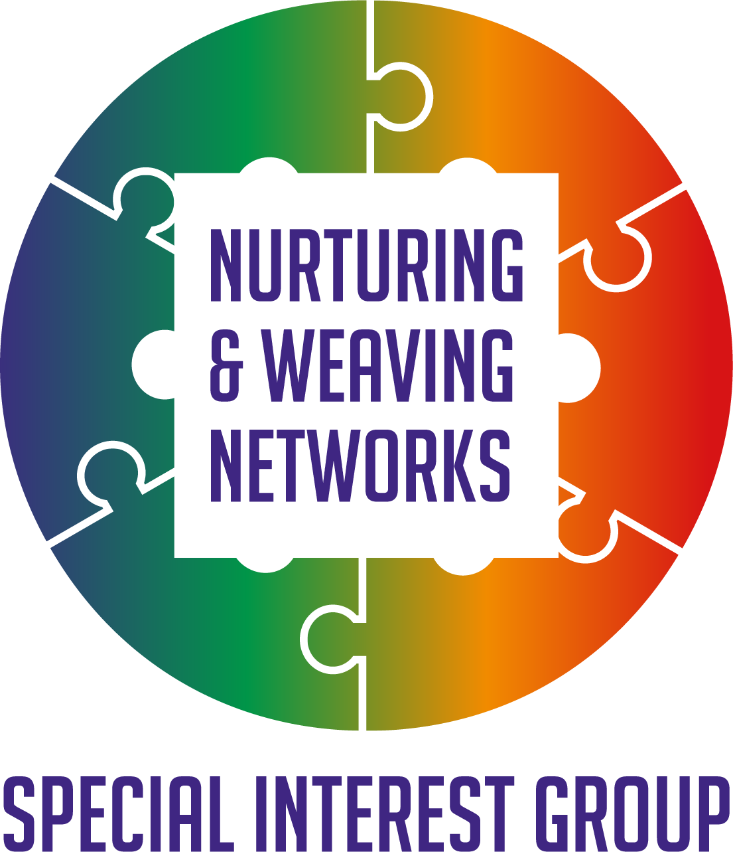

Reflections

Almost one year on and we decided to invest some time in reflecting where the Nurturing and Weaving Networks SIG started from, where it is now, and where those interested would like to go next. This space evolved after a Network Weaving Learning series offered by the Q Community, following which some of those who attended and worked in Scotland got together to consider, what next. This infographic shares those original ideas. A full-size PDF is available. We realized to make this happen we would need resources so were delighted to secure funding from Supporting Q Connections by the Health Foundation. It became clear to us that we didn’t want only to involve only Scotland but the whole Q Community and Guests as together we achieve more and the Nurturing and Weaving Networks SIG was born.

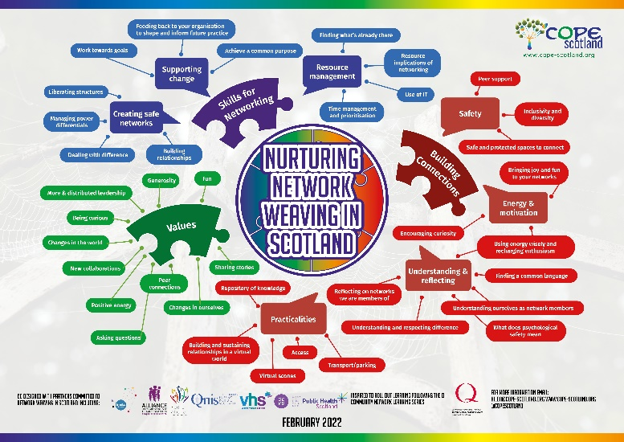

Self-care
While working with others can be very rewarding, it can also sometimes be challenging, it mattered to us, that self-care was promoted at every session, which starts with a brief exercise to be in the moment. This has proven really popular with feedback that people are now using this within their own networks and before team meetings. Taking a moment to pause, matters. Sometimes we do not have a whole heap of time, so offering ideas to be in the moment which do not take a lot of time is important. This is one wee example of a 3minute relaxer you can watch on your phone Link
Where have we been and where are we now?
The slides from the reflection session are Here Since the SIG started we have: sought to create many doors to enable people find an access point which works for them, including:

- Established regular active learning sessions.
- Established regular peer assist sessions.
- Set up a document library to share resources.
- Created links within Hexitime
- Created links with other SIGs and co presented e.g. Liberating Structures User Group
- Hosted open space conversations, focus groups and individual conversations to understand what people wanted to learn about improving networks and addressing network challenges, which informed developments.
- Created and promoted resources to help support our networks.
- Promoted existing resources shared by June Holley in the Network Weaving Handbook
- Created a tools and resources booklet to share ideas to support network effectiveness.
- Created a reflective log for our own journey as network leaders and guardians.
- Invited members to present at active learning sessions to share knowledge.

Where are we now?

We are in a time of reflection, considering where we have been, where we are now and where we want to go next. The session on the 9th of March supported this reflection. What people shared they wanted now included:
- To be stimulated by ideas
- To actually understand what Network Weaving and its relevance is to their work.
- To work with the capacity which exists within the membership recognizing staff are busy.
- Improve notifying people of what is coming up.
- To reflect more on when networks have formed in a crisis to help each other e.g., what happened during the pandemic.
- Continue to develop resources and thinking around Network effectiveness and Network Weaving
- More marketing and sharing stories, e.g., podcasts, introductory videos, ‘celebrity interviews’ where Network leaders share their challenges and what they found helped as well as their success.
- Create a safe space for people to share when it does not go to plan.
- Share and roll this learning out to others.
What next?
- Formal launch of the new materials.
- Strategy to help share the new materials and evaluate their impact.
- Continue with the 6-week peer support sessions.
- Continue with the active learning sessions but change the format slightly so that a new idea is presented from a place of experience of using it.
- Understand more how people find out what is going on to share information and events coming up.
- Create an introductory video around Network Weaving and its relevance in many settings and promote this widely.
- Continue to build connections with other SIGs.
- Invite those interested in Network Weaving to share what they can contribute recognizing capacity issues across the board.
- Continue to build a library of resources and promote what is there.

In addition to developing new resources, it would be helpful to explore how the existing resources have been accessed and where improvements can be made e.g. in the document section there is a series of materials around an introduction to network weaving. These are the slides Link which is one of 7 resources to be used individually or with groups to explore ideas around what network weaving may means for us. Discussing how we raise further awareness of these resources would be helpful.

Current contents Nurturing and Weaving Networks SIG document space.
This is the link to the document section Here Most materials can be viewed by anyone, only the editorial is controlled.
The materials at the moment are in 6 categories with current contents as follow:
Communication and co design
- Slides from reflective session March 2023
- Flash report from active learning session on Jigsaw Lids Feb 2023
- Communication update December 2022
- Flash report from conversation on networking skills and support for those who network October 2022
- Evolving Communication plan for Nurturing and Weaving Networks SIG July 2022
- What we have learned so far around Networking Needs and Network Weaving July 2022

Links to resources to support Network Weaving

- Initial tools and resources booklet to support networks and networks weaving. (Footnote this has since been updated and the new booklet launched soon)

Network assessment tools

- Network Maturity Matrix

Reflection tools for Networking

- Mind Map supporting Q Connections fund application.
- Conditions and priorities which support Networks and Network weaving Mind Map
- What role best describes you at the moment reflection poster.

Wellbeing of Network Members

- The Battery exercise poster side one
- The Battery exercise poster side two
- PowerPoint slides, self-care is not self-indulgent.
- Challenges on the sea of life poster and anchors which can help sustain us.

Workshop facilitation Materials

- Notes to accompany PowerPoint Slides assessing your Network held November 2022
- Slides for assessing your Network further developed from the session held November 2022
- There are 7 sets of materials from the workshop a brief introduction to Network Weaving Held October 2022 which offer people the resources to explore and share with others an introduction to Network Weaving

Events coming up.

6th April 4.30-5.30pm Peer assist around Networks and Network Weaving Register

20th April 12noon-1pm Social Network Mapping with the Liberating Structures User group. For more information Here

27/4/23 4-5pm (with 30min if anyone wants to stay on and chat) Active Learning session Network Maturity Matrix Register

Together we achieve more than we ever can alone. Thank you for being part of building a kinder, healthier fairer world for al and for your support in the past year, let’s see where we can go next.
For more information hilda@cope-scotland.org
Follow on twitter @COPEScotland

