Nurturing Networks and Network Leaders
Launch of Suite of resources June 2023

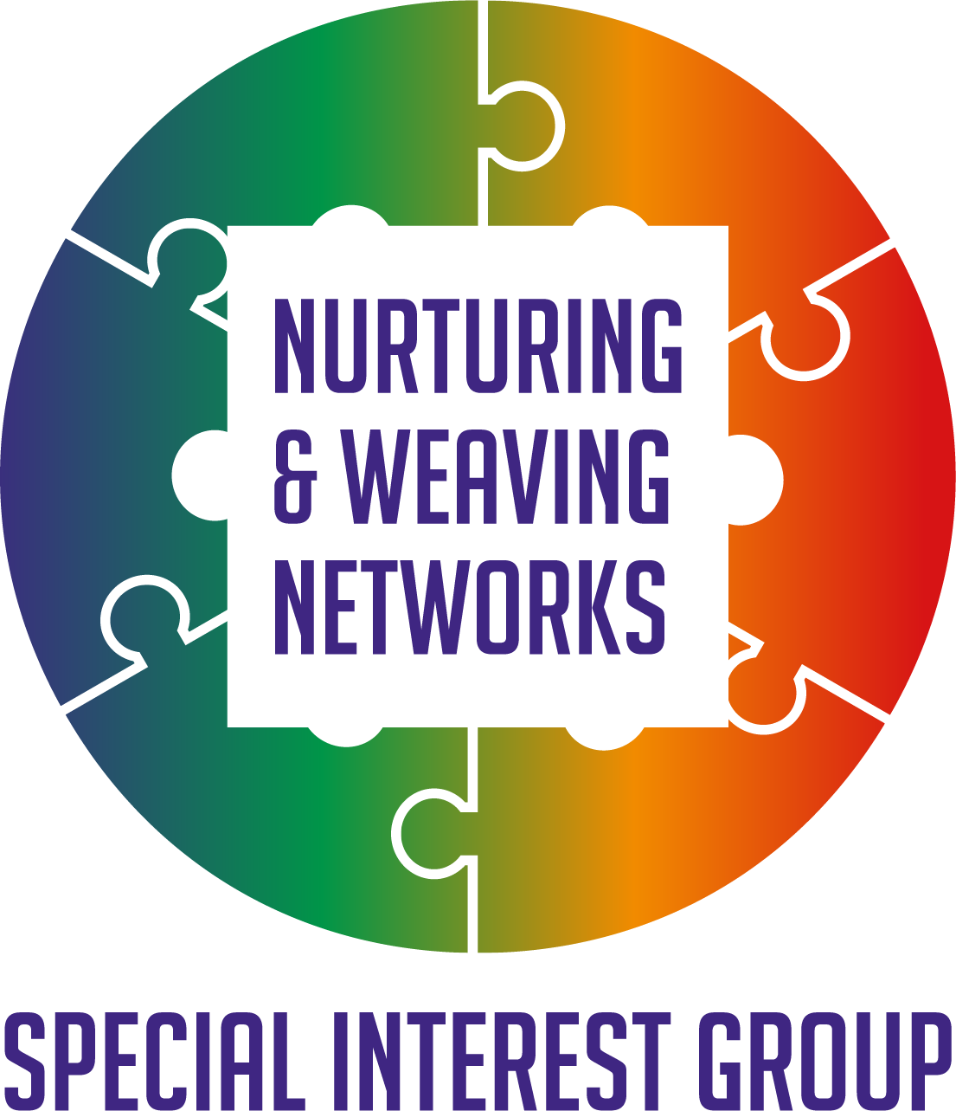

Reflections

Background and context to the suite of resources to support and nurture our networks and our roles as network leaders.
The Nurturing and Weaving Networks Special Interest Group was set up following the Network Weaving Learning sessions offered by Q. The ideas and resources shared during that learning it was felt would be of interest to others. With June Holley’s permission and working with others a new set of resources went into co design to share. For more information on the work of June Holley and colleagues check out Network weavers
Through many events, conversations, active learning sessions the following resources were produced. We would like to thank Supporting Q Connections Fund for their support in enabling this to happen and to everyone who helped us get to this point and to all those who will go on and use the materials.
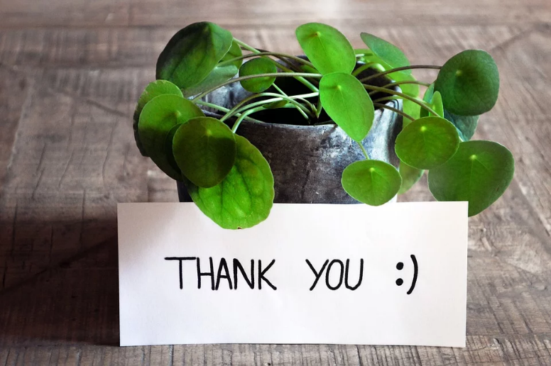
The suite of resources
The Curiosity poster
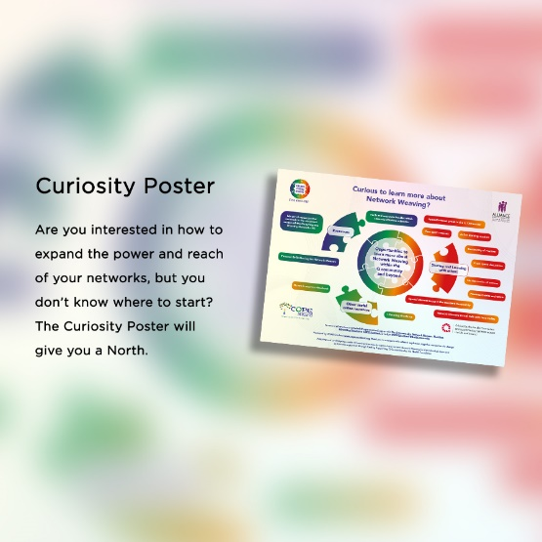
A simple tool to invite curiosity about learning more about network effectiveness, network leadership and network weaving.
A tools and resources booklet offering ideas on places to find out more about the issues identified. This includes.
Curious to learn more about Network Weaving?
Building relationships
Evaluating your Network
Finding the time
Generating Ideas
Hassles with Hierarchies
Ideas to action
Inclusivity and Diversity
Network Mapping
Peer Support asking for and receiving help as well as offering it.
A reflective workbook offering a CPD log for those leading networks. Contents include.
Chapter one: Ideas on how to use this workbook
Chapter two: Understanding my role as a Network Weaver
Chapter 3: Relationship with myself and others
Chapter 4: Understanding my Networks
Chapter 5: Motivating & energizing my Networks and me
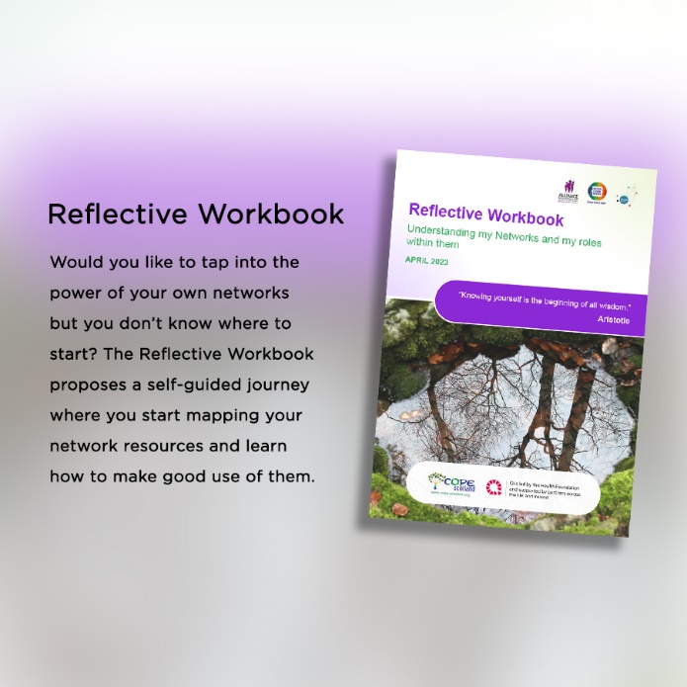
Download the materials Here
What next?
There were some ideas emerged from the launch which will help us in our next steps including:
- Following up people who specifically requested this in the chat. If you didn’t request this but would value a chat around using the materials in the context of your networks, please get in touch. hilda@cope-scotland.org
- Design another simple resource which helps easily prioritize where to get started. Already in development for more information contact hilda@cope-scotland.org
- Create spaces where people can share ideas and experiences of using the materials. Follow up session planned 19th July to register Here At which we will also plan ideas for future sessions.
- Promote how to join the Q community for people currently attending as guests. For more information Here
- Record sessions where possible for those who cannot attend them.
- Offer an opportunity for those interested in being part of a community of practice to support each other support our networks. If this is of interest, please email hilda@cope-scotland.org
- Learn from each other’s experiences. If you would like to share, please get in touch hilda@cope-scotland.org

Thanks again, everyone who helped get us to this point and to all who attended the launch and offered such kind words of encouragement and appreciation. This was a launch, we are still in flight, let’s see where we land together.

