Active Learning the Compassion Paradox

March 2023

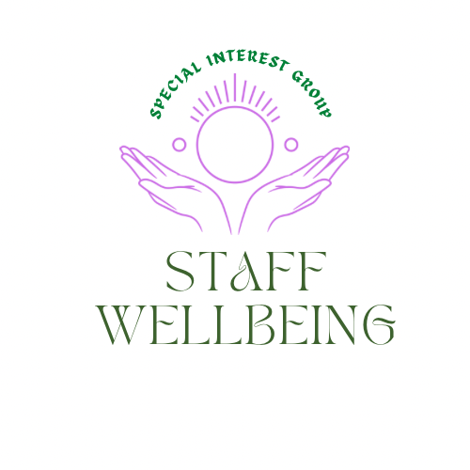

Reflections

Recognizing the need to ensure staff also experience a state of wellbeing to avoid compassion fatigue and burn out. A session was held exploring the compassion paradox and using liberating structures, beginning to form the wicked questions which may help find ways to address this which supports those receiving and offering care.
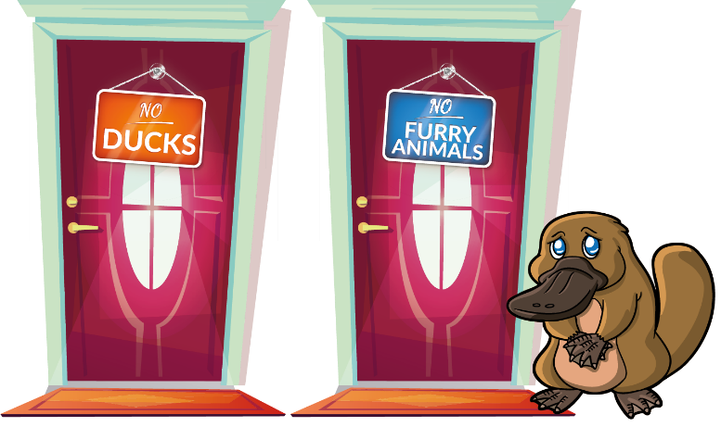
Self-care
It matters that we also are available for our own self-care as well as helping create the conditions where people can experience compassion and a culture where wellbeing is promoted. To model this the session started with a short visualization exercise. There are many ways to be in the moment. This link offers a grounding exercise using fingerholds to manage challenging emotions. Link
Activities are led by lived experience.
The lived experience of staff working in health and social care, including volunteers, is important in determining how this special interest group and the sessions and materials it offers evolves. Themes around what people hope to get from this space include:

- Managing guilt and being able to say no.
- Avoiding/managing mental exhaustion
- Maintaining energy
- A tool, framework and/or working example to use ourselves and share with others to be more compassionate to oneself.
- How to hold the tension of a paradox and be OK with discomfort
- Tips and tools to support colleagues and students to maintain their own compassion.
- Boundaries and being realistic of the ask.
- Tools for personal and team development
- Strategies for how to introduce staff wellbeing conversations and how to better look after myself and my colleagues.
- Something to use and share with staff and volunteers who have asked for help with supporting themselves.
- Explore the compassion paradox using wicked questions to schedule light on my own burnout situation and how I can help others.
- Tips for teams needing support.
- Using the compass points. This Link offers information on the Compass Points

What is the Compassion Paradox?

The full set of slides from the session are available Here. However, an overview of the Compassion Paradox is:

’Health care is inherently compassionate, and yet the very sense of connection with patients that can make us effective caregivers can lead to feelings of stress and burnout—which then undermines our ability to be compassionate.’’
Leif Hass, M.D

What do we mean by Wicked Questions?
For more information on Wicked Questions which is a liberating structure please visit Link You may also be interested in joining the Liberating structures user group within the Q community Link
‘’ Wicked Questions make it possible to expose safely the tension between espoused strategies and on-the-ground circumstances and to discover the valuable strategies that lie deeply hidden in paradoxical waters.’’
Attribution: Liberating Structure developed by Henri Lipmanowicz and Keith McCandless. Inspired by professors Brenda Zimmerman (see Edgeware) and Scott Kelso (see The Complementary Nature).
If we are to begin to address the challenges offered by the Compassion Paradox, it matters we find ways to ask the right question, otherwise we may end up with an answer which does not make any sense, we invest time and energy in implementing and………..nothing changes!
‘’If I had an hour to solve a problem and my life depended on the solution, I would spend the first fifty-five minutes determining the proper question to ask, for once I know the proper question, I could solve the problem in less than five minutes.’’ Albert Einstein
The Wisdom in the room
To harness the wisdom in the room, we went into discussion groups using Jam Boards to begin to formulate wicked questions to help us in the future find some of the answers which just may help. This link takes you to a blank jam board if you would like to do this exercise with your team Link It would be advisable to also cover the slides.

Reflections from the Jam Boards.
The following offers reflections from the post its shared on the jam boards. What may come as no surprise is how much similarity there is in what people determined was good for people receiving care wellbeing and staff wellbeing.
Initially the group reflected individually on the conditions which provided a compassionate response to people receiving care which included:
- Active listening not jumping in with solutions.
- Being understood and valued
- Kindness and listening to concerns.
- Being supported and supportive
- Clear communication that is understandable - no jargon
- Provide information in a clear and calm way.
- Being listened to and have the time to be heard.
- Take time to pause and listen.
- Mindfulness on demand
- Space to have ME time.
- A caring member of staff
- Non-judgmental staff
- Staff to introduce themselves and see the patient as a person.
- A compassionate staff member

The groups then discussed collectively the conditions which provided a compassionate response to people receiving care which included:
- Having things around them that are familiar and important to them.
- Having places that people can go outside the caring environment. staff safe spaces
- Turn defensiveness into inquiry.
- Stop and listen.
- Non- judgmental genuine presence of staff
- Demand of time VS being compassionate

For interest, the following infographic was created with those who use services when asked what they were seeking from health care professionals.
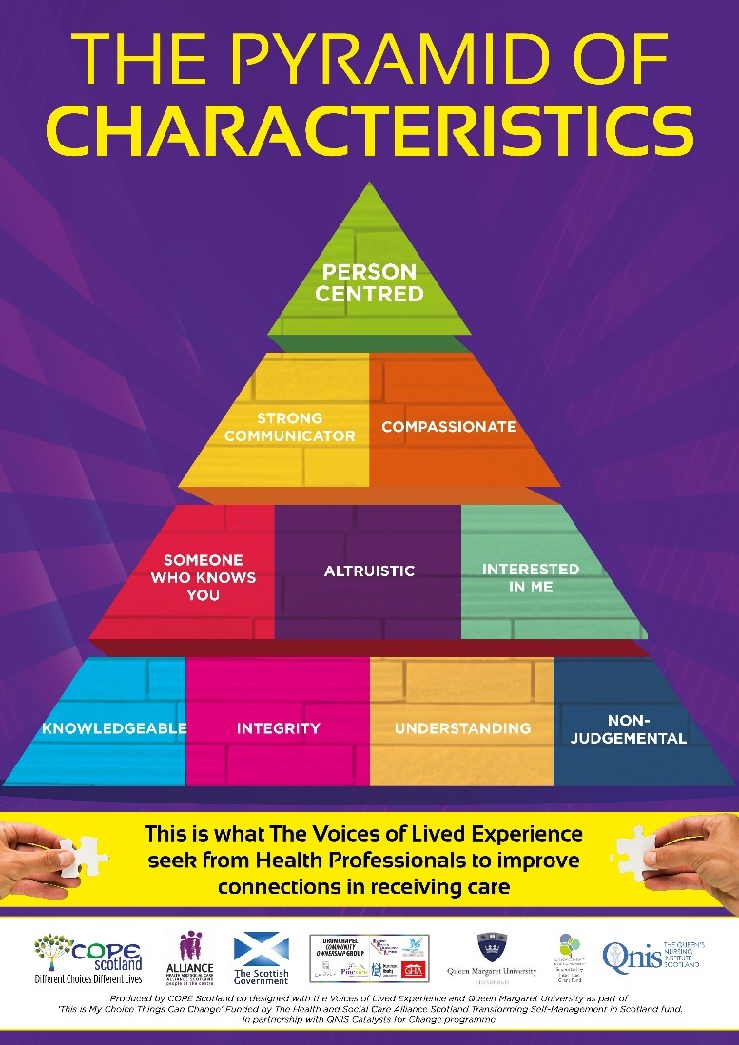
It is interesting that the discussion held by the group during this session and the results of that discussion echo very closely what those receiving care seek to improve their experience of receiving care.
Next the group reflected individually the conditions which provided a compassionate response to people offering care which included:
- Being supported and supportive
- Having time to talk and listen.
- Having time with nature, outside
- Developing trust in your carers and colleagues
- Being understood and valued
- Take time to pause and listen.
- Take time to pause and check in with myself.
- Knowing your own boundaries as well as the organizations. And keeping to those when it is difficult.
- Colleagues who see their colleagues as people and not numbers / rivals / subordinates
- Having adequate breaks and time to feel connected only with them.
- Variety of sessions available free
- Having managers that ensure they feel ok.
- Thinking of themselves before others
- No permission to wellbeing time
- Reminding staff to take regular breaks.
- Time to have a break between demanding tasks.

The groups then discussed collectively the conditions which provided a compassionate response to people offering care which included:
- Taking time to actually listen & understand.
- Look for and share or ask about what brings joy (or a smile) in the last 24 hours... or week or clinical rotation.
- Leadership role modelling and supporting
- Looking after yourself Vs Time and work demand

The following infographic was created during a co design session with nurses offering ideas on what would help support self-care. For more information on this please visit Link and for a full size copy of the poster in PDF please email hilda@cope-scotland.org It is interesting during the group exercise the pieces which people suggested supported wellbeing, however, a later exercise exploring what drained energy included not feeling listened to, or appreciated, which resonates with the discussions held at this session.
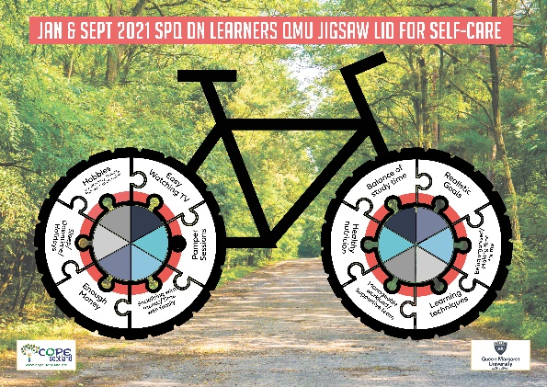

The session on wicked questions then went onto begin to explore both sides of the paradox to consider if perhaps we could phrase our questions in a way which helped us have a shift in thinking which may help in finding some new ideas which may be effective in nurturing staff wellbeing. These included the following:
- Why do we have time for some things but not others that may be more valuable.
- How is it that we can collect data to assess program quality and simultaneously excite staff to use the data for improvement and decision making when they are so stressed and anxious?
- How is it that we are kind and compassionate and impatient and irritable at work.
- How can we create environments that support client and colleagues’ wellbeing and still be functional as a clinical space?
- How is it that we expect patients and colleagues to listen and understand when we don't actively ourselves?
- Why do we treat ourselves more badly than we do others.
- How is that we show our patient they are important and simultaneously cope with the demand?
- How is that Manager can role model wellbeing time for themselves and simultaneously supporting their team to do the same.

Other points captured from discussion included:

- How is it that we are kind and compassionate and impatient and irritable at work?
- It is like two opposites; it depends on what is going on in your personal life. That is extremely difficult.
- Little things - like did you get parking, did your day start right, it is like a domino effect.
- Acknowledge the wasted energy.
- How is that Manager can role model wellbeing time for themselves and simultaneously supporting their team to do the same?
- Quicker to protect staff than protect ourselves.
- The word 'manager' sounds like you have to take things on /take more responsibility.
- Managers often protect staff from workload and absorb some of the stress - is this a parent-child relationship? Protect them as your children.
- Why do we protect people if they have the ability to protect themselves?
- Manager is aware of the challenges and obvious demands.

What emerged here shows the complexity of finding ways to address the Compassion Paradox and the need not only to provide ideas and tools to support staff wellbeing and help reduce compassion fatigue and burnout, but the wider changes needed to create an environment where collective care for people receiving and offering care becomes the norm.
What next?
There is a need for a variety of responses to help us address the Compassion Paradox, which may be as follows.
- Active learning sessions to learn about and practice tools & ideas to support staff wellbeing and compassion to the self.
- Active learning sessions for those who manage teams around the need to care for self., the team and those receiving care.
- Peer discussion to explore the issues raised in this report and share ideas and learning which may help make an impact.
- Coaching support to deliver wellbeing sessions to teams.
- Go to library of resources to support wellbeing and compassion.
The next session of the staff wellbeing SIG will be using the Liberating Structure 1-2-4-all to further capture the wisdom in the room to help identify 2 specific Wicked Questions which we will seek to find answers to. For more information on 1-2-4-all Link
It matters that we try and find days and times which suit people to attend. It would appear, that Tuesday, Wednesday, and Thursday work best and either lunchtime 12-1 or at the end of the day 4.30-5.30. With a preference of 12-1 on a Thursday where possible, but not overlapping with the Liberating structures user group sessions.
We plan to repeat some sessions over the next few months to see if that is helpful for people and then together, we can decide what works better going forwards. We know time can be a challenge and do not want to present people with even more challenges!
Other planned events coming up include:
6th April 4.30-5.30pm Nurturing and Weaving Networks Special Interest Group. Peer Assist click to Register For more information on the Nurturing and Weaving Networks SIG Link
20^{tht} April 4.30-5.30pm 1-2-4-All The staff wellbeing SIG. The Compassion Paradox: making sense of a difficult work environment together. Register To For more information on the Staff Wellbeing SIG Link
27th April 4-5.30pm The Network Maturity Matrix Nurturing and Weaving Networks SIG. Click to Register
2nd May 4-5pm Peer discussions around supporting staff wellbeing Register Staff wellbeing SIG
18th May 12-1pm -2-4-All The staff wellbeing group Register
25th May 12-1pm Maintaining energy levels delivered in partnership with the Joy in Work SIG. For more information visit Joy in Work SIG Link
3rd August 12-1pm Peer discussions around staff wellbeing Register

Current resources in the document section of the staff wellbeing SIG
Please feel free to visit the document section and share, if you are not a member of Q then please sign in as a guest. It would also be great if people wanted to add resources to this library. Currently we have:
Communication and Newsletters
The Flash report and Slides from the 15sec30min active learning session on finding more time, by saving each other time.
Communication update from the Nurturing and Weaving Networks SIG conversation café which may be of interest to Staff wellbeing SIG members.
Tips for wellbeing
PowerPoint Slides for workshop on self-care is not self-indulgent.
Fingerholds for managing challenging emotions poster. Multi-colour version
Fingerholds for managing challenging emotions poster. Black and cream version
The Art of Communication. Tips on listening when someone needs to share, and sharing when we need someone to listen.
Wellbeing reminder postcards
Personal promise and ideas to maintain personal energy levels.
Kinder conversations postcard can be used to reach out to someone to let them know you care.
Personal Promise Postcard offers ideas to make a promise to ourselves to practice self-care.
Wellbeing tools
The battery ‘dude’ and battery exercise side one and two.

Remember, you really do matter too.
Hilda Campbell
Convenor Staff wellbeing SIG

