Active Learning 1-2-4-all to explore answers to the wicked questions and relax using all the senses.

April 2023

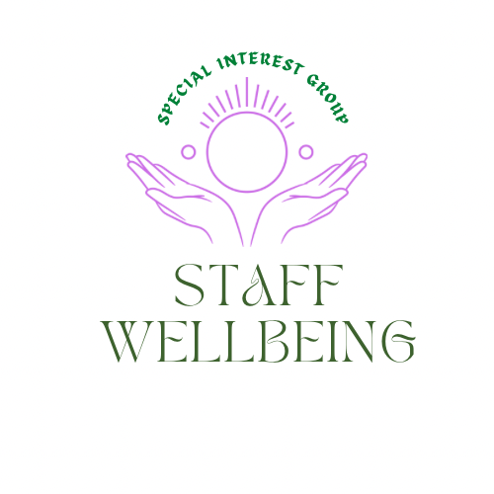

Reflections

In March we began to explore the compassion paradox and used the liberating structure ‘wicked questions’ to help us consider the answers we were seeking to help staff avoid compassion fatigue and burn out.
For more information on Wicked Questions please visit Link You may also be interested in joining the Liberating structures user group within the Q community Link
Self-care
A priority shared by members is having a toolkit to draw on to share and use ourselves to help reduce the risk of compassion fatigue and burn out. This session started with sharing a video on using all the senses to relax. This can be viewed Here It was interesting the session shared how sharing food can be a way to help team bonding, mindful eating maybe an interesting activity as a team wellbeing exercise. There are pieces on this online.
We also wanted to share a the following offered by the Community Hospitals SIG sharing good practice Staff wellbeing resource You can find out more about the SIG Here
Emerging themes
The lived experience of staff working in health and social care, including volunteers, is important in determining how this special interest group and the sessions and materials it offers evolves. Themes around what people hope to get from this space so far include:

- Creating psychologically safe spaces to have conversations around wellbeing and self compassion
- Boundaries and managing guilt
- Tools/framework to introduce to support staff wellbeing and compassion for self and others including for those in a management role

The wisdom in the room

The following are ideas shared at the session by participants on steps they take to nurture their own and the wellbeing of staff in work and included:

- Eating pancakes together at coffee time
- Eating strawberries mindfully on a summer day
- Eating together, sharing breaks
- Respecting people need their own space during breaks.
- Getting out for a short walk together at breaks
- Share tastes in music.
- When working remotely, book online time to just chat, diffuse, make plans to catch up face to face.
- During team 'away' day we could think about co-create some art that represents the team or the team’s vision or how we feel as a team, lots of textures and smells of different pastels, paints, wax, textiles etc. can engage lots of senses and making a shared piece of art together could become a reminder every time we see it (to appreciate or chuckle at it)
- Use social network webbing as a way to find common interests. Link

The wicked questions identified at the session in March included.

- How is it that we can collect data to assess program quality and simultaneously excite staff to use the data for improvement and decision making when they are so stressed and anxious?
- How can we create environments that support client and colleagues’ wellbeing and simultaneously be functional as a clinical space?
- How is that we show our patient they are important and simultaneously cope with the demand?
- How is that a manager can role model wellbeing time for themselves and simultaneously supporting their team to do the same?

Seeking answers to the wicked questions around the compassion paradox using 1-2-4-all
1-2-4-All is a liberating structure. This helps immediately include everyone regardless of how large the group is. You can generate better ideas and more of them faster than ever before. You can tap the know-how and imagination that is distributed widely in places not known in advance. Open, generative conversation unfolds. Ideas and solutions are sifted in rapid fashion. Most importantly, participants own the ideas, so follow-up and implementation is simplified. No buy-in strategies needed! Simple and elegant!
Attribution: Liberating Structure developed by Henri Lipmanowicz and Keith McCandless
More information Here
The slides from the session are available Here If you missed this session it is being repeated on the 18th of May 12-1pm, Register here
We chose to look at the following wicked question.
How do we offer compassion and care to enable us to ease the suffering of others and simultaneously nurture the wellbeing of staff to remain compassionate in the face of continued exposure to others suffering
Reflections from the room
We reflected on our own, then went into pairs, then came back into the main group to share as the group was small enough it enabled this and offered space for a rich conversation.
As well as exploring ideas to help address the wiecked questions we realised we needed to reflect more on the actual challenges so what emerged had meaning for people.
New themes which emerged for attention included the following as well as suggestions of things which may help:
- The wellbeing needs of staff working from home and the isolation they can experience as well as ‘Toxic Productivity’ as they never switch off and go home.
- Enable permission to have down time. This is the new reality for us, and we need to find ways to adjust to get the job done and maintain the wellbeing of the workforce to be able to do the job as effectively as possible.
- Practical strategies, e.g., when emails can be sent, do not make working while on holiday seem like a virtue.
- Recognizing workaholism and doing something about helping address this as a culture of promotions and careers depend on always being available including on time and days off, working over the odds all the time is not healthy.
- Create space to be compassionate to one another. Offer space to explore what each of us thinks compassion means to us.
- Remember why we came into the job and how that aligns with our organizations.
- Autonomy, contribution, alignment, purpose, why did we go into health care, being able to act, feeling valued around feedback of what we are doing,

- Giving space to exchange ideas so room for printer but not a staff room or it was the storeroom! Informal learning by sharing space for downtime with other disciplines.

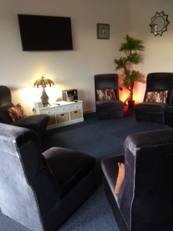
This image is of a multi room which was in COPE Scotland’s premises staff used for breaks and lunch. It was also used for small groups and one to one, but we ran an appointment system so this room was free over lunch, and everyone could meet there and enjoy lunch together if they wanted. Cost less than you may think to create and was appreciated by all who used it. The chairs were easy to move and configured to reflect the purpose of the room at that time.
This resource may also be of interest Making spaces for staff breaks A design anthropology approach" Link

- Modelling kindness
- Considering the wisdom of the sheet number of meetings and the time they take versus the time available to do the work that comes from the meetings, this does not end up being done on staff’s own time.
- Be available to form working relationships, get to know people which supports understanding when working together.

- The world we live in is worried so many things on our mind outside work and we bring it to work, what do we do with the mental load, acknowledge this can help to carry this load and ask for help where we need it. Link offered around living in uncertain times Here

- Have a sense of community and identity which sometimes can be lost when working remotely or in isolation. While welcoming diversity of opinion and connecting with new networks. This is great about echo chambers and the benefit of diverse perspectives. Link

- Listen to 70s music on the way to work and be kind to myself. Bring that positivity into work.

- Do not reply to emails from people I know are on holiday and plan a couple of days myself where I do not check emails!

- To make time and space to check in with myself and others about our 'purpose' and whether we are on the right track with our work.

This was also a link shared around a couple in China’s way of helping maintain wellbeing and recover from depression following a traumatic incident Shuffle Dance
What next?
Burnout survival guide
If you are interested in being part of a community of practice to begin to pull together resources to share from the wisdom collected from the group please let Hilda know by emailing hilda@cope-scotland.org This is not a replacement for professional advice, it’s a peer co designed resource responding to the issues raised and suggestions made by those who have lived experience of working in stressful environments within health and social care.

Tunes to inspire.
As well as creating playlists within our teams it may be nice to share songs which inspire us, and we create a playlist for the SIG which we can share and inspire others to create their own. Any ideas please email hilda@cope-scotland.org or post in the SIG space they will be collated and shared.
Share spaces created for staff downtime.
Be great to see images of other spaces created for staff to unwind and connect at their break, which could be shared in the SIG space, guests welcome Link
Other planned events coming up include:
2nd May 4-5pm Peer discussions around supporting staff wellbeing Register Staff wellbeing SIG
18th May 12-1pm -2-4-All The staff wellbeing group Register
25th May 12-1pm Maintaining energy levels delivered in partnership with the Joy in Work SIG. For more information visit Joy in Work SIG Link
3rd August 12-1pm Peer discussions around staff wellbeing Register
Future active learning sessions will be determined at the peer discussions and will build on the issues being raised and ideas people are sharing.
Remember, you really do matter too. Together we can find ways to help restore the balance between caring for others as well as ourselves.
Hilda Campbell
Convenor Staff wellbeing SIG

