Active Learning
Jigsaw Lids
February 2023

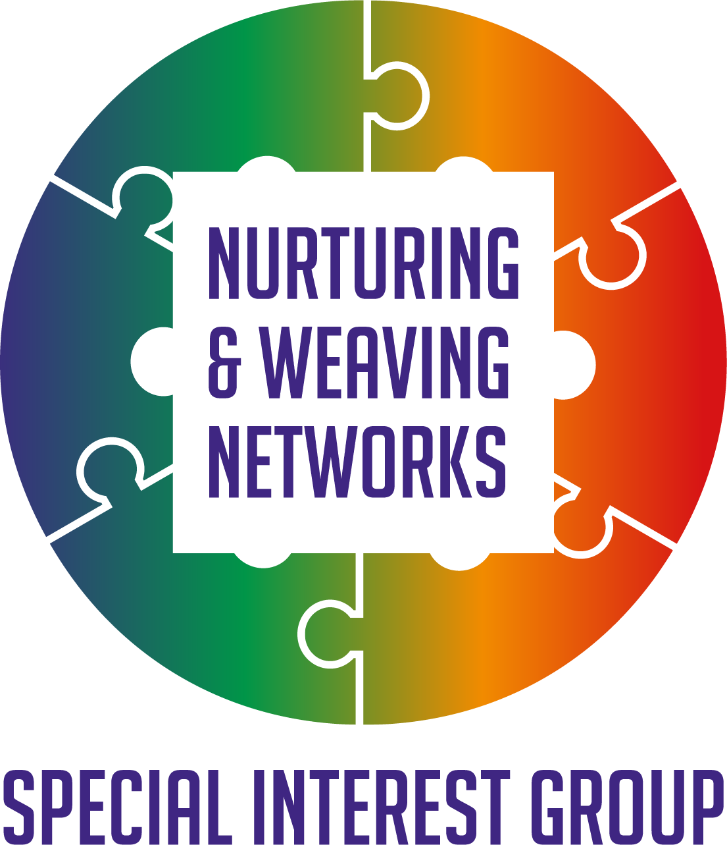

Reflections

Members of the Q Community Special Interest Group and guests explored the Jigsaw toolkit as a resource to help gather and share views on the pieces which can help support effective networks. The image below is one example of an earlier Jigsaw lid developed from views shared by members of the Q community which helped shape the ideas for action within the special interest group space.
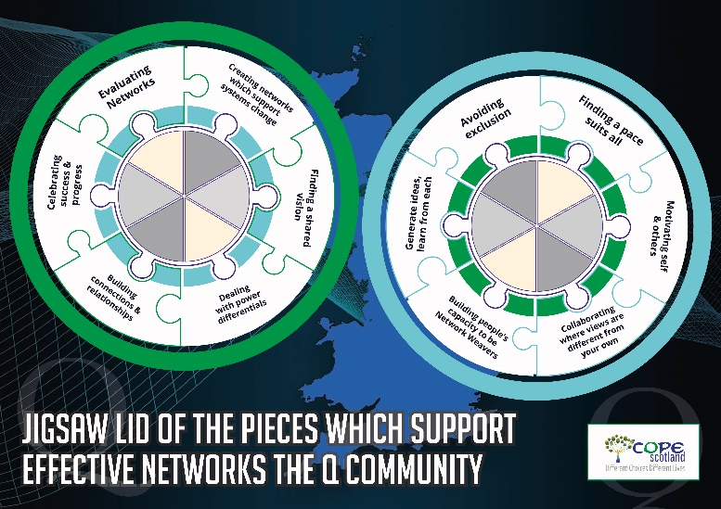
Self-care
It matters that we also are available for our own self-care as well as helping create the conditions where people can experience compassion and a culture where wellbeing is promoted. The session started with a meditation and sharing our experiences of what makes us smile. Which included hugs, puppies, meeting and making new friends and more. This link takes you to a wellbeing video offering ideas to relax using all the senses Link
Views on Networking
Each active learning session we run we welcome back old friends as well as new and its helpful to make space to reflect on our shared views on networking. These are examples of the views shared on why we may choose to network.
- Making connections to get what I need.
- Building helpful and supportive relationships
- Connecting to contribute to a common purpose.
- Exchanging information on an equal level
- Alliances to meet your goals.
- Finding innovative ideas and viewpoints

What gets in the road of Networking?

We also spent time exploring what gets in the road of networking and there seemed to be some key issues shared across those who gave their views.
- Time and lack of it
- Ego, power dynamics, agenda, politics
- Lack of commitment
- Red tape and bureaucracy
- Type also clarity of purpose
Increasing the value of Networks
We then explored what would support a sense of increased value in Networks. Views included.
- Putting shared learning into practice
- More time to follow up.
- A shared understanding.
- If there was a way to be pointed to people who have a shared interest or could be a resource to a challenge, I have.
- I would value networking more if the importance of relationship building had a stronger importance than more traditional approaches.
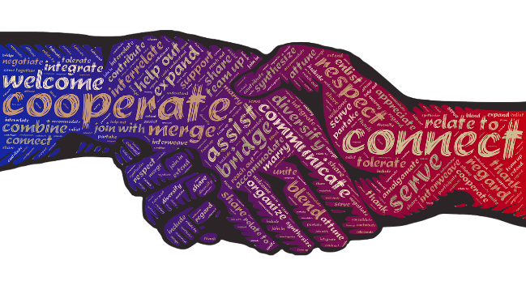

The Jigsaw Toolkit
The Jigsaw toolkit was originally created to support courageous conversations in a piece of work involving various stakeholders interested in primary care transformation, with a focus on the conditions which supported good mental health. The full report on that work can be found Here Since then the Jigsaw Toolkit has evolved to explore how we share our visions to agree on common priorities on which we can plan action for many other areas of interest from Climate Change to Gambling Harms to identifying the pieces which support our own wellbeing and more..
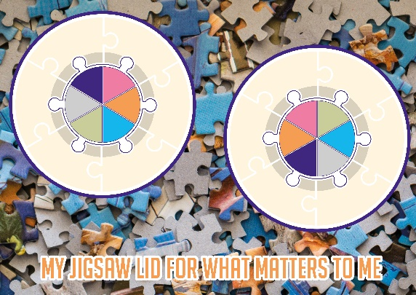

The slides for the active learning session on the Jigsaw Lids are available here Slides. We then went into groups to consider the key elements we felt supported effective networks, which could then help develop our own Jigsaw lid and points for action
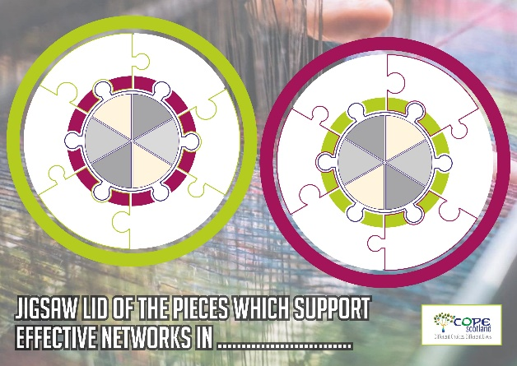
The table which follows offers the Pieces fed back by some of the breakout groups. One group identified 9 priorities and were happy to leave the others open to see what other groups offered. Each group was asked to identify a maximum of 12 priorities. When using the Jigsaw toolkit with diverse stakeholders it is helpful for each stakeholder group to have their own Jigsaw lid. In this piece we have shared 3 lids for supporting effective networks. One for the Wider Q community, one from a session in Scotland and an example of a blank lid which people can complete themselves. We share some images for illustration however, full size PDF versions are available if you email admin@cope-scotland.org

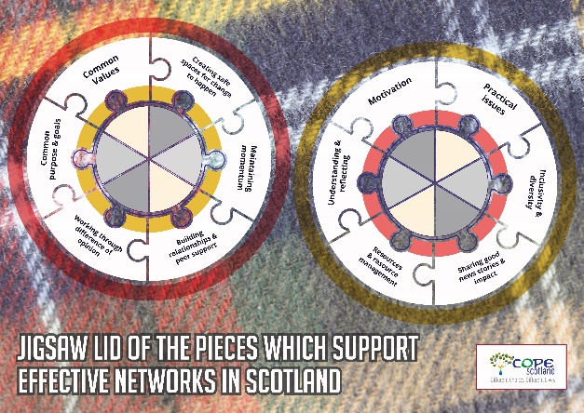

It should be noted, the reverse of the Jigsaw lid poster offers full instructions for facilitating your own Jigsaw lid sessions. COPE Scotland who created this resource are happy for others to share it and use it so long as they are credited and recognized as the originator of this Jigsaw Toolkit
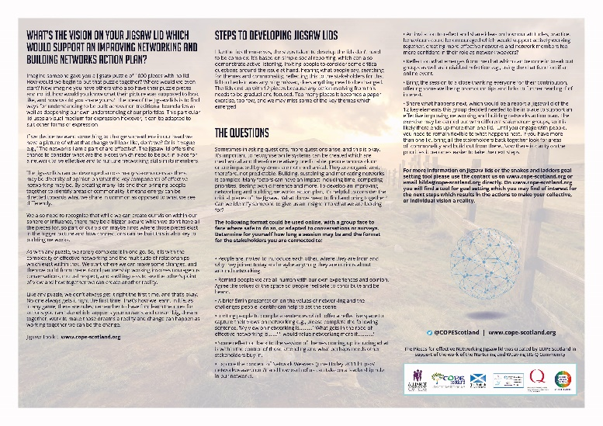
Please note, we realize the image of the reverse of the Jigsaw Lid for effective networks is small, a full size version is available from admin@cope-scotland.org This is for illustration only.
For the purposes of sharing the feedback from the groups on their view of the pieces for effective networks we have captured them in a table, and where there has appeared a common theme matched these and where there has not been a common theme given this its own place on the table. This offers a straightforward way to view the areas the two groups shared and also where there were differences.
While using a table like this can save costs of making different Jigsaw Lids it is not as powerful as having separate ‘visions’ and also runs the risk of people perceiving a hierarchy of priorities as they are shown in columns rather than a circle. But to share views captured at the learning session we have offered them in this format for now in order that we could send out the flash report from the session timeously and in the hope that we have created a safe enough space within the SIG and its active learning sessions that people recognize we do not have a hierarchy all views are equal..

Table of views on pieces which support effective networks.
Group one | Group two
Time | Time, location, and pace [ with time to process and include breaks]
Shared purpose | Common goal
No Hierarchy | Equitable inclusion
Assess and Celebrate progress
Trust
Open Mindedness
Network oversight or leadership that can address challenges, help with conflicts, engagement of members, capturing decisions and "to dos
Balance work, play, formal/informal activities
 | Innovative approaches to engagement
 | Diversity of people
 | Accessible
 | Unconscious Bias
 | Good facilitation/holding the space
 | Psychological Safety
 | Digital inequalities
 | Include Lived experience at all levels

Reflections
When we look at the table of views, we can see there are some areas where there are similarities, e.g., shared purpose and common goal, others where in conversation it may be agreed there are overlaps e.g., trust and psychological safety and others where there may be different priorities.
The success of using the Jigsaw lid toolkit is to focus on where there are similarities and overlap. That does not mean the other issues are not also important, simply when we are working with others, it is easier to build relationships on common priorities, then once those relationships become established then other priorities can be considered.
It may be that the activities to support the other priorities are similar e.g. balance of informal and formal activities and innovative approaches to engagement.
What the Jigsaw lids offer are a new way to have conversations, recognizing and respecting we may share some views and some we may differ, but our energy is invested in those areas we agree on, so we can plan what next.
Views to action
It matters when time is of the essence that it is used to best effect and this includes taking the collective views, reaching a consensus which may not be perfect but is good enough and then exploring what actions are needed to help bring about the change which has been identified as needed. There are many tools and resources which can help, its finding those which work for your group.
The Nurturing and Weaving Networks special interest group will soon be launching some new resources which may be of interest. These events coming up may also be of interest.
23rd February 4.30-5.30pm Using Peer Asist to support each other find solutions to common Network challenges. Click here to Register
On the 9th of March 4-5.30pm Open space café to explore ideas for the SIG moving forwards. Click to Register

None of us can do it alone, that is why we have each other.
We are all too aware of the many challenges and commitments on our time and the recognition that changes are needed. However, none of us alone can achieve this. The Q community offers a safe space to connect with others who want to help improve health and social care and the lives of those who receive support and offer it.
We are unlikely to find one answer which suits everyone or every situation, however, the more we learn from each other and share, the more likely we are to be able to move towards that vision of a healthier society where fewer people are impacted by inequality, to find new ways of working and service delivery that addresses the challenges we face and to be able to express that in a way that other can learn from and adopt and adapt in their situations.
You matter, what you do matters and together we can be the change. Thanks for reading and for all you do. Let us find a way through the woods, together!
Hilda Campbell
Convenor Nurturing and Weaving SIG

