Active Learning 15sec30min

February 2023

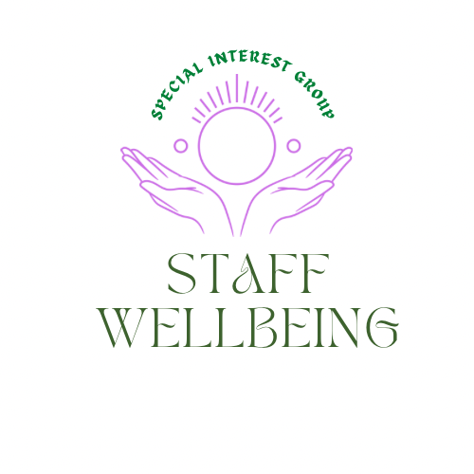

Reflections

Members of the Q Community Special Interest Group and guests explored the resources available on the 15sec30min website 15sec30min. The motivation behind this was the recognition that time pressures have on stress levels and that the tools offered by 15sec30min may offer teams some ideas to explore what actions could be taken which only require 15sec but could save someone else 30min. In a world where increasingly, we can often be asked to do more with less, it matters more than ever that where we can find ways to save time, which increases joy and reduces stress.
Self-care
It matters that we also are available for our own self-care as well as helping create the conditions where people can experience compassion and a culture where wellbeing is promoted. The session started with a meditation and sharing our experiences of what we are looking forward to now spring is on the way. Which included more daylight, getting back into just a t shirt, daffodils, not having to hose the dog after every walk and more. This link takes you to a wellbeing recording offering a space to pause Link
Views on why time can be a challenge.
Its important during and active learning session that we share and learn from each other. We took some time to reflect why finding time can be a challenge.

- Guilt if not working all the time.
- Competing priorities
- Hard to say no.
- Constant never-ending demands on our time.
- We have less time than we think.
- Exhaustion by the end of the working day and impact on how time is spent after work.
- Lack of energy as much as lack of time
- Too many meetings especially since working from home, so can’t get the actual work done.
- Not being able to finish one thing before something else is needing attention.
- Too many distractions and competing commitments.
- Meeting the needs of others.
- Constantly reprioritizing the to do list.
- It can be hard to know what to prioritize and taking a break to think about it feels self-indulgent.

What can help managing time?

We also spent time exploring what can help us manage our time when it is under such pressures. The following are some ideas shared.
- Blocking out time to complete specific tasks.
- Reducing distractions
- Having control of your own diary
- Planning ahead and prioritizing
- Focusing on a few things to be accountable and responsible for and be realistic about expectations.
- Turning off email notifications.
- Building in moments to pause in the day to help refocus, reprioritize.
- Not working alone, being able to check in with a colleague.
- Turn off instant messenger or put up a do not disturb.
- Get easy things out of the road first.
- Avoiding unnecessary perfectionism.
- Not taking in my nonclinical work notebook on my clinical workdays and vice versa.
- Not receiving replies from a mail all which are not relevant for me to read or receive.
- Being respected that I know best how to manage my workload and given space to prioritize.
- Being rested and feeling energized

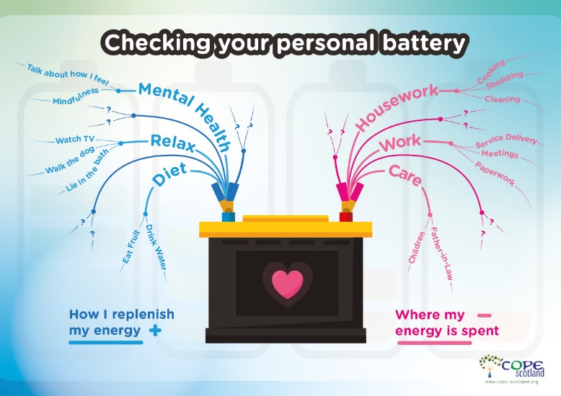

!5sec30min active learning session
The session covered:
- Why finding time is a challenge’?
- How 15sec30min can help
- Where to get more information on 15sec30min
- Small group discussion of this approach

The slides for this session are available Here

Feedback on the session
‘’you could incorporate the 15s30m approach into planning improvement projects by applying it to each connecting line on a driver diagram to streamline each step of the process.’’
‘’I would like to apply this concept with the wider training programs for front line staff.’’

‘’The importance of stopping to take a breath and survey the situation at the start of a task’’

‘’ Power of peer assists and resources.’’

‘’ That no matter where you work the common frustrations are the same.’’

‘’Great suggestions such as Effective meetings template and simplicity of 15mins and 30secs info’’

‘’Easy tool to use and linking it to joy and impact is powerful.’’

On a scale of 1-10 where 1 is I will not and 10 is I definitely will how likely are you to share this approach with your team average score 8
On a scale of 1-10 where 1 is there is no value to this approach and 10 is there is definitely a value in visiting the 15sec30min website and learning more average score 8.6

Reflections
Those who attended recognized the value of the 15sec30min approach and are considering how to apply it within their teams/workplaces. It would be great in future to perhaps be able to share what happened next if anyone wanted to offer a blog on this to inspire others.
What is coming up next?
.
The Staff wellbeing special interest group plans to offer a series of activities in the coming year including:
- Active learning sessions
- Sharing materials to promote staff wellbeing.
- Linking to other special interest groups
- Setting up a Community of Practice for Network Guardians
- Develop space in Hexitime for staff wellbeing.
Some dates for the diary may be of interest:
9th March 12-1pm The Compassion Paradox Staff wellbeing special Interest Group. Click to Register
9th of March 4-5.30pm Open space café to explore ideas for the Nurturing and Weaving Networks SIG moving forwards. Click to Register

None of us can do it alone, that is why we have each other.
6th April 4.30-5.30pm Nurturing and Weaving Networks Special Interest Group. Peer Assist click to Register
27th April 4-5.30pm The Network Maturity Matrix Nurturing and Weaving Networks SIG. Click to Register
There are also sessions coming up in partnership with the Joy in Work Special Interest Group and Liberating Structures user group, details will be shared on twitter and in the Staff wellbeing Q space
We remain in strange times and it matters when we are caring about others we remember its all right to look after our own wellbeing also.
Hilda Campbell
Convenor Staff wellbeing SIG
