Introduction to Improving Joy in Work.

Oct 2023

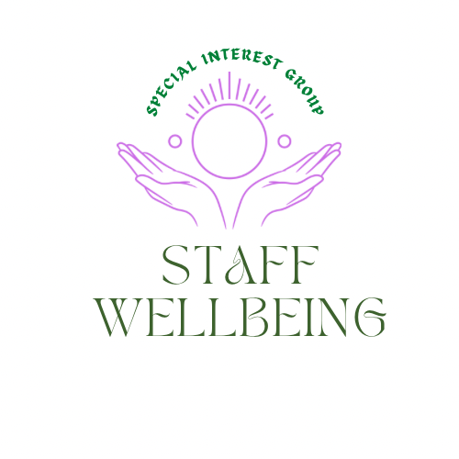

Reflections

Each session of the Staff wellbeing SIG seeks to build on previous conversations. To catch up on these, please visit the document section in the link above where previous flash reports are shared.
We were delighted to invite Julia Wood, the convenor of the Improving Joy in Work SIG, to share more about the ideas behind joy in work and how to get involved with that special interest group and its community of practice. This is the link to the Joy in Work SIG Link Julia shared that the term ‘joy in work’ may not sit with everyone, so please feel free to reflect on what you may prefer to call those moments we can have in the workplace which can help ease tension and promote Joy. Those attending were invited to share what brought them Joy in work. The answers offered were as follows:
What brings you joy in work?

- Being creative
- Connecting with people
- Sharing a meal with colleagues
- Colleagues
- Connecting with colleagues
- Connecting
- Learning new things
- Supporting growth
- Feel free to organize my own time.
- Openness to new ideas
- Learning
- Getting good feedback and using knowledge
- Conversations with colleagues. autonomy and seeing the impact of what we do.
Self-care
A priority shared by members is having a toolkit to draw on to share and use ourselves to help reduce the risk of compassion fatigue and burn out. This session started with a brief exercise focusing on our breath and being in the moment. Further information and a poster on ‘being in the Now’ can be downloaded and shared Here

In the busyness of the day, it matters to our wellbeing that we find moments to pause and be and not be doing.

Who is here?
It was great to see so many countries and regions attending today’s session including:
- The Northeast of England
- Milton Keynes
- Newcastle upon Tyne,
- Scotland
- Paisley
- Northern Arizona (USA)
- Rural Perthshire
- Leicester.

Not yet a member of the Q Community?

These sessions are open to nonmembers of Q. If you would like to find out more about the benefits of being a Q member and how to join, please check out these links. Join Q and Information about Q

Views from the zoom!
Some of the reasons people shared as to why this session had possible value for them.

- Keen to understand how to support and spread joy at work.
- I recently did a presentation on Joy at Work within Highlands Care homes.
- The chance of some joy is what drew me.
- I would like to hear more about joy and cultivate my openness. I tend to think joy needs to be limited to quick openings and then let’s GET TO WORK. I know that isn’t what I want. So, hoping to learn and be inspired by others.
- I want to know how I can spread joy to the places not yet reached in my workplace(s).
- I'm interested in Joy in Work
- It’s ‘’optimistic October’’ so a great time to talk about Joy. Action for Happiness
- As improvement lead for community health services. I want to know more about joy at work to support teams involved in wider improvement work.

Presentation by Julia

Julia then offered a presentation on Improving Joy in work. The slides will be circulated, and the session was recorded and will be on the Q You Tube channel. If not already checked out Q’s YouTube channel worth a visit, lots of great information shared there Link

This is also the link to the video on 15sec30min which Julia spoke about Link For more information on 15sec30min visit Link This link also takes you to a session offered by the staff wellbeing SIG on 15sec20min Link

The idea of 15se30min is based on the idea that often we can do something which takes us seconds but can save someone else minutes. Issues of managing emails has often been mentioned at staff wellbeing sessions, which prompted the development of this tips sheet Making emails work for you This is just one small example of ways to save ourselves and each other time.

Plans following the session.

Participants were invited to share what they may do next as a result of attending the session.

- I will look for the Harvard Business Article on resilience. I will share specific take ways with two people who would like to know about it. I will look at the “firefighter table” and reflect on how it might be useful at an upcoming event. HBR article https://hbr.org/2019/07/making-joy-a-priority-at-work https://hbr.org/2017/08/the-dark-side-of-resilience
- I will offer to share this in our monthly team wellbeing sessions.

- Share some of the ideas from today with colleagues - wellbeing Wednesdays, you've been spotted, positive gossip https://positivepsychology.com/positive-gossip/ etc. we are collectively exploring team wellbeing.

Feedback on the presentation

- Thank you - a really thought provoking and informative session.
- Thank you, Julia. Love Joy in Work and the concept behind it
- Thank you for this. I was told that I am too positive by a colleague!
- I have been told similar.
- Thanks for the interesting presentation.

Julia details and links again to the improving joy in work SIG.

- Julia's twitter: https://twitter.com/JuliaWoodQI
- The improving Joy in Work group
- https://q.health.org.uk/community/groups/improving-joy-in-work/
- The next Joy in Work Community of Practice virtual event:
- https://q.health.org.uk/event/joy-in-work-community-of-practice-event/

For more information on Improving Joy in work check out the Institute of healthcare improvement Link The IHI Framework for improving Joy in Work can be found here Link

What else is coming up

Q Community online event 16th and 17th October Register

Peer support session 26th October 16-16.50pm Register Exchange strategies about personal and team wellbeing

There are 4 dates planned so far:
26 October 2023, 4-4.50pm
5 December 2023, 12-12.50pm
16 January 2024, 4.30-5.30pm
15 February 2024, 12-12.50pm

Active learning session with Guest speakers Clare Cable Chief Executive of QNIS Scotland and Nancy Adams, Trainer, and Communications Coordinator for Capacitar Scotland and Capacitar Europe
14th November 2023 12pm-12.50pm

Brief overview
Nourishing Wellbeing in the Nursing Community: how Capacitar practices empower nurses and those in their care to manage their energy resources and their emotions
Register

In person regional collaboration Q event (Glasgow) Register 23rd November 2023
Additional resources shared.
- Tips for joy in work can be downloaded and shared Finding Joy in the moment also includes affirmation cards.
- Video introduction to Laughter Yoga
- Guide on starting your own peer support group at work Here
- What matters to you conversation guide Here
There are many more tools and resources in the document section of the staff wellbeing SIG Join here
Other special interest groups
There is no one person, group, organization, has all the answers to the challenges we face. There is rarely one approach which suits everyone.
A strength of the Q community is the diversity of its members, and the interests, skills, wisdom, curiosity, compassion, and commitment to collaboration which means we achieve so much more than we ever could alone.
These are just some examples of the amazing groups in the Q community.
The Improving Joy in work SIG Link
The improvement Culture club Link Which seeks to understand the conditions needed for staff to engage with improvement when they already face so many pressures and demands.
The nurturing and weaving networks SIG Link which explores how we can work together, nurturing ourselves and each other.
Staff wellbeing and quality healthcare Link Which seeks to explore the compassion paradox and find answers to the wicked question around being compassionate to those in our care while ensuring those who provide that care are nurtured as well and feel valued for themselves and not only what they do for others..
Community Hospitals Group sharing good practice Link which has many useful resources including for staff wellbeing.
Liberating structures in health care, which offers a safe space to practice using LS tools Link They have a great session coming up 2nd of November on Myth Turning Register. Myth Turning exists to gently challenge the beliefs and assumptions that guide the decisions we make, either as individuals or as a group
And so many more SIGs from making videos and podcasting to philosophy and ethics and more. Check out Special interest groups for details.

Please remember, in a world beset by challenges what you do and who you are is part of the solution. Never doubt what you do makes a difference. It also matters that you make time to keep your energy topped up, not only for what you do for others, but also for you. You matter too.
Hilda Campbell
Convenor Staff wellbeing SIG
hilda@cope-scotland.org
@COPEScotland

