Civility saves lives.

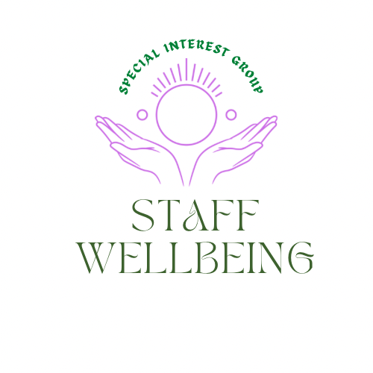

August 2023

Reflections

Each session of the Staff wellbeing SIG seeks to build on previous conversations. To catch up on these, please visit the document section in the link above where previous flash reports are shared.
We have been using the liberating structure Wicked questions to explore the compassion paradox.
‘’ How do we offer compassion and care to enable us to ease the suffering of others and simultaneously nurture the wellbeing of staff to remain compassionate in the face of continued exposure to others suffering?’’
One of the themes emerging is around how we disrupt the behaviors which can lead to toxic productivity. The guest speaker for today’s session, Suzanne Turner (Queen’s Nurse) was on the impact of incivility in the workplace. Suzanne’s slides will be available in the document section of the staff wellbeing SIG and shared with those who registered.
Self-care
A priority shared by members is having a toolkit to draw on to share and use ourselves to help reduce the risk of compassion fatigue and burn out. This session started with a short breathing exercise to help bring us into the moment.

It matters when we are often rushing from one thing to the next, we take a moment to pause, let the tension drop from our shoulders and just breath,

An exercise on learning to hit the paise button can be downloaded Here

Creating a culture where everyone feels valued.

The session started by inviting those who attended to share some behaviour, or action they would demonstrate to help create a culture where everyone feels valued. The suggestions were as follows.

- 'I’d say great idea, let's do it.'
- I would make sure I tell them they are appreciated whether it’s a good day or not.
- I would make sure I sought their opinion.
- I feel it is important to be present when speaking to colleagues, sometimes we might speak to someone whilst emailing or other duties and that might feel that we don't value that conversation/individual.
- I would actively listen.
- I would try to be truly present and listen to understand someone I wanted to feel valued.
- I would thank them for a particular piece of work, telling them how it impacted me.
- For me it's about making time, being present and being thankful for them and what they do.
- Give a specific compliment about a piece of work they've done and acknowledge their effort.
- I like to tell people when they've made a difference to my day and say thank you.
- Let people know they are doing a great job, thank them and tell them they are making a difference.
- To be honest, actually seeing someone act on something I’ve said is key.
- Don't just send them an email. Make the effort to go and talk to them in person or give them a call and ask them how they are.
- Since COVID I have been trying to see people face to face rather than in teams, even just to say hello and spend a minute or two passing the time of day.
- Being present and making people feel valued.

Civility saves lives presentation.

This website may be of interest Link The video link on the site When rudeness in teams turns deadly is very powerful and worth watching to emphasize why civility matters.

Suzanne’s slides will be available in the document section of the staff wellbeing SIG and shared with those who registered.

Comments from the chat

- New book by David Naylor which includes good discussion around incivility: 'Speaking up in a culture of silence - changing the organization activity from bullying and incivility to one of listening and productivity’.
- Classic old book on the spread of process, of technique - and the downsides of it - by Jaques Ellul. It's called The Technological Society.
- Information on speak up guardians Link
- I find it quite interesting (and sad) that we need evidence to show why incivility matters and evidence to highlight the importance of being kind and a good person and the financial consequences if you are a bad person. It’s also amazing that it’s only recently that incivility has had any research done on it and that it is seen as a new concept (or as a concept at all). It says a lot about the financial, mechanical, and transactionally (non or inhuman) driven world we are in that this is only becoming a 'thing' and that it requires evidence and to be called a 'concept' for people to take notice of it and want to do something about it. We should be asking ourselves why we have created a world and systems, processes, teams, and organizations like this.

- Interesting to think about how incivility manifests in the virtual meeting space (e.g., multitasking during the meeting). I suspect there's more of a passive-aggressive aspect, compared to face-to-face settings.
- I suspect that most training we're offered is informational, or skills-based, but if we want to see growth in our self-awareness, in our ability to challenge others, something much more transformation is needed. This is possible, but rare....
- How do we reward civility (rather than being punitive for being uncivil)? There is often no 'reward' in the system for being a nice person. All the incentives in the system are based around KPI's and performance measures. People don't get promoted or recognized by any core metrics for being kind. What if the number 1 competency for promotion etc. was kindness
- I have been part of an interview panel where one of the candidates was described by other panel members as 'too nice'!!
- Transformational techniques for developing self-awareness. I have found coaching so helpful but complemented by yoga and meditation. Without these techniques I wouldn't be able to cope in the current workplace. There are other techniques of course but these are what I use, and they require lots of practice/commitment.
- I think things like coaching and meditation have indeed been found to support inner psychological growth towards more self-awareness, and also inner strength.

Appreciation
We are grateful to Suzanne for offering us this session, here are some of the comments people shared in the chat box:

Thank you for a thought-provoking session.
Thanks Suzanne, this was very informative.
Thank you, Suzanne!
Thanks for a really interesting session!

Useful links
Series on resilience and wellbeing (in September) For more information visit Link

New Community of Practice being established for Joy in Work More information For more information on the Joy in Work SIG Here We are also delighted to have Julia come and speak to the staff wellbeing group 3rd October 12-12.50pm ‘Joy at work, why it’s important and how to get started; Register

New suite of resources for nurturing our networks and ourselves as network leaders
Link

If you are not a member of Q and would like to learn more then please visit Link

If you would like to find out more about how to join the Q community, please visit Link

If you would like to find out more about the staff wellbeing special interest group please visit Link

Remember and check in with your personal battery regularly: 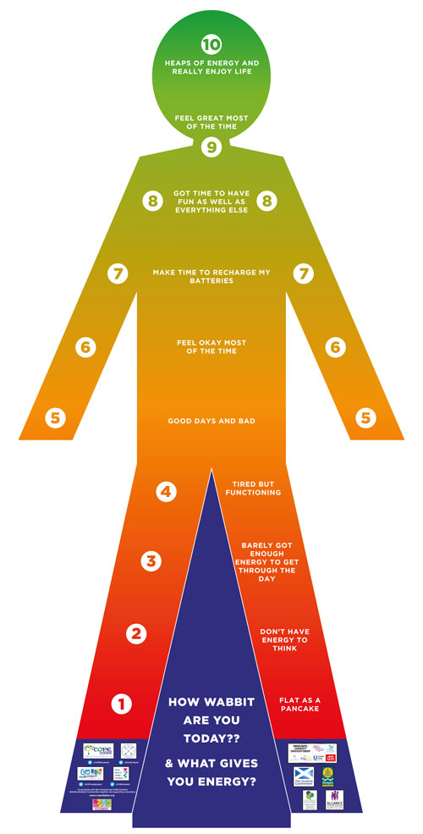

Staff wellbeing sessions coming up includes:

5th September 12-12.50pm where we have a guest speaker coming to talk about

‘’Being present and the Three Principles of the Mind.’’
Register

7th September 2023 12-1pm

Liberating structure ‘Heard. Seen respected’ To register. Link

Our People, Our Planet. 25th-29th September
Climate action without despair Link.
For the full line up of events Link
3rd October 12-12.50pm where we have a guest speaker coming to talk about
‘Joy at work, why it’s important and how to get started; Register

14th November 2023 12pm-12.50pm

‘’Nourishing Wellbeing in the Nursing Community: How Capacitar practices empower nurses and those in their care to manage their energy resources and their emotions’’
Register

Please remember to look after you and monitor your energy levels as your wellbeing does matter too.
Hilda Campbell
Convenor Staff wellbeing SIG
Feel free to direct message via Q or hilda@cope-scotland.org
More ideas on wellbeing and self-care at www.copes-cotland.org and follow on @COPEScotland for posts on wellbeing ideas and resources.

