Disrupting the behaviour which can lead to toxic productivity.

August 2023

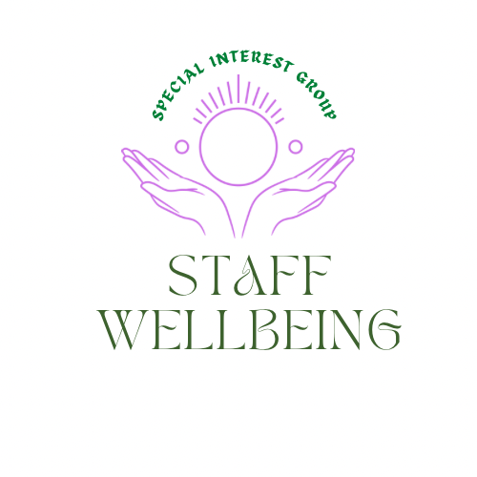

Reflections

Each session of the Staff wellbeing SIG seeks to build on previous conversations. To catch up on these, please visit the document section in the link above where previous flash reports are shared.
We have been using the liberating structure Wicked questions to explore the compassion paradox.
‘’ How do we offer compassion and care to enable us to ease the suffering of others and simultaneously nurture the wellbeing of staff to remain compassionate in the face of continued exposure to others suffering?’’
One of the themes emerging is around how we disrupt the behaviors which can lead to toxic productivity. The session we held in July sought to explore this further. The session we held in August was built on the conversations we started in July.
Self-care
A priority shared by members is having a toolkit to draw on to share and use ourselves to help reduce the risk of compassion fatigue and burn out. This session started with a short breathing exercise to help bring us into the moment.

It matters when we are often rushing from one thing to the next, we take a moment to pause, let the tension drop from our shoulders and just breath,

An exercise on learning to hit the paise button can be downloaded Here

Even taking time to look at a picture which creates a feeling of calmness or listening to a piece of music. Find what works for you and practice it until it becomes part of your daily routine. You do matter.
Model taking this moment to pause when meeting or working with others e.g. How do you start your meetings? We are all human, none of us, regardless of the roles we have, are machines.

Previously we connected to share ideas using Jamboards and TRIZ

For more information on the liberating structure TRIZ Link

The themes which emerged as areas where it would be helpful to disrupt behaviours to lead to a healthier working environment included:
- How we use email. The tips on this piece may be of interest Making emails work for you
- How we organise and reschedule meetings
- Leading by example
- Creating space to reflect on workloads and actions where possible to reduce unnecessary pressures.
- Ensuring staff feel valued.
- Adopting a flexible approach which is outcomes focused.
- Boundaries around time when working and our time away from work.
- Breaks during working time and space to nurture relationships.

This session used the ideas of the liberating structures 15% solutions to consider the things in our control, where we can makes changes.

Wisdom in the zoom

We have heard the importance of feeling valued for staff morale and wellbeing. This piece written by Investors in People may be of interest Link For the purposes of today’s session we considered the 15% solutions within our direct control which may help us value others more, as well as promoting behaviors where we also value our own wellbeing and health.

Individual reflections

Those who attended took 5 minutes to reflect on their ideas for 15% solutions which could lead to a healthier workspace. This included:
- Celebrate achievement.
- Involve people in decisions.
- Be honest even when the message is a challenging one.
- Reach out to individuals who may be struggling.
- Make time to connect one to one. Recognize someone as a person not only the label they carry at work.
- Model the behaviour which supports a healthy working environment.
- Recognize if you work part time you cannot deliver the same output as someone who works full time. This applies also when you work full-time but on multiple projects. You cannot invest in full-time hours for each project unless you use your own time. If you do this, when do you have time to recharge and spend time with friends, family, hobbies?
- Acknowledge we have a personal life as well as work life. Being able to share things that are different now, many of us work from home can also help reduce stress.
- Better role modelling and being visible in taking uninterrupted breaks, especially when in a leadership role.
- Be mindful of the time when you send emails.
- Create space for people to talk online and in the office. Don’t feel guilty using outdoor spaces which are a pleasure to meet in. Joy in work matters.
- Be curious and listen to others as we all have views and opinions. Create spaces to be heard and listened to.

- In the delegation of tasks and picking up new work, consider what else you have on. Value your own and other people’s time to explore what is realistic. Recognizing to start something new, something else may need to stop.
- When there is a need for a conversation which may be uncomfortable seek where possible to have this face to face. Where this is not possible, create as psychologically safe a space as possible.
- How we offer supervision matters and how we value the restorative side of supervision and making time for supervision. Use outdoor spaces. Where possible, face to face time.
- In group supervision acknowledge people’s feelings in a meaningful way.
- Take time to understand what people want from situations around new responsibilities and accountability.
- Recognizing the world of work has changed for many who no longer work 9-5 but may work 2-10 and all variations in between. However, others may still work 9-5 so find meeting times and times to send emails which work best in the networks you are involved in. Perhaps even agreeing to a time when emails will be checked and responded to. That would help manage expectations and communication for those who only have email to connect Equally agree meeting times work best for all concerned.

Ideas for change
Having shared personal reflections, the group explored these ideas further. The following themes emerged as actions those attending were going to consider adopting and sharing:
Being a role model to others of adopting healthy and productive patterns of behaviour at work and being seen to model this behaviour.

Reflect on working hours and putting laptops on in the evening. which may mean missing time with friends, family or for hobbies. Find a balance.
If you can see on your system that someone else you work with is online and it is after working hours, perhaps be kind and remind them to look after themselves. This is a reminder to look after yourself too.

If you really do need to work late for some reason, then work offline as others seeing colleagues working may make them feel they need to be working also.

Schedule time to manage emails.

Don’t feel guilty doing something that is fun.
.
Take stretch breaks and encourage these in online meetings.

Take eye breaks when you look away from the screen.

Set up your phone/computer to remind you to take stretch breaks/eye breaks until this becomes routine.

This piece may be of interest around the importance of taking breaks at work, especially when remote working Here

Useful links
Series on resilience and wellbeing (in September) For more information visit Link

New Community of Practice being established for Joy in Work More information For more information on the Joy in Work SIG Here We are also delighted to have Julia come and speak to the staff wellbeing group 3rd October 12-12.50pm ‘Joy at work, why its important and how to get started; Register

New suite of resources for nurturing our networks and ourselves as network leaders
Link

If you are not a member of Q and would like to learn more then please visit Link

If you would like to find out more about how to join the Q community, please visit Link

If you would like to find out more about the staff wellbeing special interest group please visit Link

Staff wellbeing sessions coming up includes:

23rd August 1-2pm where we have a guest speaker coming to talk about
‘’Exploring the impact of incivility on staff wellbeing, patient care, and safety.’’ Link

Pre reading which may be of interest Civility saves lives

5th September 12-12.50pm where we have a guest speaker coming to talk about

‘’Being present and the Three Principles of the Mind’’
Register

7th September 2023 12-1pm

Liberating structure ‘Heard. Seen respected’ To register. Link

3rd October 12-12.50pm where we have a guest speaker coming to talk about
‘Joy at work, why it’s important and how to get started; Register

14th November 2023 12pm-12.50pm

‘’Nourishing Wellbeing in the Nursing Community: How Capacitar practices empower nurses and those in their care to manage their energy resources and their emotions’’
Register

Please remember to look after you and monitor your energy levels as your wellbeing does matter too.
Hilda Campbell
Convenor Staff wellbeing SIG
Feel free to direct message via Q or hilda@cope-scotland.org
More ideas on wellbeing and self-care at www.copes-cotland.org and follow on @COPEScotland for posts on wellbeing ideas and resources.

