10/30/2022
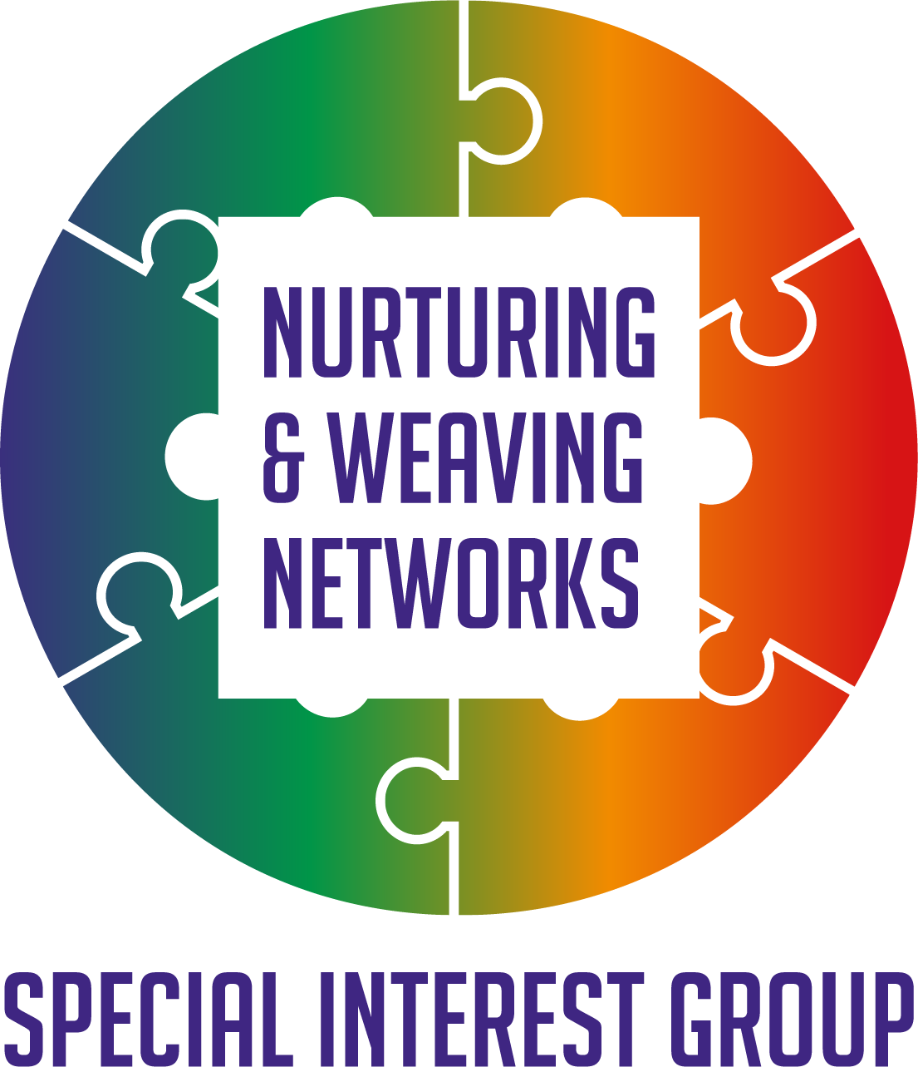
Hilda Campbell
WWW.COPE-SCOTLAND.ORG. COPE Scotland Established 1991 Registered Charity Number SC022807
Brief Introduction to Network Weaving Workshop
Notes for presentation

Introduction

Following a learning opportunity within the Q community on Network Weaving there was an interest from those who had attended in how we could share the ideas and tools more widely.
This website offers the link to the Network Weavers handbook as well as an opportunity to sign up for the newsletter and connect with others interested in Network Weaving. https://networkweaver.com/
It was clear to those not familiar with the term Network Weaving that some introductory workshop to invite curiosity would be helpful. This brief workshop is one response to support that. We are grateful to June Holley and Kristin Johnstad for their support and wisdom. June wrote the Network Weavers Handbook and Kristin was one of the lead trainers in the Network Weaving Learning Series.
Following the Network Weaving Learning series, a Nurturing and Weaving Networks Special Interest Group was established within the Q Community. We welcome guests as well as members of the Q community https://q.health.org.uk/community/groups/nurturing-and-weaving-networks/
We were also delighted to connect with Hexitime https://hexitime.com/ and create space there also for those interested in learning and sharing skills and ideas around Networks and Network Weaving. https://hexitime.com/activity/contribute-to-the-nurturing-and-weaving-networks-special-interest-group

The following offer ideas for those who plan to facilitate this workshop on how to use the slides and should be read along with the session planning notes for the Introductory workshop to Network Weaving. We are happy for these materials to be shared freely; all we ask is if you please mention the original source.

Please read these notes along with PowerPoint presentation on an introduction to Network Weaving.
The aim of this FREE resource is to create interest, curiosity, and awareness of the idea of Network Weaving and the importance of nurturing ourselves and our Networks in the hope it inspires people to go on to learn more and to share that learning with others. The resource can be used many ways; as a learning aid for someone involved in a Network, an established Network seeking to see if there is anything which may be helpful for them. A Network just setting up and looking for ideas which may help make the group a success.
The workshop materials can also be used directly face to face as well as online.

Opening slide (one)

There is an opening slide to display when the group begins and people arrive, or settle down to watch online, they can see what the session is going to be about and provides the link to the source of the Network Weavers Handbook written by June Holley networkweaver.com Before delivering any awareness raising session on Network Weaving please visit this site and familiarise yourself with its contents and the Network Weavers Handbook. You do not need to read it cover to cover, simply connect with it as a resource so you have a sense of what it is when you are referring to it.

Introduction Slide two

This provides participants with an overview of the session. The slide show ends with a contact from the Nurturing and Weaving Networks special interest group in the Q community however, you may also want to share details of more local contacts, please feel free to amend that slide to add local contact details.

Slide three
Invite people to take a couple of moments to bring their attention to the moment. The aim of this is to promote self-care as well as acknowledging that people have many priorities and that we cannot do everything at once, only many things, one thing at a time. The one thing people are invited to bring their focus to at the present is the workshop. There are many ideas and resources online which you can use, pick something which you feel comfortable to share, it could be talking through a breathing exercise or showing a video. Visit www.cope-scotland.org for some ideas you may find of interest.
You may choose to introduce this by saying
‘’Most of us have a lot going on which can be distracting. For the next few minutes, we are going to bring our attention to the now. While we take a moment to pause, there is nothing else to do, and nothing else to think about’’
This activity can also be helpful for creating a safe space where people feel nurtured and may be more likely to share and connect. It is worth sharing with people that for all throughout the session there will be opportunities to share views, people only need to do that if they want to. If they do not want to share openly this is fine, but you would suggest reflecting on the answers privately may also have value in becoming more aware of our Networks and the idea of Network Weaving.

Slide four

It is important that people are offered an opportunity to share their thinking and learn from each other if they want. The next slide offers a series of questions phrased as ‘we invite you to complete the following sentence’ in the chat box. Bring one question forward at a time and offer space for people to answer. Acknowledge the comments made in the chat box. If doing this face to face, invite comments from participants. This slide offers participants a chance to reflect on what they view Network Weaving to be. People can choose not to participate; they only share their views if they feel safe to do so, however, even if people choose not to share, there is value in private reflection.

Slide five

Having invited people to share their thoughts use the next slide to reflect back some ideas around, networks, meetings, forums, and introducing more around the concept of Network Weaving

Slide six

We are motivated to learn most when that learning has meaning for us and our lives. The next series of questions people are invited to reflect on, and answer relates to why we connect with others. The aim being to support a space where people can invest some time in reflective practice around the reasons why we connect with others. Remind people again, they do not need to share their responses however, there is value in using this for private reflection. To encourage people to feel safe to share, we can create that safer space by saying when we share, we learn more about each other and what we may have in common as well as be curious about differences. Perhaps use this as an opportunity to share the idea that diversity of opinion offers a richness to our learning as well as our Networks. It invites us to look at situations with a different perspective. We may not always agree, but when we are respectful to ourselves and others in sharing opinions we can agree to disagree; while looking for areas of commonality where a joint action can achieve more than we ever can alone.

Slide seven

Read the slide and the points made on it, feel free to elaborate. The aim of this slide is to invite people to consider that sometime even with the best of intentions our networking and collaborative efforts do not go to plan. The aim being to create a curiosity around whether there are ideas and resources which may help joint endeavours be more effective, which then helps lead us to sharing the ideas around Network Weaving as one source of inspiration for those seeking ideas for improvement.

Slide eight
It is important to recognise that not every network member needs to agree on every point for action. This slide shows two ‘Jigsaw lids’ a concept shared by COPE Scotland https://www.cope-scotland.org/wellbeing-tips/entry/finding-common-priorities-matter which enables different stakeholder groups to identify their priorities and then using the visual tool of the ‘lid’ seek areas of commonality which they can agree on as points of action moving forwards. It is advised before delivering the workshop to visit the link above to be familiar with the background to Jigsaw lids.

Slide nine

Building effective networks can take time. This slide is to emphasise that Networking isn’t mechanistic we do A, B, and get C, we may do A, B and get Q, however time spent building Networks is important and Network Weaving offers us some ideas to help us move towards those more effective networks we do want to experience. Read what is on the slide but feel free to add elements which make it your own.

Slide ten

Power and power differentials exist, the aim of this slide is to name that, while promoting the value of Networks and Network weavers to help address the power imbalance.

Slide eleven

People have been listening for a while now and been presented with a lot of information they may want to comment on. Invite people in the chat box, or if face to face directly, to share their view on Network Weaving from what they have heard so far. Reminding people only to share if they feel safe to do so, while also reminding people the value of sharing is that we learn from each other.

Slide twelve and thirteen

Read these two slides as a way to begin to encourage more curiosity around Network Weaving and the ideas, tools, and resources which they may find of value in their improvement work, in whatever form that may take. Network weaving can be applied within many settings and interest groups.

Slide fourteen

It is helpful to remind people of the value of Networks, the example on this slide takes its inspiration from nature. Read what is on the slide.

Slide fifteen

It is important people recognise as individuals they can make a difference. It is also worth reminding people that sometimes we may need space to reflect on what our contribution may be. The tool shared in this slide is available on www.cope-scotland.org It would be helpful for you to read this and be familiar with it before delivery. You may also want to share with people the various roles of Network Weavers which can be found in the Network Weavers Handbook June Holley 2011

Slide sixteen

This is an invitation for people to openly share any of their experiences of Networking including stories to inspire others, this can be done by taking questions from participants in a face-to-face session or inviting people to come off mic if online.

Slide seventeen

It is helpful for participants to reflect on any learning/awareness raising opportunity, its also helpful for the facilitator to capture what went well and what may change for the next time this is delivered. The sentence completion suggested in this slide is one way of doing this, you may have other evaluation/feedback methods of your own. A tip can be keep it simple. People may be rushing away so something. A simple tool which captures their impression in itself can be helpful. It is not possible to measure impact from a one-hour workshop, only whether the aim was met ………. Did people become more curious about Network Weaving as a result of attending?

Slide eighteen

Share there is a Nurturing and Weaving special interest group in the Q community and Hexitime community if people want to get involved

Slide nineteen and twenty

Offer further reading for those who have attended if of interest. You can add to this further as these are only some of the many resources available.

Slide twenty-one

Thank people for coming and share the origins of the workshop, add any other contact details you think are relevant to this slide.
Thank you for helping create more curiosity around Network Weaving

