Better Local Care Hampshire Multispecialty Community Provider Vanguard

Deep Dive Evaluation Report: Integrated Pharmacy

May 2017

Table of Contents
1 Executive Summary 3
1.1 Findings 3
1.2 Methodology 5
1.3 Limitations 5
1.4 Recommendations 5
2 Introduction and Background 7
3 Context, Need and Objectives 8
3.1 Context 8
3.2 Local Issues and Rationale 9
3.3 Objectives 9
4 Model and Activity to Date 11
4.1 The Integrated Pharmacy Model 11
4.2 Activity to Date 12
4.3 Additional Resources Provided 15
4.4 Further Planned Developments 17
4.5 Successes, Challenges and Learning 17
5 Ouputs and Outcomes 19
5.1 Patient Outcomes 19
5.2 Staff Outcomes 22
6 Value for Money, Budget and Projected Spending 26
6.1 Budget 26
6.2 Spend 26
6.3 Initial Cost Savings Estimates vs Actual 27
7 Conclusions and Recommendations 29
7.1 Strategic Fit 29
7.2 Emerging Findings 29
7.3 Funding and Sustainability 31
7.4 Recommendations 31
Appendices
Appendix 1 – integrated pharmacy staff survey
Appendix 2 – Integrated Pharmacy Patient Survey

Executive Summary
The Integrated Pharmacy Project began in September 2016 in South West New Forest as a pilot site for Southern Health’s ‘Better Local Care’ vanguard.
The Integrated Pharmacy project aims to supplement and complement the current pharmacy services, to develop a fully integrated service, embedded in primary care, across the South West New Forest Area.
The integrated pharmacy services aimed to deliver on the following outcomes:
- Number of patients at risk of falls who had a ‘culprit drugs’ de-prescribed;
- Increased de-prescribing of problematic polypharmacy using the STOPIT Tool and / or STOPP START criteria (Baseline: number of problematic polypharmacy medicines stopped (de-prescribed);
- Increased number of pharmacy led medication reviews performed;
- Reduction in prescription items ordered through rationalization of repeat prescribing processes and systems in Practices, care homes and community pharmacies;
- Improved patient satisfaction; and
- Delivery of financial savings of £856,743 and improved budgetary control across the South West New Forest.
The budget for delivering the Integrated Pharmacy pilot was £245,096.

Findings
Integrated Pharmacy has been rolled out across 7 practices covering the New Milton and Lymington area since September/October 2016. The project is staffed by New Medicines Optimisation Pharmacists 8a (3.3 WTE) and new Medicines optimisation technicians 5 (0.5 WTE).
The services provided by the project include:
- Practice based medication reviews;
- Domiciliary Care Visits;
- Care home visits;
- Clinical appointments;
- Telephone consultations;
- Supporting patient integration with hospital care; and
- Supporting patient integration with community pharmacists.
The lack of maturity of the project makes the establishment of outcomes and impacts challenging however the levels of activity across the various activities is encouraging and provides a positive view of the work undertaken by the team. As of March 2017:
- Over 4,000 patient queries had been dealt with by members of the integrated pharmacy team. Of those:
- 2111 (50.5%) patients had a Practice Based Medication Review carried out;
- 688 (16.5%) patients were supported by the integrated pharmacy team to integrate their care with the hospital
- 277 (6.6%) patients had a telephone consultation with the integrated pharmacy team;
- 243 (5.8%) patients were supported by the integrated pharmacy team to integrated their care with the community pharmacy team;
- 118 (2.8%) of patients had a care home visit undertaken by the integrated pharmacy team; and
- 44 (1.1%) of patients had a domicilary care visit undertaken by the integrated pharmacy team.
Having interacted with 4,179 patients in total since September 2016, the BLC cost per patient is currently calculated at £58.65. When considering the wider cost savings generated by the integrated pharmacy project early evidence indicates that across the 7 SWNF practices £32,072 less has been spent on FP10 during the period October 2016 – January 2017. This is compared to the same time period in the previous year.
Comparing this with the 43 non-vanguard practices in the same time period (i.e. October 2016 – January 2017) they have collectively spent £19,296 more on FP10. The estimated net impact of the Integrated Pharmacy project is a saving of approximately £7,500 per practice in other prescribing savings.
12 staff responded to the integrated pharmacy staff survey. Some of the key findings from this include:
- 16.6% (n=1, base=6) of those surveyed reported that involvement in the project had encouraged them to become independent prescribers;
- 66.6% (n=4, base=6) of staff are involved in assessment of patients within the GP for medication optimisation.
- 83.3% (n=5, base=6) of respondents also believe that the project has improved the management of patients requiring polypharmacy care.
- 66.6% (n=4, base=6) of respondents believe that the project allows for more efficient use of resources.
- 33.3% (n=2, base=6) of respondents believe patient information is being shared more accurately and that since project inception.
- 83.3% (n=5, base=6) believe that the project will also free up GP time. All respondents believe that the project was implemented well and that the pharmacy team worked well alongside the GP.
- 66.6% (n=4, base=6) of the respondents believe that the project was good value for money.
10 patients provided feedback using the patient survey. Some of the key findings from this include:
- All participants (n=10, base=10) believe that the medical review they received was useful.
- 80% (n=8) either agree or strongly agree that the service has provided relevant information to self-manage health.
- 80% (n=8) of respondents believe that the service improves hospital discharge.
- 80% (n=8) believe that they do not need to see the GP as much since the project was introduced.
- 80% (n=8) of respondents believe their health problems are being dealt with faster since being introduced to the project.
- 80% (n=8) also believe that the service is tailored for their needs, and that the service is a valuable addition to the NHS.
- 80% (n=8) believe that staff were understanding and knowledgeable of their condition.
- 80% (n=8) of respondents also believe that they receive appropriate treatment in good time within the Integrated Pharmacy service.
- 80% (n=8) also believe that they are less frustrated waiting for GP appointments as a result of the service.

Methodology
Our methodology used a mixed method approach and the main strands are detailed below:
- Desk Based Research: focused upon the data and information collected by the project team. This included but was not limited to financial reports, progress reports, databases on activities e.g. number of participants, attendance at each session etc. and information outputs and outcomes.
- 2x in depth interviews with managers (Project Manager and Pharmacy Lead): we conducted in-depth interviews with the managers responsible for the implementation and delivery of the programme
- Survey of staff involved (x12 responses): staff involved in the project received a survey which they completed and returned to the project manager.
- Survey of patients involved (x10 responses): the pharmacists involved supported the collection of information from the patients benefitting from the service.

Limitations
At the outset there are a number of limitations in relation to this report which are highlighted below:
- The programme has only been active for 6 months and therefore the data in relation to outcomes and impacts, which is often longer term, is limited;
- Integrated pharmacy staff gathered patient feedback directly. Whilst this is a perfectly acceptable approach given the profile of patients involved, and logistics of capturing data, caution should be exercised in the interpretation of the results given the potential risk of positive bias.
- Robust cost-savings analysis was hindered by a lack of clarity in relation to the cost saving calculations carried out by the integrated pharmacy project team. This report makes reference to these calculations however they should be treated with caution given the potential risk of positive bias.

Recommendations
Recommendations for the Integrated Pharmacy Project include:
- Recommendation 1: Provide clear guidance on remit, roles and expectations – there is a need to be clear with the staff involved about the remit and role of the new pharmacist, particularly the interactions between the pharmacist and GPs, and the levels of expectation to ensure that there is sufficient time for the project to become embedded in the practice;
- Recommendation 2: Clearly defining the limitations of the Pharmacist – it should be recognised and reiterated that the pharmacists are not GPS and therefore do not have the skills or training provided across all areas of practice work. They do have a particular skillset which can help patients with their medicines and help GPs to free up some of their time;
- Recommendation 3: Treat activity monitoring, patient feedback and other evidence gathering with high priority so that more robust data is available to evidence progress against KPIs in future.
- Recommendation 4: To continue to share the learning and provide a forum for feedback – it is recognised that sharing what works between practices is helpful to address issues related to visibility and effectiveness. A continued forum for shared learning should be provided. In addition, the Medicines Optimisation Group provides a forum to discuss and share what pharmacists and technicians are doing. This is useful and should continue so that there is a forum for feedback.

Introduction and Background
RSM PACEC were appointed to by the Southern Health NHS Foundation Trust on behalf of the Hampshire MCP Vanguard to complete an evaluation of the NHS Vanguard Pilot to implement a new care model with GPs called a multi-specialty Community Provider (MCP), known locally as Better Local Care.
Better Local Care multispecialty community provider vanguard, will support people in taking a more active role in managing their own care and will offer access to improved care where needed.
The aim of Better Local Care is:
To improve the health, well-being and independence of people living in our natural communities of care, making Hampshire an even greater place for all our residents to live.
Better Local Care has four key themes:
- Improving access to care: So it’s easier for people to get a same-day or urgent appointment at their GP surgery, and so people with complex health problems get more input from their GP.
- Joining up the professionals that support the same people: So doctors, nurses, social and voluntary sector workers and volunteers are part of the same extended team, making care more straightforward (especially for people with complex needs).
- Bringing specialist care nearer to you: So patients can see the professional they need, sooner: For example physiotherapists and mental health workers in local GP surgeries.
- Concentrating on prevention: to support people earlier, and help them make the right choices about their health and wellbeing, to stay independent and reduce the need to go to hospital.
The BLC vanguard is a partnership of GPs, NHS providers and commissioners, Hampshire County Council, local councils of voluntary services, a number of local community, voluntary and charity organisations.
This report is one of a series of Deep Dive Evaluation Reports which aim to evaluate some of the projects supported under Better Local Care to explore the outputs, outcomes and impacts, the successes and challenges and importantly the learning which can be used to improve the projects in the future. This Deep Dive Evaluation report focuses on the Integrated Pharmacy Project.
The pilot begin in September 2016 and is run by Medicines Optimisation Pharmacists Medicines optimisation technicians in seven practices in the South West New Forest area.

Context, Need and Objectives

Context
The NHS Five Year Forward View set out details of new models of care to proactively target services at registered patients with complex ongoing needs such as those with chronic conditions or the frail, offering greater convenience for patients and making full use of new skills and roles.
The Better Local Care Vanguard aims to redesign the workforce to deliver their proposed care model and address the recruitment and retention challenges facing health services whilst targeting frail and vulnerable patients.
Workload for GPs and staff is the largest issue of concern for the NHS. There is increasing pressure on the general practice workload and capacity. The General Practice Forward View Pharmacists identifies pharmacists to be one of the most underutilised professional resources in the system and must take into account the skills they have to offer in general practice. It notes that the weakness in the system is “its failure to develop consistent systems that free up time and resources to devote to improving care for patient”. The GP Forward View sets out to add a further 1500 pharmacists to general practice by 2020 in order to build a wider workforce, join up pathways between different professional groups and enable every practice to access a clinical pharmacist. GPs are in low supply whilst there is an oversupply of pharmacists.
The NHS Business Plan 2016/2017 has set out a clear visions to transforming care and closing the care and quality gap. The plan identifies the pressure of patient satisfaction and aims to strengthen primary care services to expand the work force and make the most of clinical pharmacists. The business plan aims to recruit an additional 5000 clinical and non-clinical staff (including pharmacists) to work in GP surgeries.
There is significant evidence that demonstrates the benefits to ‘medicines optimisation’ or integrating pharmacy. Black and Glaves (2011) state that pharmacy interventions have a number of positive outcomes including; effective optimisation of medicines use for patients, a reduction in the number of potentially inappropriate medicines that patients are prescribed and possibility of significant savings. They recommend Integrated strategies between acute to primary/community care and social services for transformational change in relation to medicines optimisation. The NHS alliance and Royal Pharmaceutical Society (2014) reported the rising demand in primary care and solutions to overcome this is to have pharmacists’ playing a key role in helping GP practices and primary care providers. The report noted that there are a significant number of qualified pharmacists available and pharmacists working in GP practices already, have helped significantly in improving care provision and work patterns. An average GP is said to authorise 200 repeat prescriptions per week, NICE described a scheme within Walsall CCG which demonstrated that a pharmacist-led strategy increased the quality of prescribing, reduced waste and saved GP time.
Hampshire Sustainability and Transformation Plan, aims to tackle their financial gap through an integrated primary care workforce with a greater range of healthcare professionals including pharmacists, who are equipped with the skills and experience.

Local Issues and Rationale
As patients age and become frail, preventative treatments may not be as useful. GPs identify when it is appropriate to stop treatments and start prescribing. The South West New Forest and Avon Valley locality, as part of the West Hampshire CCG, have one of the highest patient percentages with long standing health conditions in Hampshire. There is a high demand from patients, with 57.8% of the patient population within SWNF and Avon Valley suffering from long-term conditions, which is over 4% higher than the England average of 53.2%. The number of people aged over 65 is 33,398, accounting for approximately 31% of the local population. This is a significantly large older population profile and almost double the patient national average of 17.1%. The older population tend to have higher needs for health care utilisation, 5.1% of the population are aged over 85 in the area, this is over double the national figure of 2.3%. The ageing population and increasingly frail drives the spread of integrated teams and pharmacists in primary care.
The vanguard practices involved in the service prescribed a total of 1,597,278 items at a cost of £13,076,847 from January 2015 to January 2016. The use of medicines optimisation has been evidenced to reduce costs.
The General Practice Forward View identifies workload pressure as the defining issue facing practitioners in coming years. One of the five themes in the document aims to ‘reduce practice burdens and help release time’, promising to ‘make better use of the wider workforce’, co-ordinating with nurse practitioners, community pharmacists and other specialists. The Forward View additionally notes that GPs find it increasingly difficult to offer timely appointments and often struggle to provide enough time for patients with complex needs. A pharmacist included in a team has potential to relieve pressure in general practice and help both patients and the over-stretched workforce. The opportunity to integrate pharmacists into general practice is seen as a way to resolve day-to-day medicine issue and provide advice on medicines.

Objectives
Locality level priorities are outlined below. These desired priorities focus on outcomes for supporting staff and creating financial sustainability but mostly enhancing patient care. The three priorities are appropriately matched to national outcomes and metrics provided by NHS Public Outcomes Framework.
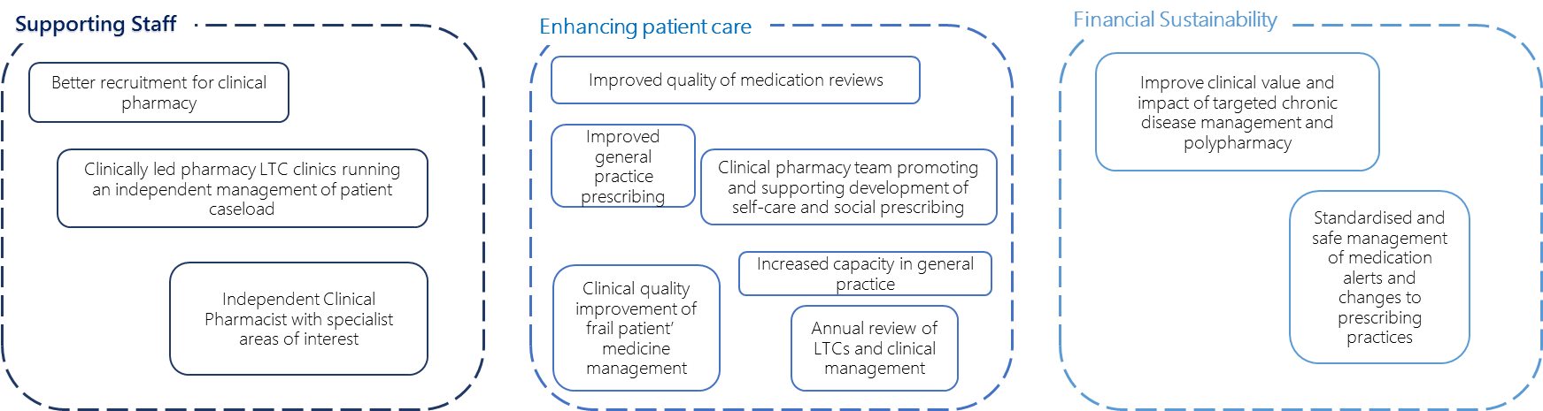
Figure 3.1: Locality Priorities
Source: Integrated Pharmacy Bid Document – June 2016
Context, Need and Objectives in Summary
- There is significant evidence that demonstrates the benefits to ‘medicines optimisation’ or integrating pharmacy. Black and Glaves (2011) state that pharmacy interventions have a number of positive outcomes including; effective optimisation of medicines use for patients, a reduction in the number of potentially inappropriate medicines that patients are prescribed and possibility of significant savings.
- The South West New Forest and Avon Valley locality, as part of the West Hampshire CCG, have one of the highest patient percentages with long standing health conditions in Hampshire. There is a high demand from patients, with 57.8% of the patient population within SWNF and Avon Valley suffering from long-term conditions, which is over 4% higher than the England average of 53.2%
- The vanguard practices involved in the service prescribed a total of 1,597,278 items at a cost of £13,076,847 from January 2015 to January 2016. The use of medicines optimisation has been evidenced to reduce costs.
- These desired priorities focus on outcomes for supporting staff and creating financial sustainability but mostly enhancing patient care. The three priorities are appropriately matched to national outcomes and metrics provided by NHS Public Outcomes Framework.

Model and Activity to Date
Three practices went live on 19 September with a staggered start for the others across September and October. The last practice started on 31 October.
During November and December further training and development was provided on a weekly basis jointly between WHCCG, Southern Health and a bespoke Centre for Pharmacy Postgraduate Education (CPPE) study day. The further training and development included:
- Consultation Skills delivered by Centre for Postgraduate Pharmacy Education (CPPE);
- Frailty, Parkinson’s disease, cognition, OPMH, history taking, agreed physical assessments (BP, pulse, temperature, BGTs ) by Southern Health clinical tutors and community specialists (in the absence of available GP trainers)
- Working with care homes by WHCCG MOT (lead pharmacist and senior technician)
- Patient-orientated medication reviews by Consultant Pharmacist for Elderly Care (Guy’s and Lewisham CCG)
Future developments planned include:
- More clinic and patient facing work: e.g. working with New Milton and Chawton House and their shared pharmacist to provide a clinic to help optimise anticoagulants and asthma treatments and to further develop Care Home work. Lyndhurst Surgery is setting up medication review clinic (4 patients booked in already).
- More patient-orientated medication reviews, seeing patients to include their goals of treatment rather than paper-based reviews.
- More working with Nursing Homes on reviews and rationalising ordering of medicines.
- Better integration and working with Community Pharmacies; evening meeting planned for 6 February to improve working together, tackle waste issues, encourage Repeat Dispensing, identify patients for signposting for New Medicines Service support and Medicines Use Reviews.

The Integrated Pharmacy Model
The problem
The problem that underpins the need for the integrated pharmacy project stems from this disjointed nature of pharmacy support in the SWNF area. At present there are three areas of Pharmacy support provided by three different teams (community Pharmacy, CCG Pharmacy and Lymington Hospital). These individual teams are not currently working together fully.
The Integrated Pharmacy project provides an opportunity to integrate these services which it is hoped will improve the services provided for patients.
TARGET: To build a locality pharmacy team alongside GPS, a ‘perfect’ model
Developing the logic model
Programme activity aims to build a locality pharmacy team that supports patient pharmacy for the locality. It also aims to support a patient centred approach to the multi-level management of pharmacy and patient prescribing.
The pharmacy team will have improved links with Community Pharmacist & influence their work to focus on areas of highest clinical value.
The Model
The diagram below depicts the integrated pharmacy model.
Figure 4.1: Integrated Pharmacy Model
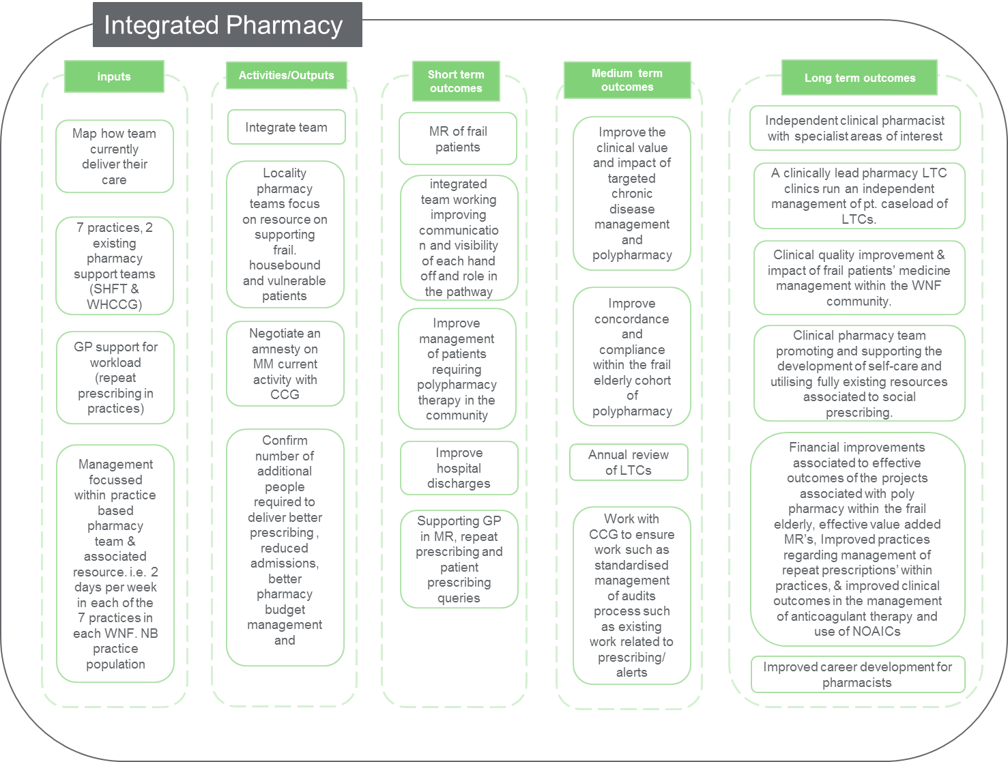
Source: RSM PACEC March 2017

Activity to Date
This section presents monitoring data gathered by the integrated pharmacy team as part of the service.
Key items are drawn from the logic model:
- Number of patients seen;
- Number of practice based medication reviews completed; and
- Number of care home visits.
The lack of maturity of the project makes the establishment of outcomes and impacts challenging however the levels of activity across the various activities is encouraging and provides a positive view of the work undertaken by the team. As of March 2017:
- Over 4,000 patient queries had been dealt with by members of the integrated pharmacy team. Of those:
- 2111 (50.5%) patients had a Practice Based Medication Review carried out;
- 688 (16.5%) patients were supported by the integrated pharmacy team to integrate their care with the hospital
- 277 (6.6%) patients had a telephone consultation with the integrated pharmacy team;
- 243 (5.8%) patients were supported by the integrated pharmacy team to integrated their care with the community pharmacy team;
- 118 (2.8%) of patients had a care home visit undertaken by the integrated pharmacy team; and
- 44 (1.1%) of patients had a domicilary care visit undertaken by the integrated pharmacy team.
The table overleaf provides a detailed breakdown of the activity undertaken by month.

Table: 4.2: Activity October 2016 – March 2017
Date | Query | Practice Based Medication Review with a stop or a change | Practice Based Medication Review - monitoring, alternative, or no action, or preparted for MDT,GP | Domcilliary Visit Undertaken | Care home visit undertaken | Clinic appointment | Telephone consultation | Repeat processes | Integated care with hospital | Integrated care with community pharmacy
Oct 16 | 36 | 20 | 166 | 1 | 2 | 6 | 14 | 30 | 10 | 13
Nov 16 | 62 | 72 | 104 | 2 | 0 | 0 | 26 | 25 | 24 | 31
Dec 16 | 48 | 55 | 87 | 7 | 1 | 1 | 21 | 34 | 13 | 38
Q3 Total | 146 | 147 | 357 | 10 | 3 | 7 | 61 | 89 | 47 | 82
Jan 17 | 65 | 120 | 243 | 9 | 46 | 5 | 35 | 47 | 101 | 28
Feb 17 | 110 | 137 | 477 | 9 | 32 | 13 | 75 | 43 | 239 | 62
Mar 17 | 122 | 137 | 193 | 16 | 37 | 17 | 106 | 34 | 301 | 71
Q4 Total | 297 | 394 | 1213 | 34 | 115 | 35 | 216 | 124 | 641 | 161
Source: Interim Progress Report on the Integrated Clinical Pharmacy Team in the SWNF Vanguard April 2017

The level of activity across the various strands is encouraging and provides a positive view of the work undertaken by the team. Further analysis is required to investigate the specific impact on GP workload, however with increasing care home and nursing home visits as well as visits to housebound patients there is optimism that the service is having an impact on workloads.
In addition, to this there have been other encouraging developments. The Polypharmacy Risk Identifier Tool (PRIT) developed for EMIS Web and SystmOne has been run in all seven practice and has identified 13 patients across 6 of the 7 practices on a diabetes medication with an HbA1c of <42mmol/mol in the previous 12 months requiring treatment review to prevent possible hospital admission as well as patients who may benefit most from a poly pharmacy medication review.

Additional Resources Provided
Integrated Pharmacy is currently rolled out across 7 practices covering the New Milton and Lymington area. The project has plans to expand to Avon Valley through a further 4 practices. The details of the practices involved and the current resources available are detailed in the table below.

Table 4.2: Practice Baseline Information
Practice | List size | Over 75s list size | Over 75s as % of list size | Current practice resource MMP (hrs p/w) | Additional practice resource MMP (hrs p/w) | Current practice resource MMTech (hrs p/w) | Additional practice resource MMTech (hrs p/w) | Total MMP hours per week | Total MMT hours per week
Arnewood Practice | 13,274 | 2,099 | 15.8 | 4.8 | 23.9 | 3.6 | 3.6 | 29 | 7.2
New Milton Health Centre | 9,896 | 1,729 | 17.5 | 3.6 | 17.8 | 2.7 | 2.7 | 21 | 5.4
Barton Surgery | 10,531 | 2,056 | 19.5 | 3.8 | 19.0 | 2.9 | 2.9 | 23 | 5.7
Chawton House Surgery | 6,968 | 1,000 | 14.4 | 2.5 | 12.5 | 1.9 | 1.9 | 15 | 3.8
Lyndhurst Surgery | 5,249 | 694 | 13.2 | 1.9 | 9.5 | 1.4 | 1.4 | 11 | 2.9
New Forest Medical Group | 7,622 | 1,094 | 14.4 | 2.8 | 13.7 | 2.1 | 2.1 | 16 | 4.2
Wistaria and Milford Surgeries | 15,197 | 2,727 | 17.9 | 5.5 | 27.4 | 4.1 | 4.1 | 33 | 8.3
Source: Vanguard Medicines Optimisation Service Proposal

Further Planned Developments
Now that the service is embedded in the seven practices in South West New Forest, there are some important developments planned for the next quarter. These include:
- More clinic and patient facing work in the care homes and home visits for the vulnerable and housebound;
- More work with nursing homes rationalizing ordering of medicines to reduce waste;
- Further review in practices as to the range of activities being undertaken and investigating the impact on GP workload.

Successes, Challenges and Learning
Anecdotal evidence from the consultees has indicated that the programme has been successful. The project has embedded well into the practices involved and is being to see positive outcomes in all target areas including the clinical medical review in high risk patients such as in frailty with multiple long term conditions.
In addition, care home and nursing home residents and those at high risk of admission have seen better outcomes and reduced risk of admission as a result of the intervention.
4 of the 7 GP practices involved attended a programme wide feedback session in March 2017. Some of the successes indicated include:
“The [Integrated Pharmacy Project] has been very helpful – the quality of prescribing has improved and provided a better service for patients. I am sure that this will continue to improve. Our practice is currently reviewing to enhance the pharmacists’ ability to impact on efficiencies and health care delivery which will improve the capacity for GPs by focusing the workload on the most appropriate resource.”
“Our practice has focussed specifically on the priorities agreed at the start (i.e. polypharmacy and medication reviews). The telephone query referrals to the pharmacist may enhance this further. The services has given the patient more confidence and assurance with a home visits”.
“The service has improved the quality and prescribing seen, it has improved relationships and it has also improved communication. We’re delighted”
“The practice is really happy with the project so far. We have enhanced the existing team and empowered them to do more. There was some initial concern regarding what could actually be delivered however now that the changes are working well – feedback from patients and staff are all positive. The services has made deprescibing much easier than expected.”
Patients were also asked about the impact of the project in a separate feedback session. The overall view was positive with all patients who provided feedback satisfied or very satisfied with the face to face appointments, home visits, clinic and telephone consultations. No patients, so far have expressed any dissatisfaction. Some of the key benefits highlighted by patients included:
- Confidence that the pharmacist was knowledgeable; and
- Content that the pharmacist could answer their questions, support their decision making and provide information to help them manage their health or wellbeing.
“I had my first appointment with the practice pharmacist, she was very professional and helpful”
As with all new processes there were also challenges faced in the establishment and development of the project. Some of the main challenges identified included:
- There was a significant amount of learning for all staff involved to undertake. In particular, this related to the new systems and associated training and new meetings and engagement which initially detracted from patient facing time.
- Developing and understanding the new roles – there were challenges faced in the development of the role and the understanding of the remit and structure of the new roles. In particular, the GPs were unsure of what their remit would be in relation to the pharmacists.
- For those based in small surgeries, space was an issue. Finding a dedicated space for the new pharmacist caused some challenges and it was often difficult to see everyone;
- There were also challenges in relation to the development of new relationships between staff who do not normally work closely together.

Ouputs and Outcomes
The section below assesses the service’s performance mapped against the outputs and outcomes detailed in the logic model. Theses have been grouped into core outcome areas, in line with the BLC programme level evaluation framework:
- Patient Outcomes; and
- Staff Outcomes.
The methodology used to capture the outcomes are described in detail in the individual sections but include:
- Desk Based Research: focused upon the data and information collected by the project team. This included but was not limited to financial reports, progress reports, databases on activities e.g. number of participants, attendance at each session etc. and information outputs and outcomes.
- 2x in depth interviews with managers (Project Manager and Pharmacy Lead): we conducted in-depth interviews with the managers responsible for the implementation and delivery of the programme
- Survey of staff involved (x6 responses): staff involved in the project received a survey which they completed and returned to the project manager.
- Survey of patients involved (x10 responses): the pharmacists involved supported the collection of information from the patients benefitting from the service.

Patient Outcomes
A patient survey was developed by RSM PACEC and used by the pharmacy team to capture information on the patient’s experiences with the service. Integrated pharmacy staff gathered patient feedback directly. Whilst this is a perfectly acceptable approach given the profile of patients involved, and logistics of capturing data, caution should be exercised in the interpretation of the results given the potential risk of positive bias.
Profile of Respondents
Only 10 responses were received to the patient survey. The profile of the respondents is detailed below.
Figure 5.1: Profile of Patient Respondents
Characteristic | Breakdown of Information
Gender | - Female: 7 respondents (70%)  - Male: 3 respondents (30%)
Age | - 75+: 7 respondents (70%)  - 65-74: 2 respondents (20%)  - 55-64: 1 respondent (10%)
Local Practice | - Barton Surgery: 4 respondents (40%)  - Chawton House Surgery: 2 respondents (20%)  - New Milton Health Centre: 4 respondents (40%)
Long Term Condition | - Yes: 10 respondents (100%)
Service Received | - Medication review and self-care plan: 6 respondents (60%)  - Repeat prescriptions: 4 respondents (40%)

Service Satisfaction and Usefulness
Patients were asked about their overall levels of satisfaction with the service provided and how useful and user friendly they found it. Some of the key findings are detailed below.
Figure 5.2: Patient Survey – Satisfaction and Usefulness
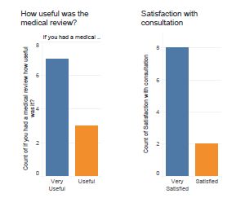
Source: RSM PACEC Patient Survey (March 2017)
- All respondents (n=10, base =10) stated that the found the medical review ‘very useful’ (n=7) or ‘useful’ (n=3)
- 8 respondents (80%) were ‘very satisfied’ by the consultation they received whilst the remaining 2 respondents (20%) were ‘satisfied’ by the consultation they received.
Patient Outcomes
Whilst formal monitoring data is not yet available on the tracking of patient outcomes, those who responded to the patient survey provided an insight into the types of outcomes being experienced by those who have benefitted from the system. The details of their responses are included below.
Figure: 5.3: Patient Outcomes (Part 1)
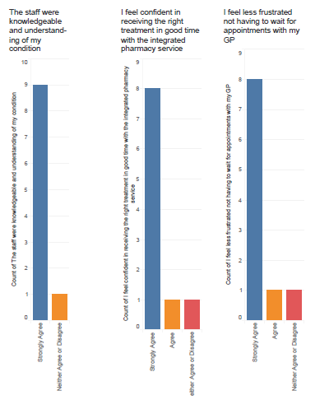
Source: RSM PACEC Patient Survey (March 2017)
Key points to note include:
- 90% of respondents (n=9) felt that staff were knowledge and understood their conditions.
- 80% of respondents (n=8) felt confident that they were receiving the right treatment in an appropriate timeframe from those in the integrated pharmacy service.
- 80% of respondents (n=8) felt less frustrated at not having to wait for appointments with the GP as a result of the new resources provided by the integrated pharmacy team.

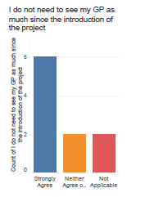
Figure: 5.4: Patient Outcomes (Part 2)
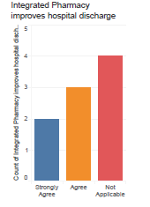
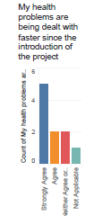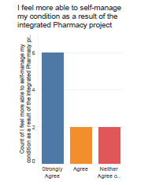
Source: RSM PACEC Patient Survey (March 2017)
- Half of all respondents (50%) ‘Strongly Agreed’ whilst an additional 2 respondents (20%) ‘Agreed’ that their health problems are being dealt with faster since the introduction of the project.
- 80% of respondents (n=8) ‘Strongly Agreed’ or ‘Agreed’ that they felt more able to self-manage their condition as a result of the integrated pharmacy project.
- 50% of respondents (n=5) felt that the integrated pharmacy project had helped to improve hospital discharge time;
- 60% of respondents (n=6) ‘Strongly Agreed’ that they felt they did not need to see the GP as often since the introduction of the project.

Staff Outcomes
A staff survey was developed by RSM PACEC and used by the pharmacy team to capture information on the staff experiences of the integrated pharmacy project. In total 12 responses were received.
Profile of Respondents
Only 12 responses were received to the staff survey. The profile of the respondents is detailed below.
Figure 5.5: Profile of Staff Respondents
Characteristic | Breakdown of Information
Local Practice | - Amewood Practice: 2 respondents (16.6%)  - Barton Surgery: 2 respondents (16.6%)  - Chawton House Surgery: 1 respondent (8.3%)  - Lyndhurst Surgery: 2 respondents (16.6%)  - New Forest Medical Group: 2 respondents (16.6%)  - New Milton Health Centre: 1 respondent (8.3%)  - Wisteria and Milford Surgeries: 1 respondent (8.3%)  - Other: 1 respondent (8.3%)
Staff Role | - Medicines Management Pharmacist: 1 respondent (8.3%)  - Medicines Optimisation Technician: 1 respondent (8.3%)  - Medicines Optimisation Pharmacist: 1 respondent (8.3%)  - Medicines Management Technician1 respondent (8.3%)  - Other: 8 respondents (66.6%)

Project Implementation
Staff were asked about their opinion on the implementation of the project. Some of their responses are included below.
Figure 5.6: Staff Survey – Project Implementation
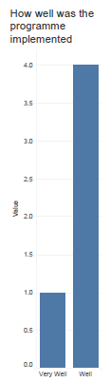
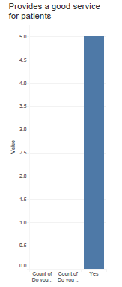
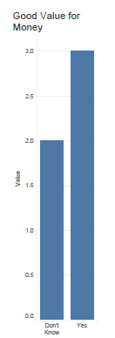

Source: RSM PACEC Patient Survey (March 2017)
Some of the key points include:
- Of the 5 respondents (41.6%) who answered this question. All thought the programme had been implemented ‘Very Well’ (n=1) or ‘Well’ (n=4).
- All 5 (41.6%) thought the programme provided a good service to patients.
- 3 respondents (25%, base =12) felt that the programme represented value for money.
Staff outcomes
Whilst no official data has been recorded in relation to staff outcomes, the staff survey provides an insight into the anticipated outcomes, based on the experience of the staff involved to date.
Some of the key findings are detailed below.
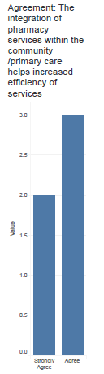
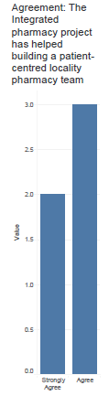
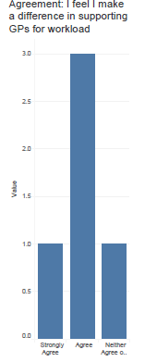
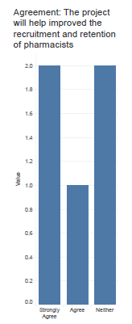
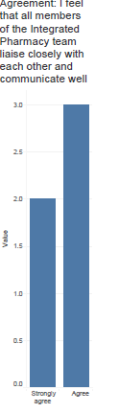
Figure 5.7: Staff Survey – Staff Outcomes
Source: RSM PACEC Patient Survey (March 2017)
Some of the key staff outcomes evidenced through the staff survey include:
- 5 respondents (41.6%) ‘Strongly Agree’ (n=2) or ‘Agree’ (n=3) that involvement in the integrated pharmacy project has led to closer working between team members and better communication.
- 5 respondents (41.6%) ‘Strongly Agree’ (n=2) or ‘Agree’ (n=3) that involvement in the integrated pharmacy project has helped to increase the efficiency of pharmacy services within the community and primary care.
- 5 respondents (41.6%) ‘Strongly Agree’ (n=2) or ‘Agree’ (n=3) that involvement in the integrated pharmacy project has helped build a patient centred locality based pharmacy team.
- 4 respondents (33.3%) ‘Strongly Agree’ (n=1) or ‘Agree’ (n=3) that involvement in the integrated pharmacy project has made a difference in supporting a reduction in GP workload.
- 3 respondents (25%) ‘Strongly Agree’ (n=1) or ‘Agree’ (n=2) that involvement in the integrated pharmacy project has improved the recruitment and retention of pharmacists.

Value for Money, Budget and Projected Spending

Budget
The bid document for the integrated pharmacy service indicates the following budget for the service. The current resource across the seven practices involved before the service began was 1.17 WTE (working time equivalent). The proposed additional resource was 3.8wte at a cost of £194,098 bringing the total cost of the service to £245,096 including the original CCG Medicines Optimisation service. The table below provides a breakdown of the costs involved.
Table 6.1: Budget for Integrated Pharmacy
Resource | WTE | Cost
Medicines Management Pharmacist 8a (Current) | 0.67 | £36,455
Medicines Management Technician 5 (Current) | 0.5 | £14,543
Sub-total (current resource) | 1.17 | £50,998
New Medicines Optimisation Pharmacists 8a | 3.3 | £179,555
New Medicines optimisation technician 5 | 0.5 | £14,543
Sub-total (additional resource) | 3.8 | £194,098
Total Service Costs (Current and Additional) | 4.97 | £245,096
Source: Vanguard Medicines Optimisation Service Proposal

Spend
Details of the spending on all vanguard projects has been provided to the evaluation team and the recorded spend in relation to integrated pharmacy is detailed in the table below.
Table 6.2: Spend on Integrated Pharmacy
Month | Finance Committed
November 2016 | £194,098
Sub-total | £194,098
Source: Hampshire Vanguard Finance Report April 2016 – January 2017
The spend report shows the initial payment to the integrated pharmacy project of £194,098 to cover the costs of the additional resources which were to be employed and provide services in the practices involved.

Initial Cost Savings Estimates vs Actual

Initial Cost Saving Estimates
In the current 12 month period for that prescribing data is available (i.e. January 2015 to January 2016), the seven vanguard practices prescribed 1,597,278 items at a cost of £13,076,847.
Financial Recovery Programme (FRP) savings of £468,547 from interventions included in the Medicines Optimisation Incentive Scheme 2016/2017 are already accounted for as needing to be delivered across the seven vanguard practices through reduced prescribing patterns.
The new services were expected to provide for additional savings of £194,098
Table 6.1: Estimated Costs Savings
Practice | Financial Recovery Programme 16/17 | Additional Savings (Full year effect) Service Cost | Total Savings
Barton Surgery | £79,008 | 32,730 | £111,738
The Arnewood Practice | £86,388 | 35,787 | £122,175
Wistaria and Milford Surgeries | £107,386 | 44,485 | £151,871
New Milton Health Centre | £66,772 | 27,660 | £94,432
Lyndhurst Surgery | £33,678 | 13,951 | £47,629
Chawton House Surgery | £45,099 | 18,682 | £63,781
New Forest Medical Group | £50,216 | 20,803 | £71,019
Total | £468,547 | 194,098 | £662,645
Source: Vanguard Medicines Optimisation Service Proposal

Realised Cost Savings
At present, prescribing data is available for the 7 South West New Forest practices to January 2017. Early evidence indicates that across the 7 SWNF practices £32,072 less has been spent on FP10 during the period October 2016 – January 2017. This is compared to the same time period in the previous year.
Comparing this with the 43 non-vanguard practices in the same time period (i.e. October 2016 – January 2017) they have collectively spent £19,296 more on FP10.
These early findings have a number of cautionary notes:
- It is acknowledged that the oral anticoagulant treatments are a significant cost pressure. Stroke prevention with arterial fibrillation tends to be more prevalent in an elderly population, and given the higher levels of older people in SWNF there are increased pressures in relation to the prescription of these forms of medication. If the oral anticoagulant treatment costs are removed from the data, it should give a better indication of the financial impact in the 7 SWNF vanguard practices.
- Prescribing patterns and spend are multifactorial and will also include full year effects of previous savings, interventions and population / demographic changes.
Considering the cost savings, excluding spend on the oral anticoagulants:
- The 7 SWNF practices spent approximately £88,000 less in the period October 2016 to January 2017 compared to the same period in the previous year. This is an average saving of £12,500 per practice.
- The other 43 non-vanguard practices spent approximately £215,000 less in the same period, averaging £5,000 less per practice.
The net impact of the Integrated Pharmacy project is a saving of approximately £7,500 per practice in other prescribing savings. Assuming these assumptions hold, if all 43 non-vanguard practices were involved in the project the total additional savings could be approximately, £322,500 for the period October 2016-January 2017.

Conclusions and Recommendations

Strategic Fit
The project demonstrates strong alignment with the national health policy objectives set out in the Five Year Forward View – particularly the need to proactively target services at registered patients with complex ongoing needs such as those with chronic conditions or the frail, offering greater convenience for patients and making full use of new skills and roles.
There is significant evidence that demonstrates the benefits to ‘medicines optimisation’ or integrating pharmacy. Black and Glaves (2011) state that pharmacy interventions have a number of positive outcomes including; effective optimisation of medicines use for patients, a reduction in the number of potentially inappropriate medicines that patients are prescribed and possibility of significant savings. They recommend Integrated strategies between acute to primary/community care and social services for transformational change in relation to medicines optimisation. The NHS alliance and Royal Pharmaceutical Society (2014) reported the rising demand in primary care and solutions to overcome this is to have pharmacists’ playing a key role in helping GP practices and primary care providers. The report noted that there are a significant number of qualified pharmacists available and pharmacists working in GP practices already, have helped significantly in improving care provision and work patterns. An average GP is said to authorise 200 repeat prescriptions per week, NICE described a scheme within Walsall CCG which demonstrated that a pharmacist-led strategy increased the quality of prescribing, reduced waste and saved GP time.

Emerging Findings
Integrated Pharmacy has been rolled out across 7 practices covering the New Milton and Lymington area since September/October 2016. The project is staffed by New Medicines Optimisation Pharmacists 8a (3.3 WTE) and new Medicines optimisation technicians 5 (0.5 WTE).
The services provided by the project include:
- Practice based medication reviews;
- Domiciliary Care Visits;
- Care home visits;
- Clinical appointments;
- Telephone consultations;
- Supporting patient integration with hospital care; and
- Supporting patient integration with community pharmacists.
The lack of maturity of the project makes the establishment of outcomes and impacts challenging however the levels of activity across the various activities is encouraging and provides a positive view of the work undertaken by the team. As of March 2017:
- Over 4,000 patient queries had been dealt with by members of the integrated pharmacy team. Of those:
- 2111 (50.5%) patients had a Practice Based Medication Review carried out;
- 688 (16.5%) patients were supported by the integrated pharmacy team to integrate their care with the hospital
- 277 (6.6%) patients had a telephone consultation with the integrated pharmacy team;
- 243 (5.8%) patients were supported by the integrated pharmacy team to integrated their care with the community pharmacy team;
- 118 (2.8%) of patients had a care home visit undertaken by the integrated pharmacy team; and
- 44 (1.1%) of patients had a domicilary care visit undertaken by the integrated pharmacy team.
Having interacted with 4,179 patients in total since September 2016, the BLC cost per patient is currently calculated at £58.65. When considering the wider cost savings generated by the integrated pharmacy project early evidence indicates that across the 7 SWNF practices £32,072 less has been spent on FP10 during the period October 2016 – January 2017. This is compared to the same time period in the previous year.
Comparing this with the 43 non-vanguard practices in the same time period (i.e. October 2016 – January 2017) they have collectively spent £19,296 more on FP10. The estimated net impact of the Integrated Pharmacy project is a saving of approximately £7,500 per practice in other prescribing savings.
6 staff responded to the integrated pharmacy staff survey. Some of the key findings from this include:
- 16.6% (n=1, base=6) of those surveyed reported that involvement in the project had encouraged them to become independent prescribers;
- 66.6% (n=4) of staff are involved in assessment of patients within the GP for medication optimisation.
- 83.3% (n=5) of respondents also believe that the project has improved the management of patients requiring polypharmacy care.
- 66.6% (n=4) of respondents believe that the project allows for more efficient use of resources.
- 33.3% (n=2) of respondents believe patient information is being shared more accurately and that since project inception.
- 83.3% (n=5) believe that the project will also free up GP time. All respondents believe that the project was implemented well and that the pharmacy team worked well alongside the GP.
- 66.6% (n=4) of the respondents believe that the project was good value for money.
10 patients provided feedback using the patient survey. Some of the key findings from this include:
- All participants (n=10, base=10) believe that the medical review they received was useful.
- 80% (n=8) either agree or strongly agree that the service has provided relevant information to self-manage health.
- 80% (n=8) of respondents believe that the service improves hospital discharge.
- 80% (n=8) believe that they do not need to see the GP as much since the project was introduced.
- 80% (n=8) of respondents believe their health problems are being dealt with faster since being introduced to the project.
- 80% (n=8) also believe that the service is tailored for their needs, and that the service is a valuable addition to the NHS.
- 80% (n=8) believe that staff were understanding and knowledgeable of their condition.
- 80% (n=8) of respondents also believe that they receive appropriate treatment in good time within the Integrated Pharmacy service.
- 80% (n=8) also believe that they are less frustrated waiting for GP appointments as a result of the service.

Funding and Sustainability
The programme enjoys significant local buy-in and is used frequently by all participating practices. It also has recently expanded to the Avon area and will be establishing a new service in this region.
There is further work to be done to ensure services can be supported in a manner that ensures equity across practices and appropriate use of local commissioning funds.

Recommendations
Recommendations for the Integrated Pharmacy Project include:
- Recommendation 1: Provide clear guidance on remit, roles and expectations – there is a need to be clear with the staff involved about the remit and role of the new pharmacist, particularly the interactions between the pharmacist and GPs, and the levels of expectation to ensure that there is sufficient time for the project to become embedded in the practice;
- Recommendation 2: Clearly defining the limitations of the Pharmacist – it should be recognised and reiterated that the pharmacists are not GPS and therefore do not have the skills or training provided across all areas of practice work. They do have a particular skillset which can help patients with their medicines and help GPs to free up some of their time;
- Recommendation 3: Treat activity monitoring, patient feedback and other evidence gathering with high priority so that more robust data is available to evidence progress against KPIs in future.
- Recommendation 4: To continue to share the learning and provide a forum for feedback – it is recognised that sharing what works between practices is helpful to address issues related to visibility and effectiveness. A continued forum for shared learning should be provided. In addition, the Medicines Optimisation Group provides a forum to discuss and share what pharmacists and technicians are doing. This is useful and should continue so that there is a forum for feedback.

Appendix 1 – integrated pharmacy staff survey

Background information

Q1 Which Local Practice do you predominantly work in? (Tick one)
Arnewood Practice
New Milton Health Centre
Barton Surgery
Chawton House Surgery
Lyndhurst Surgery
New Forest Medical Group
Wistaria & Milford Surgeries
Other (please specify)
Q2 What is your role? (Tick one)
Medicines Management Pharmacist
Medicines Management Technician
New Medicines Optimisation Pharmacists
New Medicines Optimisation Technician
Clinical Pharmacist
Pharmacists
Pharmacy Technicians
Assistant pharmacist
ATO assistant
Other (please specify)

Your involvement in the Integrated Pharmacy Pilot project and Process

Q3 How did you become involved in the Integrated Pharmacy Pilot Project?

Q4 Did you receive enough information/briefing/support prior to becoming involved in the project?
Yes
No
Not sure
If no, please tell us what type of information/briefing/support would have been useful to you.

Q5 Were the objectives of the project made clear to you?
Yes
No
Not sure
If no, please tell us what could have been made clearer?

Q6 What did you expect to gain from your involvement?

Q7 Are you an independent prescriber? (Tick one)
Yes (Go to Q11)
No (Go to Q8)
Q8 Are you working towards independent prescriber status? (Tick one)
Yes (Go to Q10)
No (Go to Q9)
If no, why not
Q9 Are you planning to work towards independent prescriber status? (Tick one)
Yes (Go to Q10)
No (Go to Q11)
Don’t know
If no, why not
Q10 Has your involvement in the project motivated you to work towards independent prescriber status? (Tick one)
Yes
No
Don’t know
If yes, how did it motivate you
Q11 In general, do you think that working as part of an integrated team works well? (Tick one)
Yes
No
Don’t know
If no, what does not work?
Q12 How often did you get involved in the following activities before your involvement in the project?
 | All the time | Most of the time |  | Some of the time |  | Never |  | Not applicable
Support the management of patients requiring polypharmacy therapy in the community
Supporting GP in MR
Repeat prescribing
Prescribing queries
Assessment of patients within the General Practitioner Surgeries for medication optimisation
Provision of advice to the Practices on the appropriate ordering of medicines and related products
Provision of advice to the Nursing homes on the appropriate ordering of medicines and related products
Helping patients with their self-care plans
Undertaking clinical medication review of high risk patients for example frailty
Medical reviews in the patient’s home
Domiciliary visits to support patients who have recently been discharged from hospital

Q13 How often did you get involved in the following activities now?
 | All the time | Most of the time |  | Some of the time |  | Never |  | Not applicable
Support the management of patients requiring polypharmacy therapy in the community
Supporting GP in Medical Reviews
Repeat prescribing
Prescribing queries
Assessment of patients within the General Practitioner Surgeries for medication optimisation
Provision of advice to the Practices on the appropriate ordering of medicines and related products
Provision of advice to the Nursing homes on the appropriate ordering of medicines and related products
Helping patients with their self-care plans
Undertaking clinical medication review of high risk patients for example frailty
Medical reviews in the patient’s home
Domiciliary visits to support patients who have recently been discharged from hospital

14 Please rate the extent to which you agree or disagree with each of the following statements. (Tick one per row)
 | Strongly agree | Agree | Neither agree nor disagree | Disagree | Strongly disagree | Too early to say
The integration of pharmacy services within the community /primary care helps increased efficiency of services
The Integrated pharmacy project has helped building a patient-centred locality pharmacy team
I feel I make a difference in supporting GPs for workload
I feel that the integrated team is more able to support frail, housebound and vulnerable patients
The project will help improved the recruitment and retention of pharmacists
The management of patients requiring polypharmacy therapy has improved since the introduction of the Integrated Pharmacy project
I feel I am receiving a lot of support in my new role
I feel that all members of the Integrated Pharmacy team liaise closely with each other and communicate well
The project will lead to more career development opportunities for pharmacists
I feel my career is now more attractive
I feel the project will help enhance patients care
I feel better and happier in my job since the introduction of the project
I received appropriate training / briefing and support to work effectively with the new model
The project allows more efficient use of resources

My job has become more stressful since the introduction of the Integrated Pharmacy pilot project
Staff have a more constructive work relationships since the introduction of the project
The project will help improve hospital discharges
Integrated Pharmacy will help free up GP time to concentrate on those patients with more complex needs
I think that the pharmacy team working alongside GPs works well
I think that information about patients are being shared more accurately since the introduction of Integrated Pharmacy

Effectiveness of the SDAS project and success factors

Q15 How well do you think the project was implemented? (Tick one)
Very well
Well
Not very well
Not at all well
Please explain your answer

Q16 How do you think the model contributes to medicines optimization at admission and discharge from hospital?

Q17 Do you think that the project provides a good service to patients? (Tick one)
Yes
No
Don’t know
Please explain your answer

Q18 Do you think the project provides value for money? Why? (Tick one)
Yes
No
Don’t know
Please explain your answer
Q19 In your opinion, what are the enablers to joint working?
Q20 In your opinion, what are the 3 things that work well with the introduction of the Integrated Pharmacy project?
Q21 How has the project help improved integrated team working?

Suggestions for improvement

Q22 In your opinion, what are the main barriers to joint working, if any?

Q23 In your opinion, what are the main 3 things that could be improved upon for the project going forward?

Q24 Any other comments?

Appendix 2 – Integrated Pharmacy Patient Survey

The Southern NHS Foundation Trust have commissioned PACEC to conduct a service improvement evaluation of the Hampshire Multi-Speciality Community Provider (MCP) Better Local Care Vanguard.
As a patient receiving health and care services, your views are very important for informing how the service can improve in future. The questions we would like to ask are about your experience and understanding of the care you have received from the Integrated Pharmacy team.
Your response to this series of questions will be anonymous and we will ensure that you cannot inadvertently be identified by using national guidelines on disclosure of personal data.
Any information you provide will be held securely on a managed computer server and can only be accessed by members of the evaluation team. Your individual data will not be shared with any third party, and results of our survey will be reported in aggregate form.
Patient profile information

Q1 Are you (Tick one)
Male
Female
Q2 What is your age group? (Tick one)
Under 18
18-24 years old
25-34 years old
35-44 years old
45-54 years old
55-64 years old
65-74 years old
75+

Q3 Which Local Practice do you normally go to? (Tick one)
Arnewood Practice
New Milton Health Centre
Barton Surgery
Chawton House Surgery
Lyndhurst Surgery
New Forest Medical Group
Wistaria & Milford Surgeries
Other (please specify)

Q4 How did you first hear about Integrated Pharmacy? (Tick one)
In my GP practice
Hospital
Media (TV, newspaper, radio etc.)
Pharmacy
Internet/online
Voluntary organisation/charity
Friends/family
Other (please specify)

About your experience

Q5 Do you have a long term medical condition?
Yes
No
Prefer not to say

Q6 Could you say how you came into contact with the clinical pharmacist? (ie did you get a home visit? Or did you go to the practice? Or did the pharmacist visit your care home? At the hospital?
Q7 What service did you receive from the pharmacist? (ie Medication review, repeat prescriptions, minor illness advice, help and support with your self-care plan?
Q8 How satisfied or dissatisfied were you with the consultation with the pharmacist? (Tick one)
Very satisfied
Satisfied
Neither satisfied or dissatisfied
Dissatisfied
Very dissatisfied
If dissatisfied, please say why.
Q9 How satisfied or dissatisfied were you with the timeframe in which you were able to consult the pharmacist? (Tick one)
Very satisfied
Satisfied
Neither satisfied or dissatisfied
Not very satisfied
Not at all satisfied
If not satisfied, please say why

Q10 Did you think that the pharmacist was knowledgeable and could deal with your issue without further need for a GP consultation? (Tick one)
Yes
No
Don’t recall

Q11 If you had a medical review, how useful did you find the medical review? (Tick one)
Very useful
Useful
Somehow useful
Not useful
Not at all useful
If not useful, please say why.

Q12 Do you think that the pharmacist could answer any questions that you may have had? (Tick one)
Yes
No
Don’t recall
Q13 Have you received a home visit from the pharmacist?
Yes (Go to Q14)
No (Go to Q15)
Don’t recall (Go to Q15)

Q14 If you received a home visit, do you think that being able to receive a home visit from the pharmacist is an improvement to the health service? (Tick one)
Yes
No
Don’t know
Please explain your answer.

Outcomes and satisfaction

Q15 To what extent were you involved as much as you wanted to be in decisions about your care? (Tick one)
To a great extent
To some extent
To a small extent
Not at all
Could you please explain your answer?

Q16 To what extent did you receive useful information from the pharmacist to help you manage your health and wellbeing? (Tick one)
To a great extent
To some extent
To a small extent
Not at all
If not at all, could you please explain your answer?

Q17 Please rate the extent to which you agree or disagree with each of the following statements. (Tick one per row)
 | Strongly agree | Agree | Neither agree nor disagree | Disagree | Strongly disagree | Not applicable
I feel more able to self-manage my condition as a result of the Integrated Pharmacy project
I think that the pharmacy team working alongside GPs works well
Integrated Pharmacy improves hospital discharges.
The service provided by the Integrated Pharmacy project was efficient
I do not need to see my GP so often since the introduction of the Integrated Pharmacy project
My health problems are being dealt with faster since the introduction of the project
I feel that the service is tailored to my needs
I feel less frustrated not having to wait for appointments with my GP
The staff were knowledgeable and understanding about my condition
I feel confident in receiving the right treatment in good time with the Integrated Pharmacy service
I feel satisfied with the support received from the pharmacist.
I feel that all the healthcare professionals in the project operated as a real team
I was referred to other health care professionals and the system worked well
I feel that I received a high quality level of care and advice from the pharmacist.
The Integrated Pharmacy project is a valuable addition to the NHS
I was satisfied with the way my health condition was handled
The support and advice I received has helped me make the most of my medicines.
I feel happier in my life now

Q18 How good was your overall experience of Integrated Pharmacy project? (Tick one)
Very good
Good
Neither good nor poor
Poor
Very poor
If poor, could you please explain your answer?
Q19 Would you recommend the service to friends and relatives? (Tick one)
Definitely
Probably
Probably not
Definitely not
If not, could you please explain your answer?
Q20 How could the service be improved?
Q21 Do you have any further comments?

As per BLC background bid document
http://www.southernhealth.nhs.uk/inside/better-local-care/
Black M, Glaves G (2011). ‘Integrated strategies will work best.’ The Pharmaceutical Journal 2011
http://www.nhsalliance.org/wp-content/uploads/2014/12/NHS-Alliance-Pharmacists-in-general-practice.pdf
See above
http://www.nhsalliance.org/making-time-in-general-practice/new-ideas-for-reducing-workload/
Making our health and care systems fit for an ageing population, Kings Fund 2014
PHE FingerTips data
Vanguard Medicines Optimisation Service Proposal
NHS Alliance
Black M, Glaves G (2011). ‘Integrated strategies will work best.’ The Pharmaceutical Journal 2011
http://www.nhsalliance.org/wp-content/uploads/2014/12/NHS-Alliance-Pharmacists-in-general-practice.pdf
See above
http://www.nhsalliance.org/making-time-in-general-practice/new-ideas-for-reducing-workload/

