Evolving communication plan Nurturing and Weaving networks SIG q community
July 2022

Background

We want the Nurturing and Weaving Networks SIG to be a lively space, where people can share ideas and connect with others interested in the principles of networking and network weaving and how to build, map, and sustain networks and ourselves and each other as networks members.
Communication is key to building relationships so we felt having a communication plan led by members may be a helpful resource to learn how we like to communicate so whatever the SIG must share has value and does not become more noise.
One of the main activities of the SIG this year is adapting the Network Weavers Handbook originally designed by June Holley in 2011 and it is important that the members of the SIG, and their guests can have access to these materials and influence how they develop.
In adapting the handbook, we also want to include new case studies showing the amazing work already across the UK around networks and if you would like to share a case study, please let us know, we need your help.
The following is an evolving document which we have had feedback on before sharing. How it evolves going forwards, will be something we do together. If there are any omissions, ideas please share, this is our plan.
We also want the SIG space to be a compassionate community where we look out for ourselves and each other and share selfcare ideas as well as ideas for network weaving and networks.
Thanks for reading
Hilda and Mandy

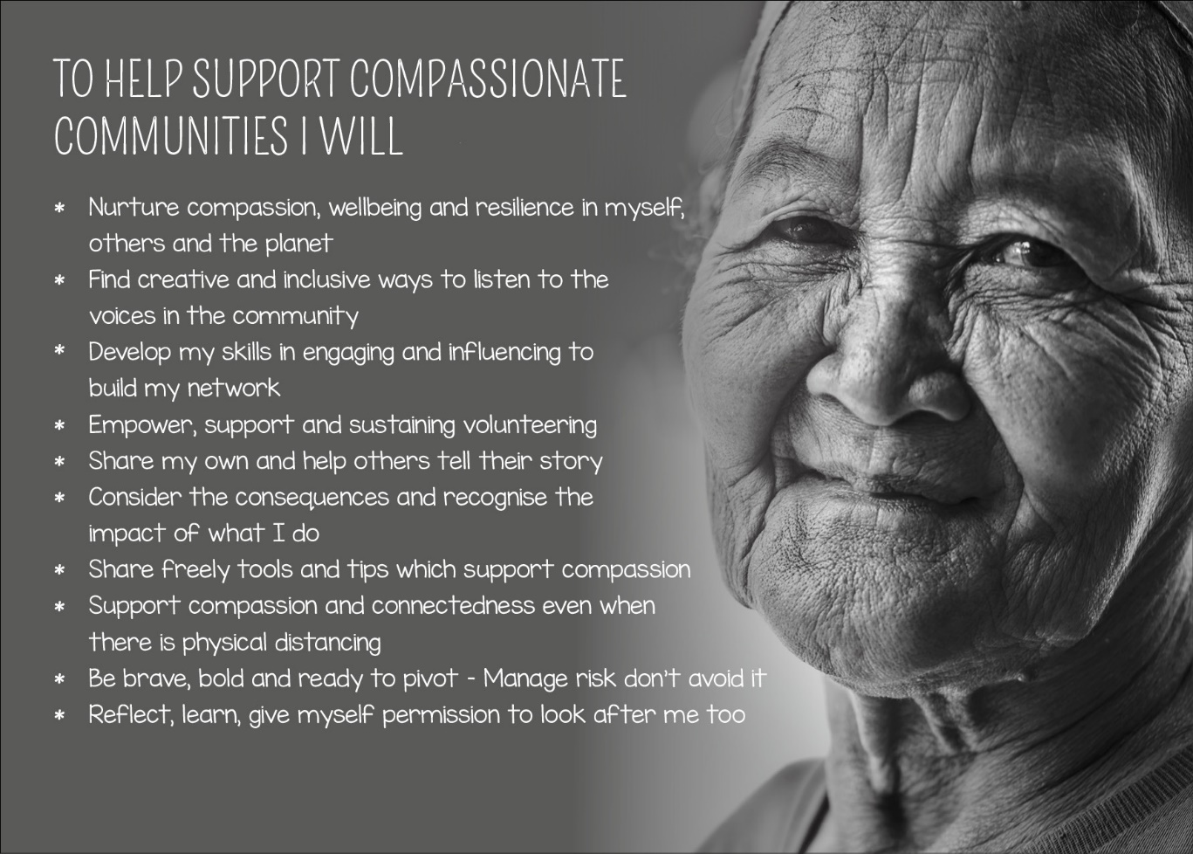

Contents

Who are we seeking to communication with? Page 3
Why do we need to communicate? Page 3
Qualities and skills which support network weaving Page 4
The evolving goals for the communication plan Page 6
The objectives of the communication plan for 2022 23 Page 7
The Key messages Page 7
Tactical communication plan Page 8

Please note, this is an evolving plan which shall be led by members so please feel free to share your ideas of what else we should include.

Who are we seeking to communicate with?

For the purposes of this specific plan the audience includes the following, but please let us know who are we missing?

- Members of the Q Community q.health.org.uk in general
- Members of the Q Community who attended the Network Weaving Learning Series
- Members of Q in Scotland
- Members of the SIGs which align with this SIG including, those concerned with staff wellbeing and liberating structures
- Non-members of the Q Community who may find being a guest in the SIG of value to them and their networks
- Colleagues who wrote the first Network Weavers Handbook and who are facilitators in the Network Weaving Learning Series
- Colleagues who work within the Q Community and funders of the building connections project in terms of monitoring and evaluation and sharing learning

Why do we need to communicate?

An effective communication plan is clear on its goals and objectives. The core of communication includes the following; however, these may have more meaning than others for you, what matters to you?
- Inform
- Influence
- Gain inspiration
- Motivate
- Learn
- Build relationships
- Promote ourselves or a cause we believe in
- To connect with others and socialise
- The key messages for the evolving communication plan

Qualities and skills which support network weaving

We have an initial mind map of the qualities identified as being supportive of network weaving. Diagram 1. This helped inform a successful application to ‘Supporting Q Connections’ for a project ‘’Adapting and co-designing a suite of learning resources to support and nurture network weaving for the individual, team and system ‘’ The initial mapping was carried out in Scotland; however, we want to build on this work with our colleagues across the 4 nations to learn and develop ideas together which works for many stakeholder groups. This link takes you to a jam board which invites your views so we can update the map to represent the views across the Q community in the UK. https://jamboard.google.com/d/1UoEmcCzSY-d3lR7RN9_MeMYmwwIp18TD3BABxWUzwdw/edit?usp=sharing
This is a small image of the map; the full-size image is in the document section. On the SIG page for Nurturing and Weaving Networks

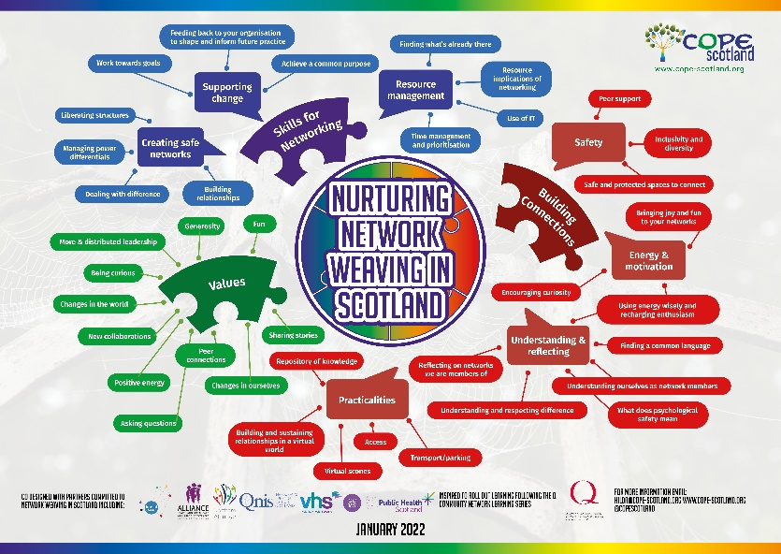
Diagram 1: The qualities and conditions which support Network Weaving

The following are the main headings and subheadings from the map created in Scotland, what we need help from our colleagues across the UK is what do you think and what is missing, please use the Jam Board to share ideas: https://jamboard.google.com/d/1UoEmcCzSY-d3lR7RN9_MeMYmwwIp18TD3BABxWUzwdw/edit?usp=sharing

Skills for Networking
Supporting change
Achieve a common purpose
Feeding back to your organisation to share and inform future practice
Work towards goals

Creating safe networks
Liberating structures
Managing power differentials
Dealing with difficulty
Building relationships

Values
Fun
Generosity
More and distributed leadership
Being curious
Changes in the world
New collaborations
Positive energy
Asking questions
Peer connections
Changes in ourselves
Sharing stories

Building connections
Safety
Peer support
Inclusivity and diversity
Safe and protected spaces to connect

Energy and motivation
Bringing joy and fun to your networks
Encouraging curiosity
Using energy wisely and recharging enthusiasm

Understanding and reflecting
Reflecting on networks we are members of
What does psychological safety mean?
Understanding and respecting difference
Understanding ourselves as network members
Finding a common language

Practicalities
Building and sustaining relationships in a virtual world
Virtual scones (creating that informal space often happens when face to face over a cup of coffee at a break)
Repository of knowledge
Access
Transport and parking

The evolving Goals for the communication plan currently are as follows

- Reputation Management Goal: Individuals working in different sectors and managers of resources see the time investment in SIG membership as having value for their department targets and their staff’s wellbeing
- Task Management Goal: Individuals will have a CPD (Continuous Professional Development) reflective tool which enables them to develop their role as a Network Weaver. Listening to people it became clear there was value to creating a tool which offered a reflective space to think about networks people may be members of/wanting to establish as well as time to reflect on themselves within networks. The CPD reflective log is the space for reflecting on ourselves and our networks so we can then decide the tools which may help us achieve the goals which arose from our reflections
- Task Management Goal: The project will adapt the network weaver handbook materials to offer an accessible suite of contextualised learning resources, complimented by a creative learning space to share knowledge, improvement experiences, resources, and tools in support of enhancing network weaving and networking in support of system transformation.
- Relationship Management Goal: There will be improved relationships between individuals working in different sectors supportive of working and learning together to support systems change

The objectives for the communication plan for 2022 23 so far are

- By June 2022 there will have been 3 events involving at least 150 people which will inform the development of the suite of learning resources for Network Weaving. A report on this is available if of interest.
- By September 2022, the Nurturing and Weaving Networks SIG will have a membership of 50 individuals who have been involved in sharing and collaborating on improved outcomes around networking
- By September 2022 there will be a CPD reflective log created which supports individual reflection and development as a Network Weaver shared with 75 individuals interested in developing their networking skills
- By September 2022 there will be an adapted network weaver handbook and accessible suite of contextualised learning resources
- By October 2022 there will be a creative learning space to share knowledge, improvement experiences, resources, and tools in support of enhancing network weaving and networking in support of system transformation
Is there anything else you would like to add?

The Key messages are

- The value of Network Weaving for supporting change and collaboration across non-traditional boundaries
- The value of learning about Network Weaving for professional and personal goals
- The promotion of existing resources which can support Network Weaving
- The opportunity to be involved in adapting and further developing resources which can support Network Weaving
- The spaces where people interested in Network Weaving can connect
- Updates on developments and learning opportunities
- Celebrating stories of change because of Network Weaving
- Feeling nurtured within a community of peers

Tactical Communication plan

Recognising the various channels of communication and that one size may not fit all, a variety of methods need considered to find one/s which work best. See Diagram 3 methods of communication

Diagram 3: Methods of Communication
Offering a range of options to communicate enables people to select those which work for them, using emergent strategizing to add new communication channels as we go along. It also matters we agree how often we want to communicate. The following offer ideas, it would be great to prioritise what works best and see how that evolves. We plan to introduce a poll to gather views as another way we can connect with each other and share views

Weekly communication
- Email
- What’s App
- Social Media
- SIG landing page
Monthly communication
- Blogs
- Teatime conversations
Quarterly communication
- Newsletter
- Online seminar and events
Ongoing communication
- Hexi time access as suits (hexitime.com enables you to share skills and ideas for health care improvement.)
- Online learning resources access as suits
- Catch up at teatime coffee chats
- Jam board
- Gantt charts

We will not be able to do everything, it is about prioritising and doing this together, so please, this is our communication plan, if you have ideas share them as none of us can do it all alone.

Thank you for wanting to be a part of this SIG, your time and interest in network weaving, it is appreciated

