Achieving equity in QI
Wherever you are in the improvement journey, you can still take action towards achieving improved equity in improvement work.
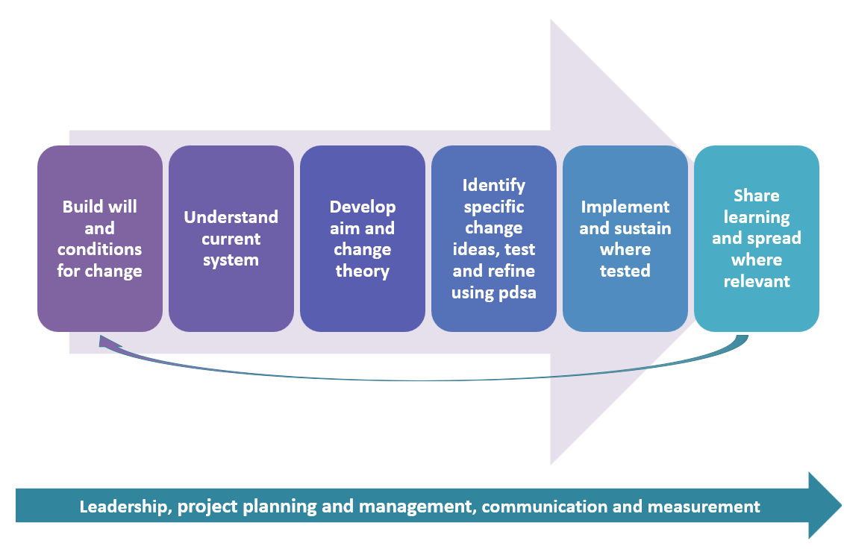
Source: https://learn.nes.nhs.scot/4095/quality-improvement-zone/improvement-journey
Build will and conditions for change
- Do the project team have an awareness of the difference between equity and equality?
- Do the project team have an awareness of the potential impact of improvement work on equity?
- Is there a way of sharing resources to share learning from equity-focused QI work in the organisation?
Understand the current system
- Have you collected and stratified data on a population’s social and demographic characteristics with the purpose of informing targeted improvement?
- Have you used tools to understand the root causes of the problem and inequalities that exist between groups? (which will improve quality for everyone)
- Is there an opportunity to influence the social determinants which could prevent ill health?
Developing the aim and change theory/ identify changes, test and refine
- Does your aim take account of groups at most risk of poorer health outcomes? Do you need a separate aim?
- Have you identified and addressed barriers unique to specific groups at risk of poor health outcomes?
- Have you identified and addressed barriers common to many groups at risk of poor health outcomes?
- Have you included balancing measures for equity?
Implement and sustain where tested
- Have you conducted a health inequalities impact assessment?

