**Improving public health capability and capacity in QuaIity Improvement**

This paper aims to stimulate discussion about how the core public health workforce can build on investment in Quality Improvement (QI) to contribute to “a Scotland in which everyone can thrive”. The core public health workforce are defined in the Review of Public Health (2015) as “all staff engaged in public health activities that identify public health as being the primary part of their role.”

**Drivers for QI in public health:**

The public health workforce are increasingly facing complex social challenges. Although knowledge exists about the root causes of these challenges and generalisable knowledge exists about what action can be taken to address them, less is known about how these actions can best be implemented in local contexts in order to achieve the ambitions of [Public Health Reform](https://publichealthreform.scot/why-reform-is-important).

QI is part of Healthcare Improvement Scotland’s [Quality Management System](http://www.healthcareimprovementscotland.org/previous_resources/policy_and_strategy/quality_management_system.aspx) model which addresses quality infrastructure design in public services.

QI approaches are increasingly being used by public service partners across the whole system to in efforts to improve their practice reduce inequalities and improve public health and wellbeing. Public health involves a broad systems approach which requires working collaboratively and influencing public service partners. [Health and Social Care Delivery Plan](https://www.gov.scot/Publications/2016/12/4275/downloads) highlights the need to build on QI investments in order to improve health outcomes and recommends that ‘services should be rooted in a widespread culture of improvement’. Brian Robson from Healthcare Improvement Scotland challenged public health staff to engage with QI at the 2016 Faculty of Public Health Conference.

QI is only one approach to delivering improved outcomes. Whole system working involves multiple interventions from partners at both national and local level. The new public health system will need to have capability across a range of approaches to choose the best approach, or combination of approaches, for the nature of the situation.

However, the [3 Step Improvement Framework for Scotland’s Public Services](https://www.gov.scot/Resource/0042/00426552.pdf) states that if transformational change is to be achieved, everyone involved must know and understand the change method for improvement in that situation.

**Learning from practice and literature in Scotland and beyond**

Riley et al (2010) define quality improvement in public healthas ‘use of a deliberate and defined improvement process, such as Plan-Do-Check-Act…to achieve measurable improvements in the efficiency, effectiveness, performance, accountability, outcomes, and other indicators of quality in services or processes which achieve equity and improve the health of the community’.[1]

Scoping work by Health Scotland revealed that QI is found to be relevant and useful in a number of public health situations in Scotland, for example:

* Increasing uptake of healthy start vouchers in an island community
* Increasing breastfeeding support using QI, coproduction and social capital
* Improving health and wellbeing in Grampian for women with a BMI>30
* Applying Lean in a public health training context
* Reducing inequalities in the reach and uptake of the Child Health Review

Aberdeen city community planning partnership illustrate how they have taken a whole system approach to building QI capacity and capability to enable collaborative action which leads to improved outcomes as outlined in the Local Outcome Improvement Plan.

A recent evidence summary carried out by Health Scotland revealed that when QI is applied to a public health context:

* It can be used to improve process, performance and large scale collaborations
* It can be used to achieve transformational change, by combining small incremental changes to processes (bottom-up) with large scale improvement intentions (top-down). NHS Improvement argue that ‘transformation of a system begins with transformation of the individuals working in the system’ [2]
* Leaders must publicly declare their intention to make improvement happen, develop a vision for the future, build a QI infrastructure, and implement basic QI methods, concepts, principles and habits
* Sustainability requires: cultivating public health leaders to empower employees; teaching, training and providing opportunities for individuals; creating national networks and resources; providing finances and incentives; resources; performance management and accountability
* It results in more data-informed decision making about how change is implemented by critically analysing processes measures (differing from other public health practice)

Health Scotland is engaging in dialogue with third sector colleagues about what the voice of lived experience, co-production and co-design of services can bring to QI.

**Recommendations**

* Understand extent to which public health workforce have engaged in QI education as well as strengths and areas for further development
* Build on knowledge from evidence summary on QI in public health to test and learn from applying improvement methodologies for public health
* Integrate training in creating the conditions for a culture of quality improvement into Public Health Leadership Programmes (e.g. Place to Be)
* Work with providers of QI education to develop workforce development solutions which meet the needs of the public health workforce and develop habits required for continuous improvement
* Test QI capability and capacity building in a public health system with third sector

Emma Little, NHS Health Scotland

Sacha Will, Aberdeen City Council

Michelle Cochlan, Aberdeen City Council

October 2018

**Developing a Quality Improvement Culture to Improve our City**

Since 2016, Aberdeen has made significant progress in creating the conditions to change the way that public services work together across the City to achieve improvement for our communities.

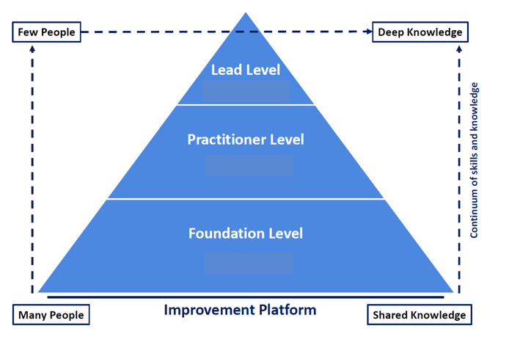Following publication of our Local Outcome Improvement Plan (LOIP) in August 2016, a review of the Community Planning Aberdeen infrastructure was undertaken to ensure it was organised to deliver our ambitious improvement aims. The new structure strengthens the distributed leadership of the partnership across the city and in local communities. It enables a whole system approach to Quality Improvement across the four themes of Economy, People, Place and Technology. Supporting all partners to develop a greater understanding about what matters to local communities, to use data and test theories of change which lead to improved outcomes.

“Transformation of a system begins with transformation of the people working in the system”

With the structure in place, the partnership recognised the importance of supporting individuals to improve their capacity and capability in quality improvement. This led to the development of our ‘Innovate and Improve Programme’.

We worked across the partnership, with Scottish Government and NHS Education for Scotland (NES), to identify a faculty with the appropriate knowledge, experience and skills to provide a learning programme which builds Quality Improvement capacity at all levels.

The Local Outcome Improvement Plan, new Community Planning Structure and our Innovate and Improvement programme have enabled improvement to flourish across Aberdeen.

In the past 18 months, the Community Planning board have supported 29 new improvement projects designed to reach our ambitions for the people and place of Aberdeen. From community-led projects such as reducing dog fouling, improving traffic safety, providing free meals to children during school holidays; to strategically led projects such as improving family support services and reducing drift and delay for our care experienced children. The Quality Improvement approach is empowering individuals, communities, public sector and third sector colleagues to collaborate and learn together about how to improve our city.

“Ambition is the path to success. Persistence is the vehicle you arrive in” Bill Bradley

  

1. **Defining quality improvement in public health.** *Journal of Public Health Management and Practice : JPHMP,* ***16***(1), 5-7. <http://dx.doi.org/10.1097/PHH.0b013e3181bedb49>
2. **Building capacity and capability for improvement**, NHS Improvement (2017) <https://improvement.nhs.uk/documents/1660/01-NHS107-Dosing_Document-010917_K_1.pdf>